Press Release Contacts:
For Immediate Release Vinitaly International
International Media Dept.
+39 045 8101447
media@vinitalytour.com
www.vinitalytour.com
Twitter: @VinitalyTour
Join Vinitaly International Network on LinkedIn

For the first time two simultaneous showcases: Vinitaly in Chengdu, China, and in Verona, Italy

Shanghai, 24 February 2015 - Vinitaly and Vinitaly International will begin the Chinese New Year with three stops (Chengdu, Jinan and Shanghai) in less than fifteen days in the name of Italian wine and will continue with a new format that engages top importers and winemakers as well as the educational program “Vinitaly International Academy”.
The opening event will be the 2nd edition of Vinitaly China at the Kempinski’s Off-site showcase in Chengdu on the 23rd of March (to the 25th). On the 27th of March the tour will continue in Jinan, Shandong region, and then move on to Shanghai on the 2nd of April for the last two stops of Expo Roadshow China. On the one hand the capital of Sichuan, chosen by Vinitaly for its second edition, on the other, the city of the latest Universal Exposition.
“To have two showcases going on at the same time doesn’t seem to be causing any problems. In fact, quite the opposite: this year Vinitaly China will be organized on the same days of Vinitaly in Verona (from the 22nd to the 25th of March). On the one hand I am sorry I won’t be there, but we believe we have created a good level of continuity with the previous edition in Chengdu, thanks to Simone Incontro and our ambassador Ling Zi, both present at our stops in Shanghai and Dalian” states Stevie Kim, Vinitaly International’s Managing Director. “To be able to organize Vinitaly in Verona and hold Vinitaly China as its ‘satellite’ is an important challenge for both our teams at Vinitaly and Vinitaly International and will, indeed, give us great satisfaction”.

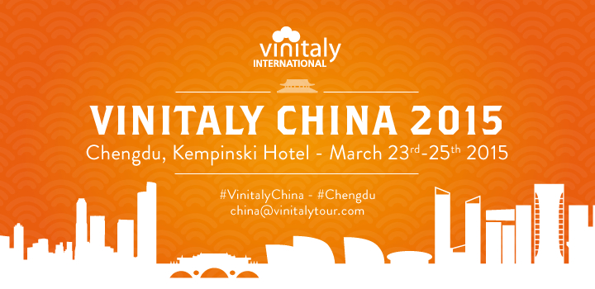
Vinitaly will be once again the protagonist in Chengdu at the Off-site showcase of the Kempinski Hotel, the hub for wine import in China since 2009 and the only b2b event of importance in the local wine sector. The Off-site showcase is part of the most important and ancient wine and spirits Fair in China, Tanjihui, traditionally hosted in Chengdu, and it always catches the attention of top local and international wine industry stakeholders. Chengdu is the only city capable of attracting professionals and buyers from every corner of the Country. Tanjihui is held twice a year: once in autumn, each time in a different city, and then in spring, in Chendgu. The latter is the most important of the two. This year’s edition will be the 92nd and over 300.000 visitors are expected to visit the city in the week that goes from the 22nd to the 29th of March.
“Vinitaly’s decision to return to China with these three stops testifies the increasing attention that Italian wine industry is showing towards this broad market” says Alberto Bradanini, the Italian Ambassador to China. “The potential for the Italian wine industry is still far from being adequately capitalized. In particular, the participation in the Off-site showcase in Chengdu will offer a valuable opportunity to show China the large variety and quality of Italian wine, with the final aim of spreading a wider knowledge of the product and increasing market shares. The Embassy and the Italian consular network in China will always be at the side of our wine industry professionals and will accompany them through this difficult but stimulating challenge with the ultimate goal of bringing the export of Italian wine to the righteous level of a Country in which oenological culture is constantly evolving and improving.”
Vinitaly’s choice to attend the Fair for the second consecutive year proves its true professionalism” adds Sergio Maffettone, the Consul General of Italy in Chongqing, “The Consulate will support Vinitaly by coordinating an Italian pavilion at the fair which will fill an area twice the size of last year. The common goal is to increase the turnover and sales volume of Italian Export, relying as much as possible on Italian retailers in China.”
From the 27th to the 29th of March in Jinan and from the 2nd to the 6th of April in Shanghai, Vinitaly International, Vinitaly’s strategic branch abroad, will bring Italian wine to the guests of Expo Roadshow China and will present Vino A taste of Italy, the wine pavilion organized with Veronafiere at Expo 2015 in Milan. The tour, that started in Bejing in October, will end this way at the same time as the beginning of Expo 2015. 8 cities, including Changsha, Fuzhou, Guangzhou, Chongqing, and Zhengzhou, have been involved in a tour that has been fully endorsed by both winemakers and buyers

About:

Veronafiere is the leading organizer of trade shows in Italy including Vinitaly (www.vinitaly.com), the largest wine and spirits fair in the world. During its 48th edition Vinitaly counted some 155.000 visitors and 4.000 exhibitors on a 100.000 square meter area. The next edition of the fair will take place on 22 – 25 March 2015. The premier event to Vinitaly, OperaWine (www.vinitalyinternational.com) “Finest Italian Wines: 100 Great Producers,” will unite international wine professionals on March 21st 2015 in the heart of Verona, offering them the unique opportunity to discover and taste the 100 best Italian wines, as selected by Wine Spectator. Since 1998 Vinitaly International travels to several countries such as Russia, China, USA and Hong Kong. In February 2014 Vinitaly International launched an educational project, the Vinitaly International Academy (VIA) with the aim of divulging and broadcasting the excellence and diversity of Italian wine around the globe. VIA is now ready to present the first edition of its VIA Certification Course to be held in Verona from the 16th to the 20th of March 2015 with the aim of creating new Ambassadors of Italian Wine in the World.

