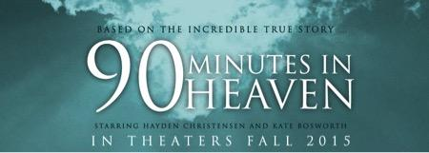

‘90 MINUTES IN HEAVEN’
WRAPS ATLANTA FILMING
Giving Films’ Inaugural Movie Features Hayden Christensen and
Kate Bosworth (with Michael W. Smith and Dwight Yoakam)
90MinutesinHeaventheMovie.com

ATLANTA – March 12, 2015 – It’s a wrap for 90 MINUTES IN HEAVEN, filmed in Atlanta, starring Hayden Christensen (STAR WARS, JUMPER) and Kate Bosworth (BLUE CRUSH, SUPERMAN RETURNS), and written and directed by Michael Polish (THE ASTRONAUT FARMER, TWIN FALLS). 90 MINUTES IN HEAVEN also is the first movie from Giving Films, which uses its profits to help widows and orphans.

90 MINUTES IN HEAVEN, scheduled for a fall 2015 release, is the true story of Don Piper’s death in a crushing auto accident, his experience of heaven and, spurred by the prayers of a pastor on the scene, his return to life and many months of grueling rehab.

“The book sold 6 and a half million copies in 46 languages because it brings hope to the hardships and challenges of our lives now,” Rick Jackson, founder of Giving Films, said. “If you loved Don’s book, you’ll love how this film widens his story to also show the people around him. If you haven’t read the book, you’re in for a great evening at the movies.”

Michael W. Smith (SECOND CHANCE), famed Gram and Dove-award winning singer and songwriter, appears in a leading role in 90 MINUTES IN HEAVEN as family friend Cliff McArdle--Eva’s rock when the accident news reaches her. Twenty-one-time nominated and multiple GRAMMY Award-winning artist Dwight Yoakam (SLING BLADE, PANIC ROOM) makes a comedic cameo as “Lawyer Beaumont,” Don’s attorney. Veteran actor Fred Dalton Thompson (SECRETARIAT, DIE HARD 2) is straight-talking Jay B. Perkins, who convinced Don to accept help. Don’s best friend, David Gentiles, is played by Jason Kennedy, correspondent for E! News, now host of “Beyond A.D.,” a digital talk show companion to the upcoming network series, “A.D. The Bible Continues.”

“I’m an ordinary man with an extraordinary story,” says Piper, who has told that story over the years in person before more than 3,000 audiences. “I want people to see hope in their challenges, to see that pain can come with purpose,” he said.

90 MINUTES IN HEAVEN is produced by Jackson, Randall Emmett, Dawn Olmstead, Michael Polish, and George Furla; executive producers are Wayne Marc Godfrey, Ted Fox, Trevor Drinkwater, and Jason Netter.

Giving Films began operations in 2015 to address the need for more high-quality faith and family films—entertainment that also can open doors to wider audiences. All movie profits earned by Giving Films go to charity.

For interviews, contact: Michael Conrad Michael@Lovell-Fairchild.com 214-616-0320

-0-
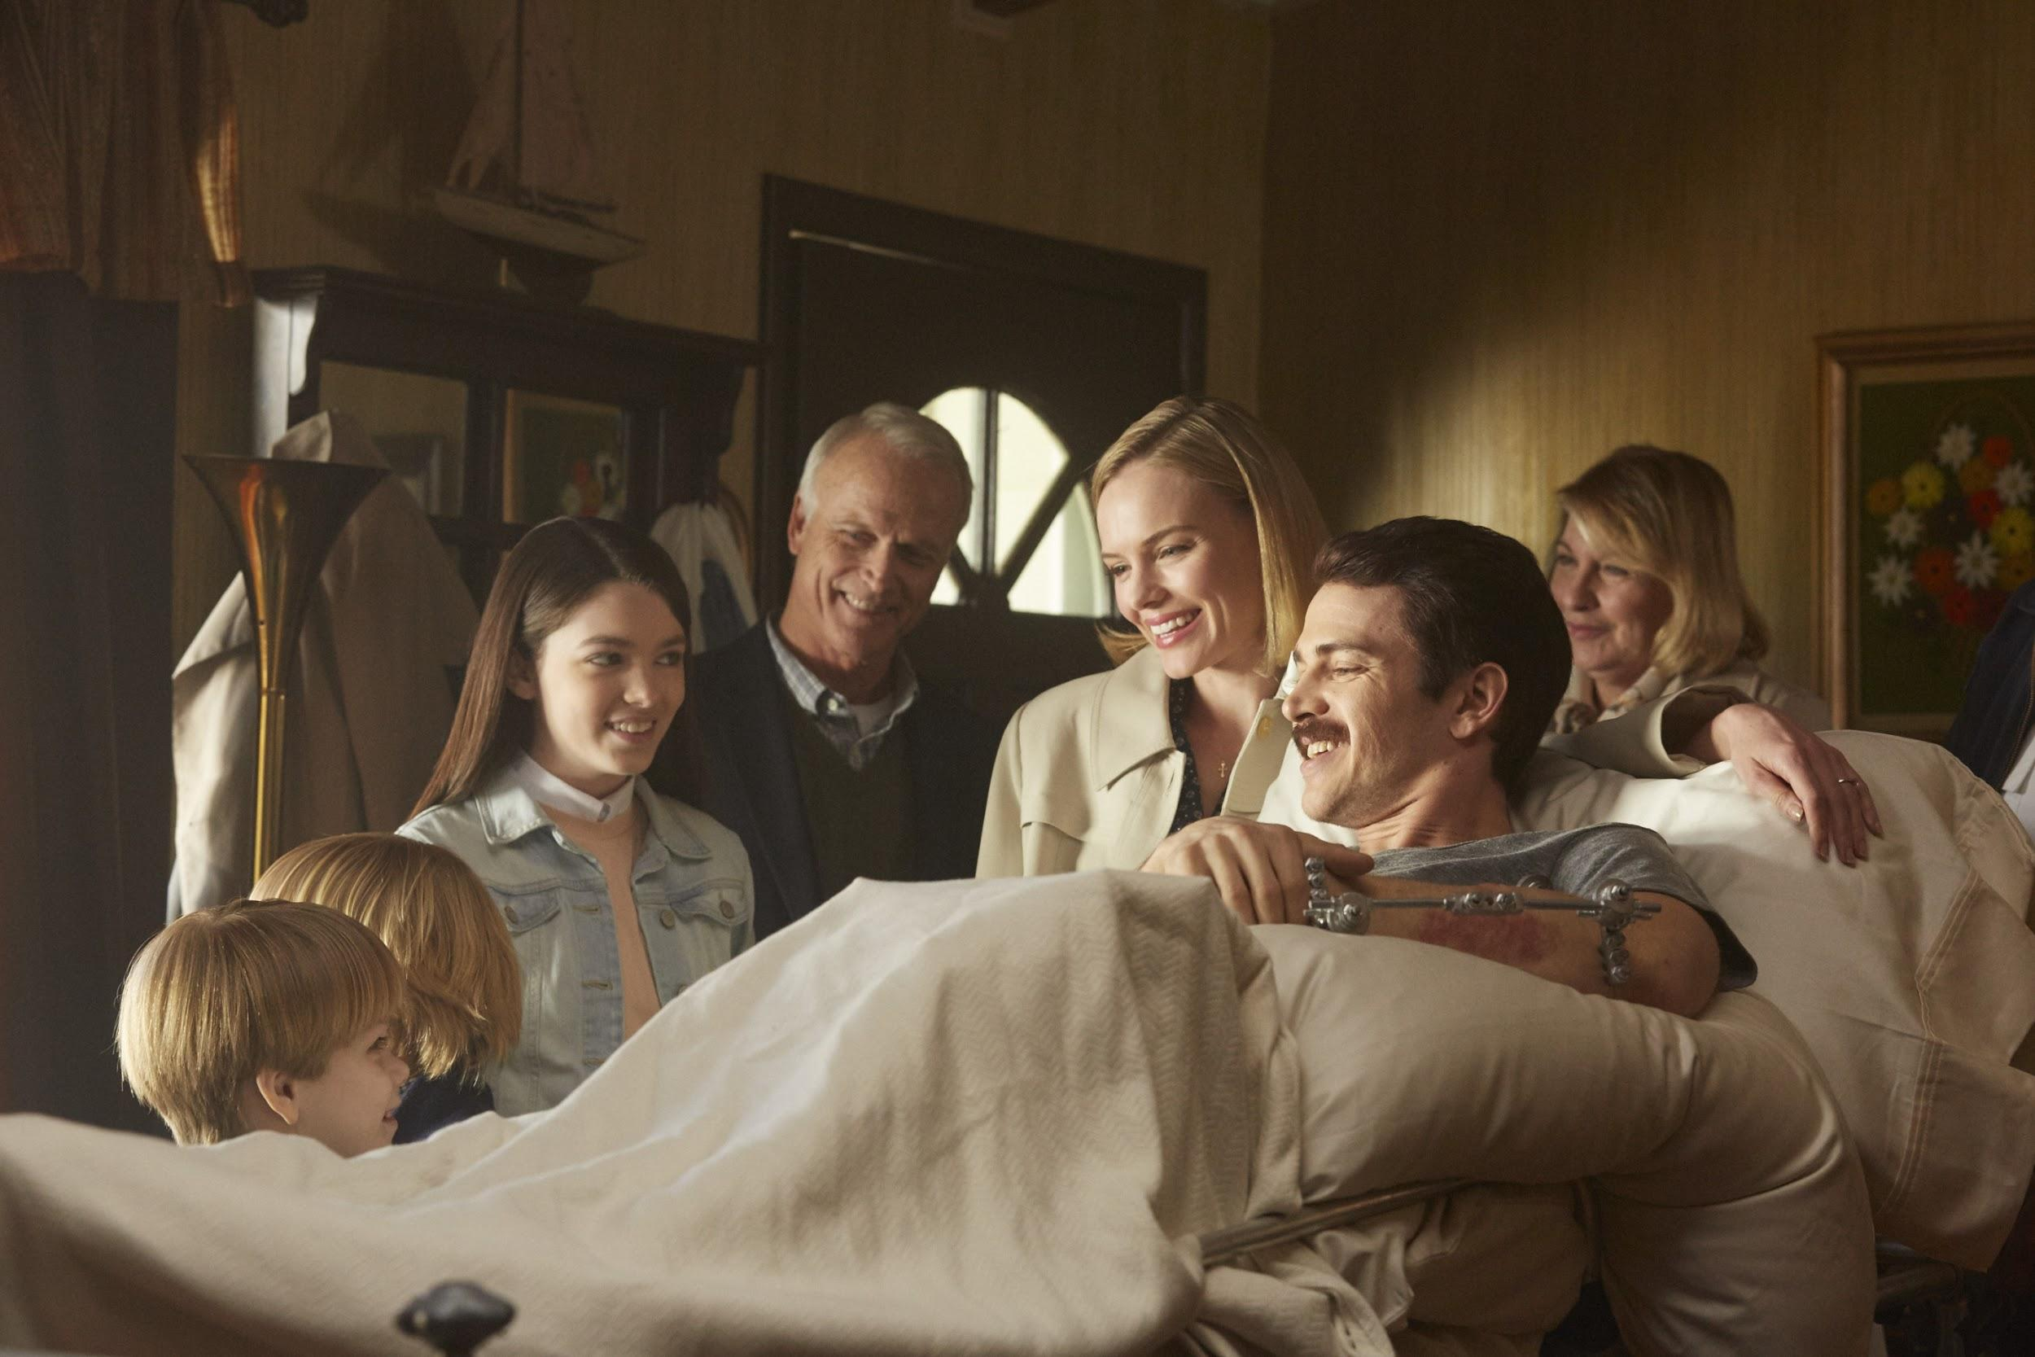
(L to R:) Hudson Meek (Chris Piper), Bobby Baston (Joe Piper), Elizabeth Hunter (Nicole Piper), David Clyde Carr (Eva’s Dad), Kate Bosworth (Eva Piper), Hayden Christensen (Don Piper) and Catherine Carlen (Eva’s Mom), welcome Don home from his 13-month hospital stay in a scene from 90 MINUTES IN HEAVEN, from Giving Films, LLC. Based on the inspiring best-selling book of the same name, 90 MINUTES IN HEAVEN tells Don’s incredible and true story, and opens in theaters nationwide this fall. (Photo credit: Quantrell Colbert)
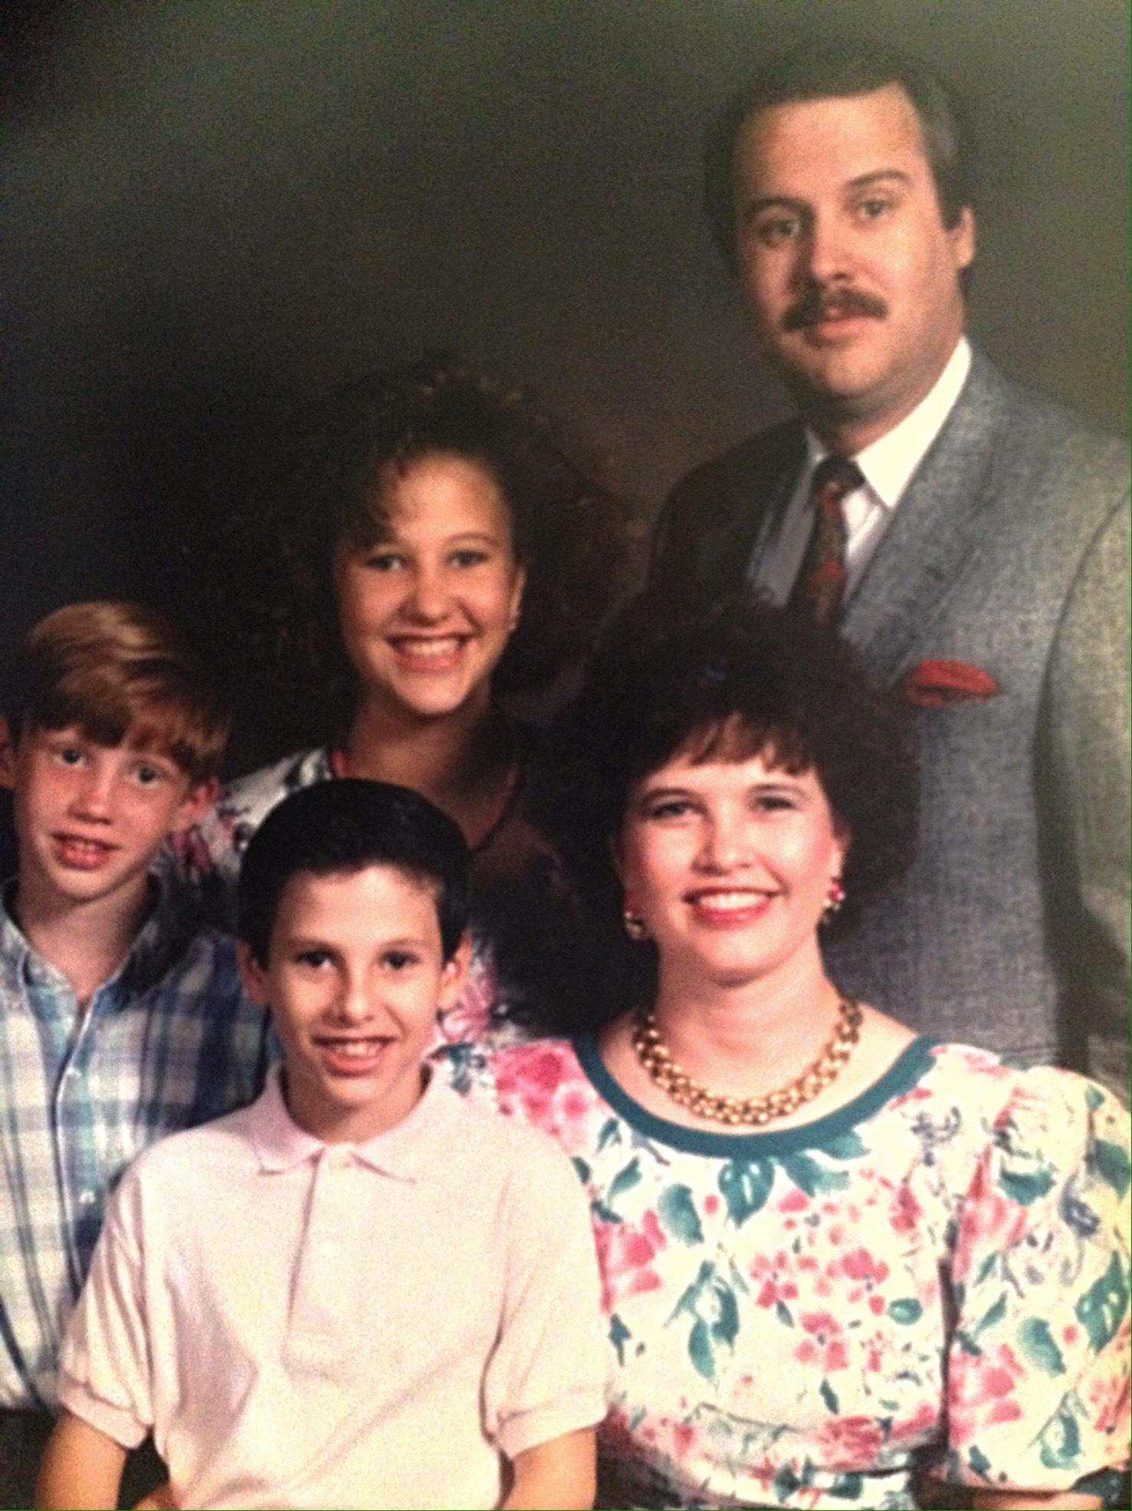

(L to R:) Joe, Chris, Nicole, Eva and Don Piper in a family photo circa 1991, shortly after he returned home from his 13-month hospital stay. The Pipers’ true story, 90 MINUTES IN HEAVEN, from Giving Films, LLC, is based on the inspiring best seller about Don’s incredible accident and recovery. 90 MINUTES IN HEAVEN opens in theaters this fall.

