Press Release Contacts:
For Immediate Release Vinitaly International
International Media Dept.
+39 045 8101447
media@vinitalytour.com
www.vinitalytour.com
Twitter: @VinitalyTour
Join Vinitaly International Network on LinkedIn

Vinitaly in Verona and Vinitaly China: bridging the gap between Italian wine and the Chinese wine market

On Monday the 23rd of March, the spotlight will be on Vinitaly in two different continents and two simultaneous showcases: the 49th edition in Verona (Italy- from the 22nd to the 25th of March) and the 2nd consecutive edition in Chengdu (China – from the 23rd to the 25th of March) at the Kempinski Hotel on the occasion of the International Wine and Spirits Show, the off site showcase of the “China Food and Drinks Fair for Wine and Spirits”, one of the most important B2B fairs in the Chinese wine sector.
The event is perfectly in keeping with the mission that Vinitaly International has been leading in Mainland China in the name of Italian wine in the past year or so: three events in just four months at the beginning of 2014 (Chengdu, Dalian and Shanghai) to be followed, at the beginning of October, by a tour of 8 major cities together with the China Expo Roadshow which offered the perfect opportunity to further strengthen ties between Italian wine producers and local importers.
“To be able to organize Vinitaly in Verona and hold Vinitaly China at the same time is an important challenge and it is bound to give us great satisfaction” says Stevie Kim Managing Director of Vinitaly International. “It fully embodies our mission to bridge the gap between these two markets by taking, on the one hand, Italy and Italian wine to China through our different events and showcases and, on the other, by bringing local wine educators, journalists and trade back to Italy so that they can get to know Italy and Italian wine first hand and ultimately, if not inevitably, fall in love with them. This year at Vinitaly we will be welcoming an entire delegation of Chinese Sommeliers and 20 out of the 50 candidates who will be taking part in the first Vinitaly International Academy Certification Course are from China”.
Despite the concurrence of the two events the number of exhibitors at Vinitaly China – Chengdu remains high with 7 local wine importers offering once again their support to the event together with a growing number of media partners (Vinehoo, Wine in China, TasteSpirit.com, Pinor, Wines-info, Fine wine & liquor and Wineluxe).

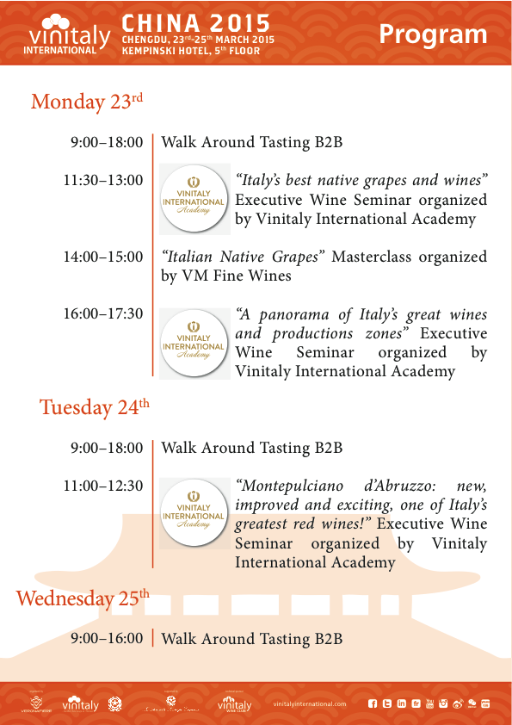

The showcase will kick off on Monday morning at 9:00am on the fifth floor of the Kempinski Hotel with the traditional Walk Around Tasting that will offer local press, operators and Italian wine aficionados the opportunity to taste some top quality Italian wines. For those who wish to acquire further knowledge and a better insight into the great diversity of Italian wines, Vinitaly International Academy will be back once again with a series of Executive Wine Seminars held by wine writer and educator Lingzi He: “Italy’s best native grapes and wines” and “A panorama of Italy’s great wines and productions zones” on the Monday, and “Montepulciano d’Abruzzo: new, improved and exciting, one of Italy’s greatest red wines” on the Tuesday.
“Italy is a country like no others that boasts hundreds, if not a thousand and more, native grapes” explains Lingzi, “this is as fascinating as it's daunting and further complicated by cultural and linguistic barriers. Thus wine education is crucial, especially in China where wine knowledge is in its embryonic stage. In this case, Vinitaly International Academy plays an important role educating and guiding wine lovers through a vinous wonderland so that when they walk out the classroom, they will be equipped with a solid foundation of knowledge and a sense of confidence to explore and enjoy Italy wines on their own”.
Vinitaly International will be in China Mainland also on the 27th of March in Jinan and on the 2nd of April for the last two stops of the China Expo Roadshow before the official opening of the Universal Exposition in Milan where, to date, more than one million Chinese visitors are expected.

About:

Veronafiere is the leading organizer of trade shows in Italy including Vinitaly (www.vinitaly.com), the largest wine and spirits fair in the world. During its 48th edition Vinitaly counted some 155.000 visitors and 4.000 exhibitors on a 100.000 square meter area. The next edition of the fair will take place on 22 – 25 March 2015. The premier event to Vinitaly, OperaWine (www.vinitalyinternational.com) “Finest Italian Wines: 100 Great Producers,” will unite international wine professionals on March 21st 2015 in the heart of Verona, offering them the unique opportunity to discover and taste the 100 best Italian wines, as selected by Wine Spectator. Since 1998 Vinitaly International travels to several countries such as Russia, China, USA and Hong Kong. In February 2014 Vinitaly International launched an educational project, the Vinitaly International Academy (VIA) with the aim of divulging and broadcasting the excellence and diversity of Italian wine around the globe. VIA is now ready to present the first edition of its VIA Certification Course to be held in Verona from the 16th to the 20th of March 2015 with the aim of creating new Ambassadors of Italian Wine in the World.

