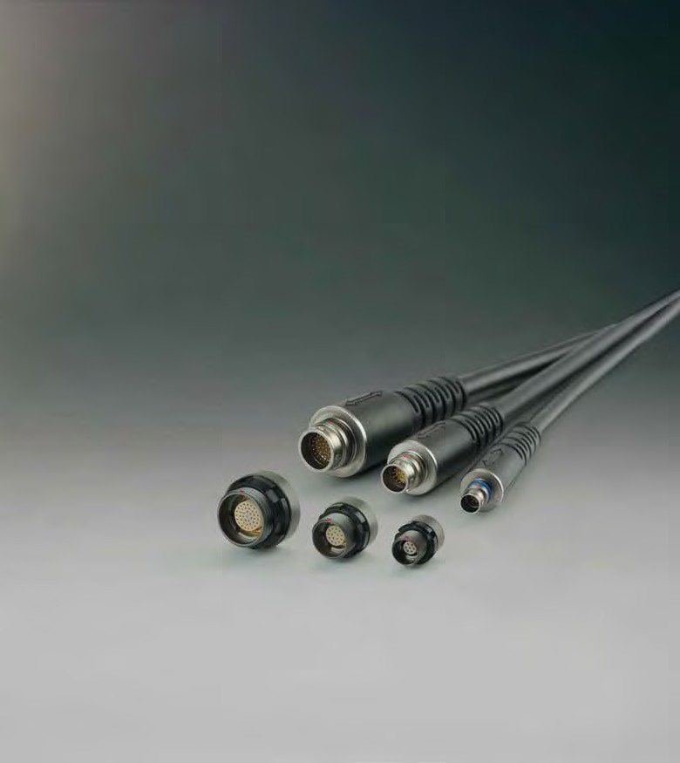A perfect AlliAnce.

ODU AMc®
HigH-Density

Innovation in a compact package. MInIature ConneCtors

fig. 1:1
14 mm
10 mm
7 mm

www.odu.de

odu – an overvIeW

• More than 70 years of connector experience

• turnover of € 135 million

• over 1,650 employees worldwide

• 7 sales subsidiaries: China, denmark, France, Italy, sweden, uK and the usa

• technologies: design and development, machine tool and special machine construction, injection, stamping, turning, surface technology, assembly and cable assembly

• We operate in the following markets: medical, measurement and testing, military and security, industrial, energy, automotive
CustoMer-speCIFIC solutIons

Contacts, connectors and cable assembly to meet the highest technical requirements – the products and services provided by odu are characterized by their uncompromising customer and results-oriented focus.

• precise implementation of the application-speciﬁc stipulations as regards to the design, function, cost and exclusivity

• Customized connector solutions originated from standard products

• Know-how and project dedicated resources under one roof

• Fast prototyping and quick production turn around

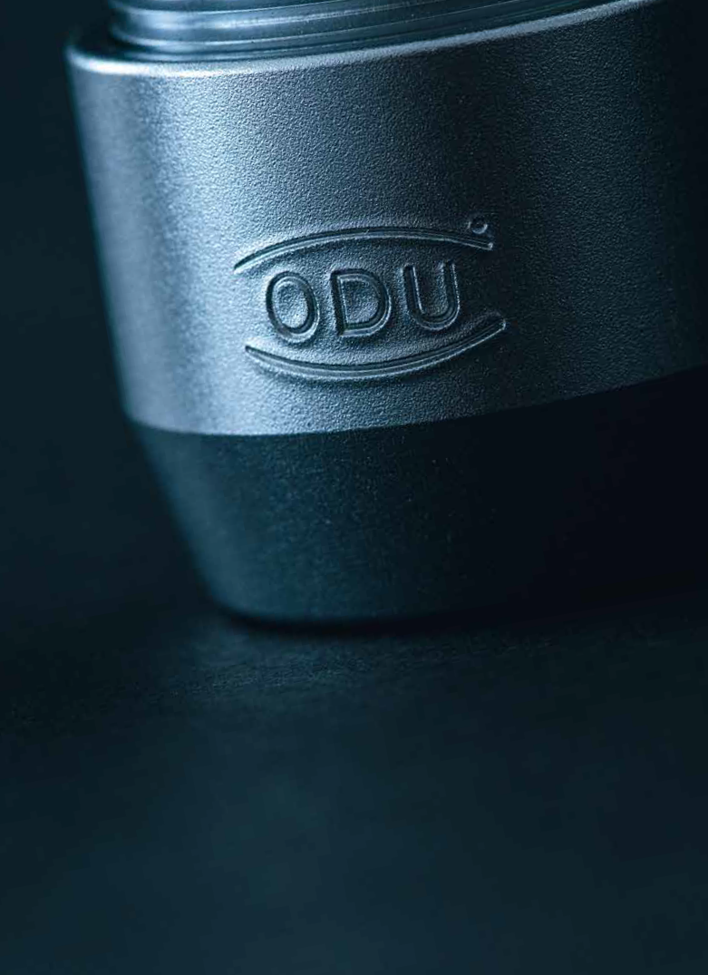

Certiﬁed quality
• dIn en Iso 9001
• dIn Iso ts 16949
• dIn en Iso 14001
• Iso 13485
• vast range of ul, Csa, sCa, vG, MIl and vde approvals
• ul-certiﬁed cable assembly

creatIng cOnnectIOns, BUIlDIng allIances, relyIng On eacH OtHer

Dr.-ing. kurt Woelﬂ
Managing Director research & Development Design
production finance & It
Dr. Joachim Belz
Managing Director
Marketing & sales
product and Market portfolio
Human resources
supply chain Management

technology that unites; connections that inspire

this is the driving force that we are committed to for more than 70 years: We provide high quality and innovative electrical connectors that create added value for our customers, and for all those that require the highest degree of efficiency and reliability in transmitting power, signals, data and media.

a perfect allIance – our belief is to develop the perfect connection. this translates not only in providing high quality and cost effective connector solutions, but also in developing strong partnerships based on trust and reliability as well as respect for our staff.
a perfect allIance based on mutual benefits, for products, compa- nies and people.

ODU is one of the world’s leading connector systems supplier and employs more than 1,650 people worldwide, generating sales of approximately 135 million euros. Our products are technologically advanced and meet the highest quality standards. to achieve all this, we continuously invest in the development and production – ultimately in our very special expertise. In recent years numerous customer-tailored, application-specific connectors have led to an ongoing expansion of our standard product range, so that we now

cover a broad spectrum of application areas. the balance between project work with its customer-specific solutions and the design-in of standard connectors will continue to shape our business in the
future. this not only applies to emerging markets such as medical, military and security, and energy, but also to the special require- ments of industrial electronics, measurement and testing, and
automotive technology.

a perfect allIance – ODU group’s future growth relies on providing reliable connector solutions for various challenging applications and on our commitment to continuously expand our technology portfolio. this company brochure is our invitation to discover more information about ODU group. We are an international technology company that devoted itself to create high quality customer oriented connector solutions.

Our creativity and innovative drive shape the future of our company and creates significant value for our customers.

ODU – a perfect allIance.

Dr. Joachim Belz
Dr.-Ing. kurt Woelfl

general InfOrMatIOn

MIlItary anD secUrIty – UncOMprOMIsIng qUalIty

Whether extreme environmental conditions or high mechanical stress: functionality under the most difficult conditions is a basic requirement for all connector technologies used in military applications.
ODU connectors ensure a fast information flow with robust and reliable

If you are looking for an innovative, robust, secure and reliable connector solution in the military/defence area – ODU is your partner!

high-tech products. We provide connectors in places where the highest
security level is the standard.

ODU is involved in many soldier modernisation programmes – worldwide. In this field, connectors must fulfil a number of rigorous criteria including easy-to-use and reliability under the most extreme conditions. ODU connectors meet and often exceed these requirements by providing a reliable connection even in the toughest of situations.

ODU sOlUtIOns fOr every DeplOyMent sItUatIOn

odu-aMC®

Group voICe and data radIo
• excellent shielding and data transmission up to 10 gBit

navIGatIon Module
• easy-clean version

rIGht-anGled ConneCtor
• compact design

personal CoMputer
• small and light

Gps antenna
• coax size 0

soldIer Control unIt
• cable-to-cable connection
vehICle adaptIon
• robust and reliable

odu MInI-snap®

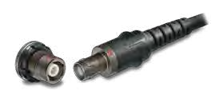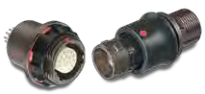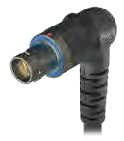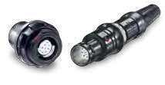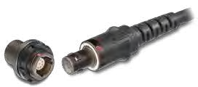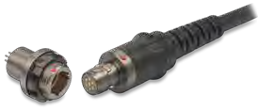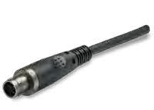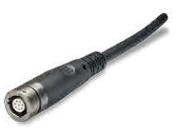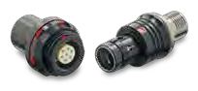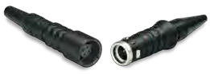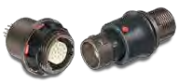odu MInI-snap serIes F
odu MInI-snap serIes K
odu MInI-snap serIes B super-shorty

odu aMC® hIGh-densIty

Miniaturization – the trend towards perfection in the smallest design.

CoMpaCt desIGn
reliability as well as electrical and mechanical robustness in spite of the compact design

sMallest dIMensIons
Diameter less than 10 mm (size 00, 7 contacts)

fig. approx. 2:1
7 mm

12 mm

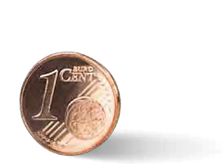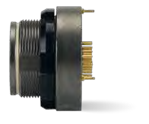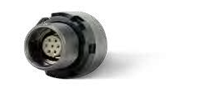from medical technology to consumer electronics to automotive technology: the trend toward miniaturization continues.
High-Density connectors provide the highest possible number of contacts in the most compact space. It gives developers new possibilities and solutions while simultaneously challenging the manufacturer. Because the connectors’ reliability and electrical and mechanical robustness must remain intact in spite of the compact size.

ODU created a highly robust miniature connector series that absolutely fulfils these demands: With a diameter of less than
10 mm to 18.5 mm and a contact density of up to 40 contacts, the ODU aMc High-Density series proves that premium quality can also come in small packages. In addition to the High-Density signal connector, the range also includes versions for "power" (up to 15 a) and "Data transfer" (UsB 3.0 with 5a power) in the most compact space. the ODU aMc High-Density connectors offer an impressively long service life of more than 5,000
mating cycles even under challenging conditions. Blind mating and optimized mechanical and colour coding ensure reliable and simple handling. thanks to the Break-away function, the reliable connection can be released with just a tug on the cable, which makes it possible to change or separate connections in a second.

Comprehensive manufacturing competence from one supplier Miniaturization demands solutions in all manufacturing areas, from the contact technology all the way through to assembly. We consolidate all relevant competencies and key technologies
in one company. We offer more than just connectors in the most compact sizes: we also supply the matching system solutions.

Upon request, we will naturally also develop miniature connec- tors to customer specifications – and consequently create
a perfect allIance around the world.

innOvAtiOn in A cOMpAct pAckAge

systeM solutIon
Innovative options for assembly and extrusion for the cable strain relief

hIGh ContaCt densIty
contact density up to 40 contacts in a minimum design

tHe evOlUtIOn Of MInIatUrIZatIOn

2000
2010 2014

odu MInI-snap® series K
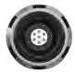size 0 / 7 contacts /Ip 68
odu aMC®
size 0 / 7 contacts / Ip 68
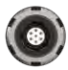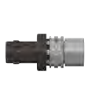45% space savings in comparison with odu MInI-snap series K
odu aMC® high-density
size 00 / 7 contacts /Ip 68
35% space savings in comparison with odu aMC series

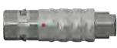17.9 mm
15.5 mm
9.9 mm

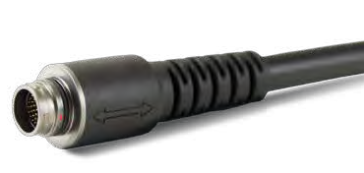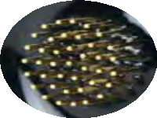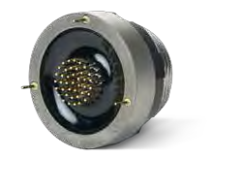37.1 mm
25.0 mm 20.0 mm

ODU aMc® HIgH-DensIty at a glance

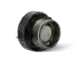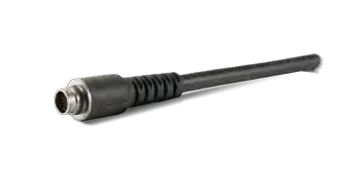up to 40 contacts (size 1.5)
Watertightness Ip 68

salt spray resistance
> 5,000 mating cycles

tested according MIl

excellent data transmission
Break-away for maximum safety
Mechanical and color coding extremely rugged and solid

Four shell sIzes For MaxIMuM FlexIBIlIty

sIze 00
• 2 way
• 4 way
• 7 way
• 4 way UsB 2.0

sIze 0
• 9 way (15a power + UsB 2.0)
• 12 way (UsB 3.0 + 5a power)
• 16 way (signal + Data)

sIze 1
• 27 way (signal + Data)

sIze 1.5
• 40 way
• Multi I/O (signal + Data)

fig. approx. 1:1

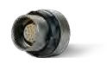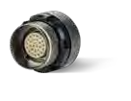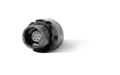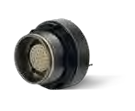

pAnel cUt-OUt DiAMeter

7 mm 10 mm 12 mm 14 mm

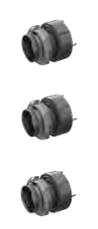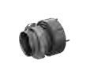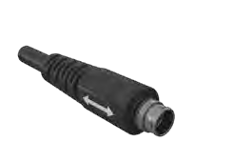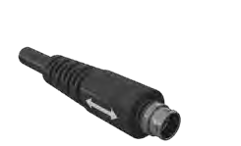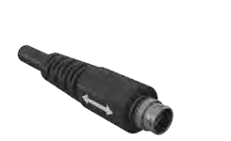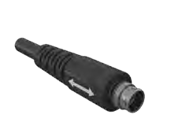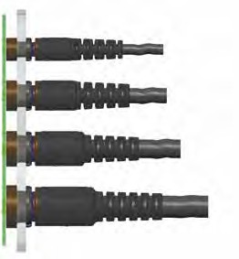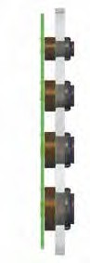

One pc-BOarD fIts all sIZes

all standard sizes can be processed at the same connection level.

this allows us to place signals, data and power in various connector sizes on one pcB height – as a basic requirement for a compact system design.

sIze 00

sIze 0

sIze 1

sIze 1.5

relIaBle and roBust CodInG

BroWn

red

Blue

Green

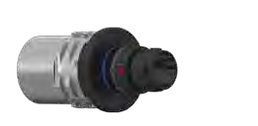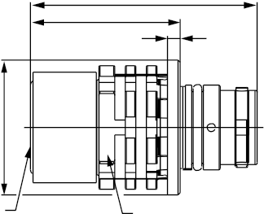DIMensIOns anD cOntact DetaIls

A1: Break-Away-plug

L1
L3
L2

D1

Max. cable
SW A

size | l1 | l2 | l3 d1 |  | sW a | Max. Ø  cable
00 | 20.0 | 1.2 | 12.8 9.8 |  | 8.0 | 5.0
0 | 21.5 | 1.2 | 14.2 | 12.8 | 10.0 | 7.0
1 | 25.2 | 1.2 | 18.0 | 14.8 | 12.0 | 8.5
1.5 | 29.2 | 1.2 | 22.0 | 16.8 | 14.0 | 10.5

k1: in-line receptacle

L1
L2
L3 L4

D1

Max. cable
SW A D2

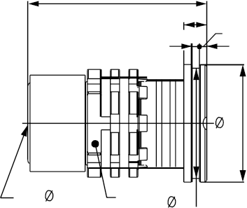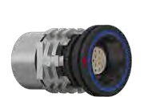

size | l1 | l2 | l3 | l4 | d1 | d2 | sW a | Max. Ø  cable
00 | 18.7 | 2.5 | 0.8 | 0.8 | 9.8 | 9.0 | 8.0 | 5.0
0 | 19.5 | 2.5 | 0.8 | 0.8 | 12.8 | 12.0 | 10.0 | 7.0
1 | 23.5 | 2.5 | 0.8 | 0.8 | 14.8 | 14.0 | 12.0 | 8.5
1.5 | 27.5 | 2.5 | 0.8 | 0.8 | 16.8 | 16.0 | 14.0 | 10.5

Dimensions in mm

DIMensIOns anD cOntact DetaIls

gk: receptacle
panel Cut-out

SW A
A1: Break-Away-plug
+0.1

D1 M D2
SW +0.1

0.3
L3 x
1.8 L1
L2

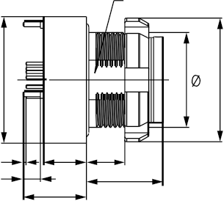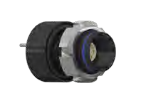panel cut-out

size l1 l21 l3 x max. d1 d2 sW a M

sW Ø

00 8.0 6.6 4.5 4.0 10.0 10.0 6.5 7 x 0.5 6.6 7.1
all dimensions in
mm

0 8.0 6.6 4.5 4.0 13.2 13.0 9.0 10 x 0.5 9.1 10.1

1 8.0 6.6 4.5 4.0 15.3 15.0 11.5 12 x 0.5 11.6 12.1

1.5 8.0 6.6 4.5 4.0 18.5 18.0 13.0 14 x 0.5 13.1 14.1

1 for solder cup version: Details on request.

Dimensions in mm

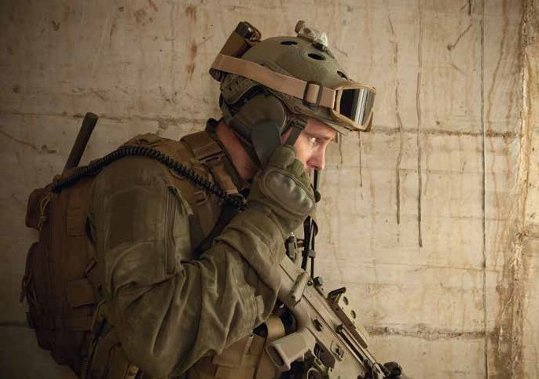

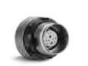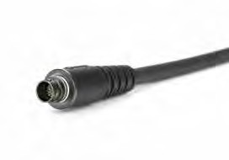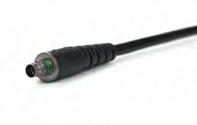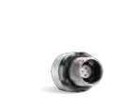HIgHspeeD Data transMIssIOn at a glance

sIZe 00
UsB 2.0 480 MBit/s

usB 2.0

0

-10
size-200

UsB 3.0 5 gBit/s
-30
-40

-50

-60

-70

-80

-90

-100
10

usB 3.0

cHaracterIstIc IMpeDance
ODU aMc® High-Density connector with 3 m cable in total and 2x UsB 3.0 type a connector

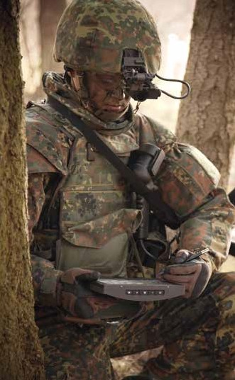140

130

120

110

100

90

80
Impedance in O

70

60

50
40

ODU

Whole channel

limits

near-enD crOsstalk

0

-10

-20

-30

-40

-50
Near-end crosstalk in dB

-60

-70

-80

-90

ODU

-100

10
Frequency in MHz

100 1,000 10,000

ance in O
limits

secure data transmission has become indispensable in military actions.

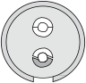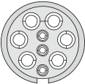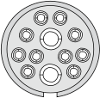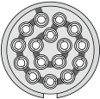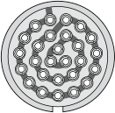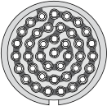cOntact cOnfIgUratIOns

shell size layout number of contacts
suitable for termination Max. wire size Max. current2 test voltage rated voltage3

pCB1 only
GK style soldercup soldercup acc. sae 13441

02 power 2 x aWG 24
• •
(power)

3 a 1,200 300

Ø 0.5

04 signal • • 4 x aWG 28 1 a 900 300
Ø 0.3
00

04 usB 2.0 o •
2 x aWG 28 1 a
(signal lines)

2 x aWG 24 3 a
(power)

750 250

07 signal • • 7 x aWG 28 1 a 750 250
Ø 0.3

09 usB 2.0

3 x aWG 28 1 a
(signal lines)
o •

6 x aWG 22

750 250

+ power
5 a
(power)

0 12 usB 3.0
+ power

10 x aWG 28 1 a
(signal lines)
o •

2 x aWG 22 5 a
(power)

750 250

16 signal • • 16 x aWG 28 1 a 750 250
Ø 0.3

1 27 signal • • 27 x aWG 28 1 a 750 250
Ø 0.3

1.5 40 signal • • 40 x aWG 28 1 a 750 250
Ø 0.3

1 layouts on request
2 single contact load
3 Maximal operating voltage at sea level up to 2000 m acc. to sae 13441.
for various applications the safety requirements regarding the operating voltage is even more severe. this must be evaluated during the time of equipment engineering.
o on request

specIal applIcatIOns neeD specIal systeM sOlUtIOns

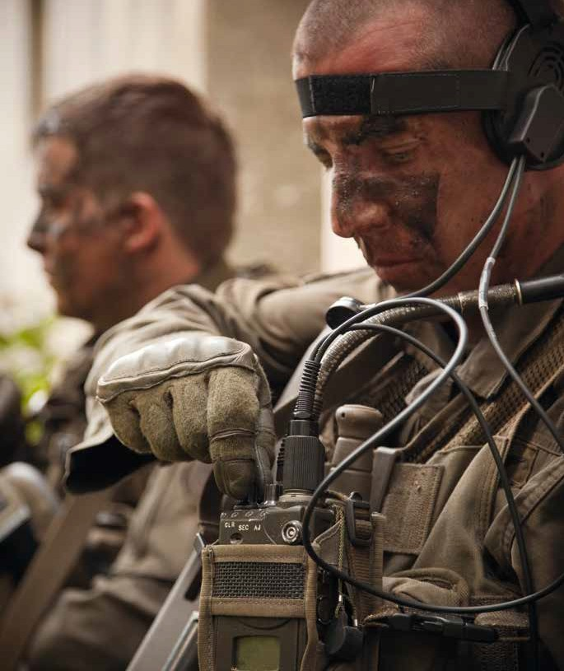every connection also needs its cable. In addition to high quality connectors, ODU also offers a comprehensive assembly service from one supplier. at the connectors side it means innovative options for assembly and extrusion for the cable bend relief, as
well as connections to flex and pcB solutions on the device side. Our component assembly team tests the complete system to
our specifications and promises you the same quality found in our connectors – without compromises.

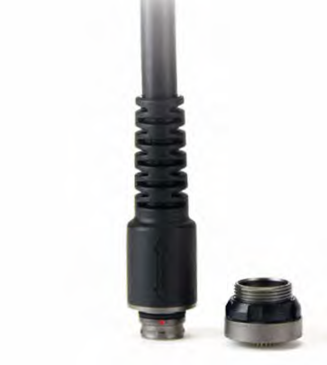a cOnnectIOn yOU can cOUnt On

• close cooperation with our customers to find the optimal solution
• ODU handles the complete processing, from procuring the cable and assembly up to individual potting or overmouldings
• 100% inspection
• the connectors are also able to be assembled by customers – supported by the ODU experts

terMInatIOn pc-BOarD

ODU aMc High-Density receptacles can be terminated with pc-boards,
flex-layers or rigid-flex solutions. the solder process is tested and qualified for all available inserts.

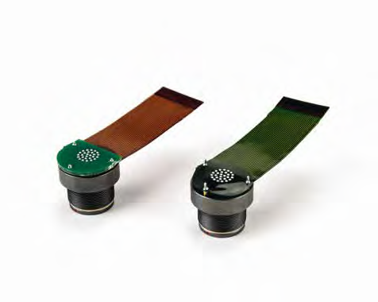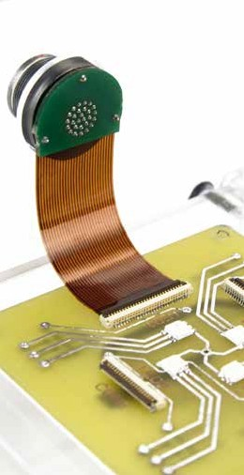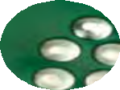rIGId-Flex

Flex-layer

A perfect AlliAnce.

ODU grOUp WOrlDWiDe

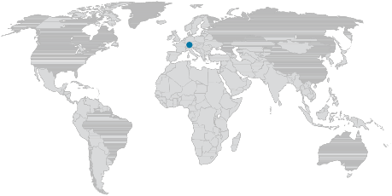HeADQUArters

ODU gmbH & co. kg
pregelstr. 11
84453 Mühldorf a. Inn germany
phone +49 8631 6156-0 fax +49 8631 6156-49 e-Mail zentral@odu.de

sAles sUBsiDiAries

ODU Denmark Aps
phone +45 2233 5335
e-Mail odu.denmark@odu.de www.odu-denmark.dk

ODU france sArl
phone +33 1 3935-4690 e-Mail odu@odu.fr www.odu.fr

ODU italia s.r.l.
phone +39 331 8708847 e-Mail sales@odu-italia.it www.odu.de

ODU skandinavia AB phone +46 176 18261 e-Mail sales@odu.se www.odu.se

ODU (shanghai)
international trading co., ltd.
phone +86 21 58347828-0
e-Mail oduchina@odu.com.cn www.odu.com.cn

ODU-Uk ltd.
phone +44 1509 266433
e-Mail sales@odu-uk.co.uk www.odu-uk.co.uk

ODU-UsA inc.
phone +1 805 4840540
e-Mail sales@odu-usa.com www.odu-usa.com

further information and specialised representatives can be found at: www.odu.de/sales

ODU AMc® HigH-Density

simply scan qr-code for the complete download of this brochure.
aMc HD / B / 1114 / e
the right is reserved to modify product and technical data.

www.odu.de

