Altium Adds New Features to Flagship High-Speed PCB Design Tool
Altium Limited, a Global Leader in Electronic Design Automation, Announces Launch of Altium Designer 15.1. New Release Adds Several New Features for Improved Design Productivity, Enhanced Design Documentation, and High-Speed PCB Design Automation.

San Diego, Calif. – April 29, 2015 — Altium has released the newest version of the company’s flagship PCB design tool, Altium Designer 15.1. Included in this release are a number of new features to improve design efficiency with expansions to productivity, documentation, and high-speed design. The newest update to Altium Designer is available now for all Altium Subscription customers.

“Altium Designer 15.1 is building upon the solid foundation we’ve had in place since the original release of Altium Designer 15,” said Sergey Kostinsky, VP Engineering at Altium. “There’s incremental improvements upon every layer in the platform for both designers and fabricators alike. This update is a win-win for everyone involved in the design process, with greater accuracy in documentation features for fabricators, to expanded productivity and high-speed enhancements for electronics designers.”

New Features for All

The new features in Altium Designer 15.1 focus on improvements to the entire design ecosystem, from a design’s inception with electrical designers to the completed pcb with fabricators. While new productivity high-speed design features keep PCB designers at the top of their productivity game, numerous documentation features expand the communication of design intent to fabricators and project managers.

Improved xSignals Management

High-speed design configurations for length matching rules can now be configured in an easy-to-use wizard that automatically accounts for T-branches, components, signal pairs, and groups, greatly reducing the time spent on setup for high-speed designs.

Improved Output Documentation

PCB designs can now be exported as 3D PDFs, allowing anyone with a compatible PDF viewer to view and rotate a design in 3D. Boards can easily be navigated with individual component selection, providing greater accuracy and design intent to fabricators.

Expanded Rigid-Flex Support

Surface layers for rigid-flex designs can now be added with “bikini” coverlays that are fully visible in 3D and can be configured with the designer’s specific material needs. Coverlay edge clearance and expansion rules have also been added to the design rule options, providing users with precise control over coverlay applications.

New Methods for Managing Pads and Vias
Pad and vias can be easily be managed in a pad and via library, allowing users to define custom templates for pad shape and size. Templates can then be applied to specific groups of pads on a PCB for easy application, saving countless hours defining pad options individually.

Improved Unions Data Management
The addition of a new Unions panel helps to better organize design data and align Union data with other PCB objects in a design. The Union panel will show a hierarchical view of Union types, Unions, and Union primitives for easy reference.

Pushing Design Possibilities Further
Overall, Altium Designer 15.1 expands upon an already robust set of features aimed at making the design process even quicker and easier for today’s electronic designs. You can view the Altium Designer product page for a full overview of all the features added in Altium Designer 15.1.

Now is a great time for designers to make the switch to Altium Designer. Take advantage of all the new features in Altium Designer 15.1 and start a free trial today.

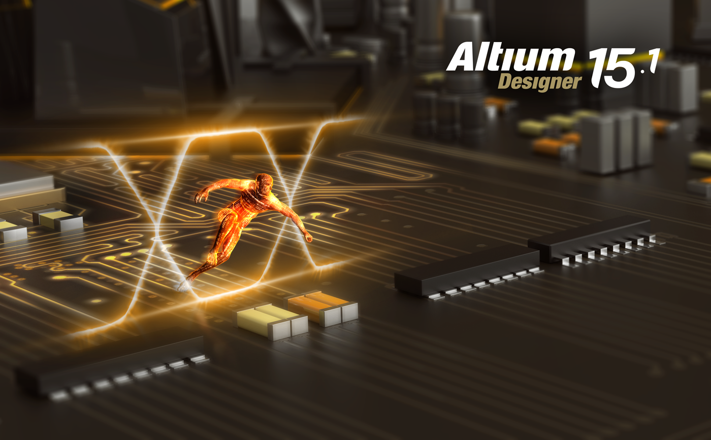

ENDS

Contacts

Americas | Wendy Krugman  The Hoffman Agency  +1 408 859 6394  wkrugman@hoffman.com | Elena Gur  Altium  +1 858 864 1573  elena.gur@altium.com
EMEA | Gabriele Amelunxen  PRismaPR  +49 8106 247 233  info@prismapr.com | Robert Huxel  Altium  +49 721 8244 170  robert.huxel@altium.com
Monika Cunnington
PRismaPR (UK, Scandinavia, Benelux)
+44-20 8133 6148
monika@prismapr.com
APAC | David Read  Altium  +1 760 207 8111  david.read@altium.com
Greater China | 王婷  霍夫曼公关顾问（北京）有限公司  电话： + 86 (0) 21 62033366-136  电子邮件：dwang@hoffman.com | David Read  Altium  电话：+1 760 207 8111  电子邮件：david.read@altium.com

About Altium
Altium Limited (ASX: ALU) is an Australian multinational software corporation that focuses on electronics design systems for 3D PCB design and embedded system development. Altium products are found everywhere from world leading electronic design teams to the grassroots electronic design community.

With a unique range of technologies Altium helps organisations and design communities to innovate, collaborate and create connected products while remaining on-time and on-budget. Products provided are Altium Designer®, Altium Vault®, CircuitStudio®, PCBWorks®, CircuitMaker® and the TASKING® range of embedded software compilers.

Founded in 1985, Altium has offices worldwide, with US locations in San Diego and Boston, European locations in Karlsruhe, Amersfoort, Kiev and Zug and Asia-Pacific locations in Shanghai, Tokyo and Sydney. For more information, visit www.altium.com. You can also follow and engage with Altium via Facebook, Twitter and YouTube.

