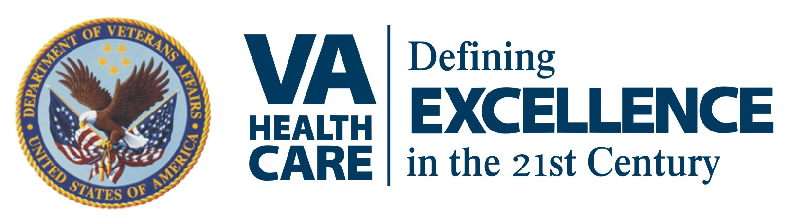

Media Advisory:
FOR IMMEDIATE RELEASE
Thursday, April 30, 2015

“Your Day at the VA” Information Fair

Cincinnati Veterans Affairs Medical Center is hosting the “Your Day at the VA” information fair Thursday, May 14 from 9 a.m. to 3 p.m. in the Cincinnati VAMC auditorium. Veterans, active-duty military, national guard members and reservists are invited to learn more about the entitlement benefits, services and medical programs available to them. Veterans Benefits Administration, social security & disability benefits, Tricare, Vocational Rehabilitation, county and state veterans benefits, compensation & pension, burial, claims and insurance eligibility experts will be available for assistance in obtaining benefits. Food and drinks will be provided.

Who: Veterans, active-duty military, national guard members and reservists are invited to the event.

When: Thursday, May 14 at 9:00 a.m.-3:00 p.m. ET

Where: Cincinnati VAMC
3200 Vine Street
Cincinnati, Ohio 45220

Background: Cincinnati VAMC hosts a VA information fair or “Your Day at the VA” event every year. Through the event, several hundred Veterans receive critical information on obtaining benefits and entitlements.

Info: Reporters interested in covering the event should call or email Denise Kerr no later than Wednesday, May 13 at 8:30 a.m. ET.

Contact: Denise Kerr, Director of Public Affairs for Cincinnati VAMC and VISN 10, denise.kerr2@va.gov, (513) 487-6056.

About Us: The VA Healthcare System of Ohio (VISN 10) is one of 21 Veterans Integrated Service Networks (VISN) of the Department of Veterans Affairs. VISN 10 is comprised of five VA Medical Centers, one ambulatory care center clinic, and 30 community-based outpatient clinics which provide comprehensive inpatient and outpatient health care to veterans in Ohio, Indiana, Kentucky and West Virginia.

