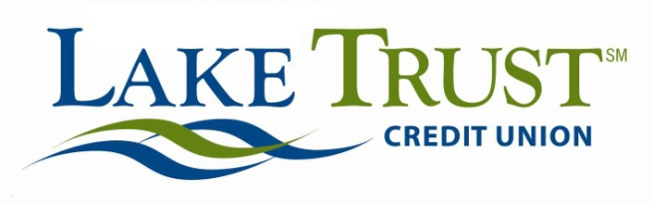

Press Release
For Immediate Release
Website: laketrust.org

Contact: Keith Koppmeier
kkoppmeier@laketrust.org
517.267.7438

Lori Anderson
landerson@laketrust.org
734.626.0319

Lake Trust Credit Union Awards 10 Michigan Students $1,000 each
All Recipients to Attend a Michigan College
Lansing, Michigan – Lake Trust Credit Union is committed to advancing their members’ success. In doing so, the organization feels strongly in supporting local high school seniors in furthering their education. Each year, through the Lake Trust Foundation, established in 2012, the Credit Union awards 10 Michigan high school students heading off to college, a $1,000 scholarship.
This year, those awarded are Morgan B. of Ithaca, Carlee D. of Allendale, Veronika D. of Rockford, Jacqueline H. of Rochester Hills, Gary H. Jr. of Lansing, Miranda K. of Zeeland, Kendra R. of Howell, Lauren R. of Grandville and Alexandra S. of Hudsonville. The Credit Union received 157 applications altogether.
“Throughout our experience, we’ve heard a lot of truly remarkable stories from students all across Michigan,” says David Snodgrass, Lake Trust Credit Union President and CEO. ”We’re inspired by each student’s commitment to their future, and honored to be part of their path to educational success.”

Every year, the Credit Union announces their scholarship program at the first of the year, and accepts applications through the end of February. Lake Trust assembles a team that reviews each application. Scholarship recipients are community-minded students who exemplify the Credit Union’s core values of Trust, Teamwork, Adaptability, Learning and Making a Difference.

“Our goal is to put young people on a path to help them reach their full potential,” says Keith Koppmeier, with the Lake Trust Foundation. “We know that education plays an important role in that journey, which is the reason our Foundation has always been committed to helping students here in Michigan to pursue higher education.”

You can find out more about Lake Trust Credit Union scholarships at laketrust.org.

Lake Trust Credit Union lives up to their name, with branches that stretch from Lake Michigan to Lake Huron. With over 165,000 members and $1.6 billion in assets, they’re the fourth largest credit union in Michigan. By participating in and sponsoring nearly 100 events locally, they reach across the state to create stronger communities. Membership is open to anyone who lives, works, worships or attends school in their 35 county service area.
Follow Lake Trust on Facebook or on Twitter @laketrust

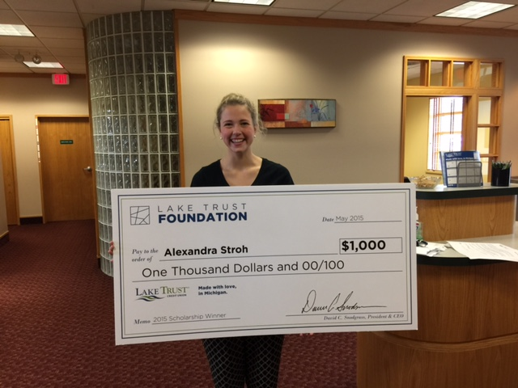
One of Our Scholarship Award Recipients, Alexandra S. of Hudsonville, MI

