Salt Lake City, UT – 9 June 2015

Beijer Electronics launches rugged 7 inch HMI operator panel
Beijer Electronics is proud to present T7BR, a rugged 7 inch operator panel designed for operation in extreme environments. The new model is tested and certified to withstand wind, snow and rain, working on heavy duty motors in remote locations, or in a steamy offshore engine room.
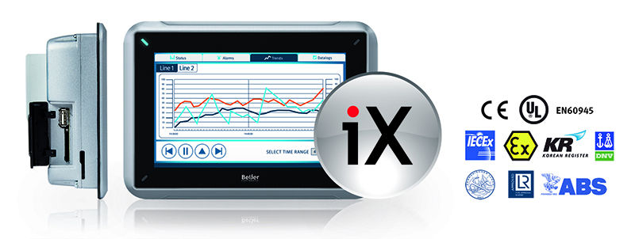
The rugged operator panel T7BR is certified by major classification societies for hazardous environments as well as to marine standards.

Proven to the extremes
The T7BR rugged operator panel adds strength to Beijer Electronics’ rugged range that also includes the 15 inch T15BR. Both HMIs are certified by major classification societies for hazardous environments (UL, IECEx, ATEX) as well as to many marine standards (ABS, DNV, GL, LR, KR) for use on vessels and offshore installations. The rugged HMI panels are designed for an operating temperature of -30°C to 70°C and conform to NEMA 4X, IP66 and UL 50E Type 4X sealing specifications. The T7BR and T15BR are available in both Beijer iX and Panel PC (WES7) configurations.

Smart iX HMI Software
Beijer’s iX HMI software empowers machine builders and end users with unique tools to communicate. It combines top-class vector graphics and smarter functions that provide intuitive operation on the spot. Not to mention the almost limitless connectivity to other equipment through the extensive list of drivers.

Features:
- Bright 7 inch operator touch panel, 800 × 480 pixels, 500 or 1,000 cd/m² sunlight viewable
- Operating temperature: -30°C to 70°C
- Hazardous area certifications: UL Class I Division 2 and ATEX/IECEx Zone2
- Marine certifications: DNV, GL, ABS, LR, KR
- Dust and water sealing: NEMA 4X, IP66, UL 50E Type 4X
- Operates in high vibration environments
- 2 × Ethernet, 2 × serial, 3 × USB standard, 2 × CiX CAN ports optional
- iX HMI Software with universal connectivity and C# scripting support on the iX T7BR models
- WES7 operating system on the PPC T7BR models

About Beijer Electronics
Beijer Electronics is a fast growing technology company with extensive experience of industrial automation and data communication. The company develops and markets competitive products and solutions that focus on the user. Since its start-up in 1981, Beijer Electronics has evolved into a multinational group present in 19 countries with sales of $180 million in 2014. The company is listed on the NASDAQ OMX Nordic Stockholm Small Cap list under the ticker BELE. www.beijerelectronics.com
or www.beijerinc.com
Contact
For more information please contact:
Bob Mullins, Product Manager, mobile: +1 801 245 0151, e-mail: Bob.Mullins@BeijerInc.com
Pictures
T7BR_PR_views_print.TIF

Web Links
iX T7BR Landing Page
beijerinc.com/product/industrial/t15br.php

PPC T7BR Landing Page
beijerinc.com/product/industrial/ppc-t15br.php

iX Software Landing Page
http://beijerinc.com/product/ix/

