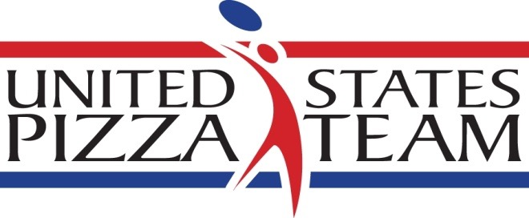

Americans take home silver for pizza acrobatics in World Pizza Championships

Parma, Italy -- Juggling pizza dough in a bright pink shirt and white fedora to the pulsating rhythms of Bruno Mars' "Uptown Funk," Jamie Culliton of St. Petersburg, Florida earned second place in Freestyle Pizza Acrobatics for the second straight year at the World Pizza Championships in Parma, Italy. This year, Culliton told PMQ that he saved his secret weapon until the second round of competition.

That beautiful surprise was a mid-routine dance turn with elegantly-gowned U.S. Pizza team colleague Samantha Jones, co-owner of Mellow Mushroom in Chattanooga, Tennessee. Saying that he was thrilled to finish again among the top pizza acrobatic practitioners in the world, Culliton thanked Jones and the rest of his American teammates for inspiring him to new performance heights. "To hear my teammates cheering me on made me proud to be an American pizzaiolo," said the veteran pie spinner and U.S. Pizza Team acrobatic coach.

First-place winner in the acrobatic event Takumi Tachikawa impressed the judges with his dramatic, highly nimble routine set to synchronized techno beats.

Although U.S. Pizza Team members didn't finish in the top three in any other events in three-day World Championships, their pizzas earned praise behind the scenes from the mostly Italian judges. The American pie makers brought their own unique ingredients with them from American home bases like California, Indiana, Nashville, Chicago, Ohio, Arkansas, and Staten Island, New York. But they also scoured the local markets in Parma, known as Italy's Food Valley, to find artisan cheese, olives, prosciutto, basil and oregano to entice the judges with customized pizza offerings.

"Our style of pizza making is different in America," explained Lenny Giordano of Mona Lisa Pizza in Staten Island, a return U.S. competitor who is originally from Sicily and speaks fluent Italian. "We get better and learn more every year we come over, but win or lose, I'm proud of my teammates and proud to be competing for America."

The team was made up of: David Sommers of Mad Mushroom in West Lafayette, Indiana; Michael Stevens of Palo Mesa Pizza in Arroyo Grande, California, John Coletta of Quartino in Chicago; Michael LaMarca of Master Pizza and William Shaw of Pizza Bogo in Cleveland; and Heather Zook of Sinfully Gluten Free in Dayton, Ohio; Leonardo Giordano of Mona Lisa Pizzeria in Staten Island, New York; Bradley Johnson, Abby Robbins and Samantha Jones of Mellow Mushroom in Chattanooga, Tennessee; Jamie Culliton of Florida; Leah Scurto of Pizza My Heart in Los Altos, California; Rick and Jane Mines of Nima’s Pizza in Gassville, Arkansas, Chris Mallon of Five Points Pizza in Nashville; and Peter Anderson of Gelsosomo’s Pizzeria in Crown Point, Indiana.

The competition pace in cooking tests such as Pizza-for-Two, Pizza In Teglia (In the Pan), Pizza on the Peel, Classica, Dough Stretching, Fastest Dough Maker, Gluten-Free Pizza and a non-pizza-making event called Heinze Beck, was grueling. But the American team found some free time to enjoy trips--and prepare an 8-course meal--while visiting the Academia Barilla and Verona, the historic hometown of Romeo and Juliet.

In all, 600 competitors from 20 nations took part in the celebration of pizza-making mastery. The sense of togetherness which propelled the American team was perhaps best exemplified by a contingent of Americans from Five Points Pizza in Nashville. Competitor Chris Mallon was accompanied on the trip by a five-person support committee including the owners of his pizzeria.
Winners included: Pizza-for-Two, Alfio Russo and Tancredi Parentignoti; Pizza In Teglia, Federico Visinoni; Pizza on the Peel, Samuel Sini; Classica, Angelo Cossu; Dough Stretching, Antonio Martos Del Arbol; Fastest Dough Maker, Giuseppe Amendola; Gluten-Free Pizza, Giuseppe Lapolla; and Heinze Beck, Emanuele Castelnovo.

For more information contact Brian Hernandez at 662-234-5481 x129 or by email @ brian@pmq.com. For images, contact Melanie Addington at Melanie@pmq.com.

The U.S. Pizza Team consists of expert pizza makers and dough-spinning acrobatic performers from pizza restaurants across the United States. The squad won second place in Individual Free Style in 2014 and first place in the Team Acrobatics World Championship in Italy in 2011. PMQ Pizza Magazine, the business trade publication for the pizza restaurant industry, created the U.S. Pizza Team in 2000. The US Pizza Team is sponsored by Grain Craft, California Milk Advisory Board, Gordon Food Service, LaNova, Paradise Tomato Kitchens, Bag Solutions, Fontanini Meats, Lillsun, Marsal and Sons, Univex, PizzaInsurance.com, Rock Tenn and Presto Foods.

