Trusted By The World's Top Companies

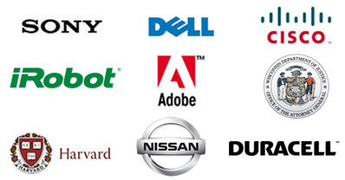
Leading companies use ProProfs Knowledge Base Software

- Instantly get all your documentation online
- Create help center, user guides & more
- Tech giants to startups, ProProfs is loved by all
- Adobe, iRobot and Nissan trust ProProfs

Technology
ProProfs is trusted by hundreds of successful companies such as Adobe and iRobot for their documentation.

Adobe
Help solution is a big hit with Primetime TV partners
View story >

iRobot
Internal documentation re-imagined
View story >

Duracell
ProProfs powers Duracell’s cloud storage support site
View story >
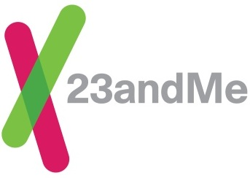

23andMe
23andMe uses ProProfs and Zendesk together
View story >

Ingersoll Rand
ProProfs brings self-service to home automation
View story >

Aquent

Aquent On Demand moves to cloud-based help
View story >

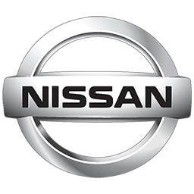
Nissan
Nissan uses contextual help for dealerships
View story >

Hoopla
What’s the Hoopla over the ProProfs?
View story >

Highq
Empowering 25,000 customers to self-service
View story >

Software
Top software companies use ProProfs Knowledge Base to create documentation for their sites & web applications.

Adobe
Help solution is a big hit with Primetime TV partners
View story >

SnapLogic
Documentation at a Snap!
View story >

Moka 5
Moka5 puts their documentation in the cloud
View story >

On24
Keeping customers always ON with ProProfs
View story >

OpenCart
Documentation that scales to their needs
View story >

Unleashed Software
Unleash the power of ProProfs
View story >

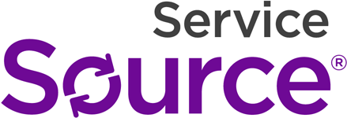

ServiceSource
ServiceSource's new online knowledgebase
View story >

Altiscale
Altiscale tips scale with ProProfs
View story >

Knoa Software
KNOA centralizes all documentation
View story >

Education & Government
ProProfs Knowledge Base is a tool that educational institutions and even government agencies trust for their documentation.

Sycamore Education
Sycamore customers get a central place for help
View story >

State of Wisconsin
Electronic Case Management Manual
View story >

