Contact:
Ruth Hawk
Public Relations Director
Higher Images, Inc.
412-203-1996
ruth@higherimages.com

Ohio Veterinarian Recognized for Excellence

Animal Medical Center of Streetsboro Ranks First on Akron-Canton List

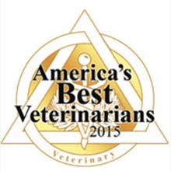
Streetsboro, Ohio (July 2, 2015) – Dr. Scott Leffler of the Animal Medical Center of Streetsboro was recently honored for excellence as the 2015 best veterinarian with his practice ranking first on the new 2015 Akron-Canton Ohio Hot List.
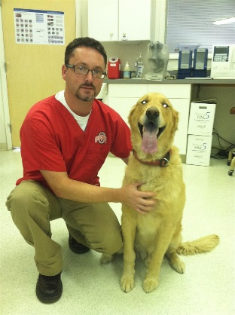
The Animal Medical Center of Streetsboro stood paws above the rest for excellence as the best place to take pets for a check-up. The distinction is based on more than 38,000 votes from local Akron-Canton area experts.
“We’re honored to be voted the best by the community. We’ve been partnering with pet owners for decades and enjoy providing compassionate and loving care for their pets,” Leffler said.
The full service animal hospital is widely known for top-notch veterinary services and respected in the community for exemplary concern for and commitment to the welfare and health of animals. Its medicine and surgical services include vaccinations, laser surgery, laser therapy, grooming, digital x-rays, ultrasound and board certified surgical cases. The hospital has been serving the community for over three decades.
“It amazes me every day how much pets trust us unconditionally. It’s a privilege to work with them every day and get to know their extended families,” Leffler said.
The hospital consistently adopts innovative solutions to improve quality of care. Numerous testimonials on Internet search engines emphasize the quality of care the facility provides and portray an environment where people want to take their furry friends.
Over the years, the Animal Medical Center of Streetsboro has been consistently recognized for bringing honor and distinction to the veterinary profession through personal, professional and community service activities. “We’re more than just a team of medical experts. We partner with our clients to provide cutting-edge care and pride ourselves on providing the highest level of services while placing an emphasis on client education,” Leffler said.
As the hospital’s owner, Leffler has extensive experience in cutting edge veterinarian practices with a background indicative of wide-ranging clinical experience at Purdue University.

