Press Release Contacts:
For Immediate Release Vinitaly International
International Media Dept.
+39 045 8101447
media@vinitalytour.com
www.vinitalytour.com
Twitter: @VinitalyTour
Join Vinitaly International Network on LinkedIn

Wine-glass ceiling: are men still holding the reins in the wine industry?

As Vinitaly 2015 drew to a close in its final gala dinner, Managing Director of Vinitaly International Stevie Kim was recognized for her contribution to the world of Italian wine with induction into the Italian national association “Le Donne del Vino.” But even as such organizations highlight the growing number of women within the wine sector, they also raise the spectre of the industry’s apparent glass ceiling, as institutional roles remain largely occupied by men.

Like much of the world of agriculture, women in the world of wine have traditionally been uncelebrated; always present, but confined to less visible, administrative tasks, while their husbands or fathers were the public face of the winery. Gender distinctions permeated wine production, consumption, distribution and appreciation.

Things, though, are slowly changing, as wine consumption amongst the female gender is decidedly on the rise. According to Felicity Carter, Australian-born editor-in-chief of Meininger's Wine Business International magazine in her thought- provoking article “We Don't Need More Women in Wine”, “women are already the most powerful economic force in the world's wine market.” Women constitute 59% of all regular wine purchasers in the USA, and seven out of every 10 bottles sold in Britain's omnipotent supermarkets are bought by women (Source: Jancis Robinson – 13 December 2014 - http://www.jancisrobinson.com/articles/the-feminisation-of-wine).
This growing female dominance is playing out not only in the buying of wine: two olfactory sensitivity studies showed women consistently out-perform men in odor identification. Women are also said to have a higher success rate than men in The Master of Wine (MW) exam.
Within the wine business things have equally changed: traditionally, women vintners inherited properties from husbands or fathers, but since the 1960s they have started to own the wineries themselves and to assume management positions based on their own qualifications. They have also emerged in higher profile roles in sales, marketing and hospitality, and as sommeliers.

According to the Italian communication agency WineNews TV, the world of wine today is one of the sectors in which women are the most present: both the Association of Italian Sommeliers (AIS), and the National Organization of Wine Tasters (Onav) count women as 30% of their membership, while the Federation of Italian Sommeliers (Fisar), of the hotel/restaurant sector, is comprised of 45% women.

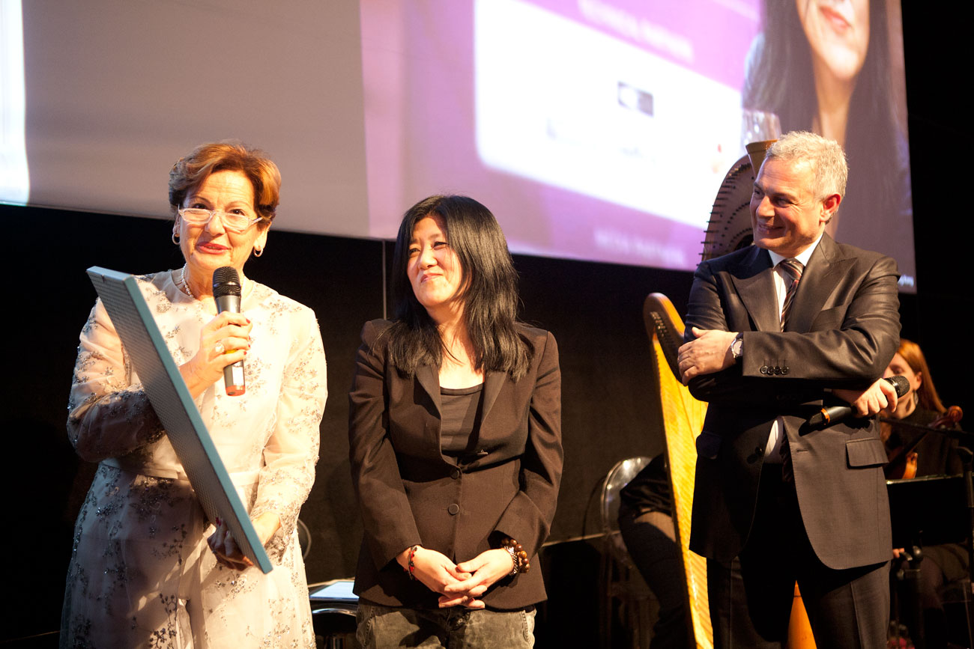

Another example is “Le Donne del Vino”, an Italian national association that through the years has gathered more than 750 members, including producers, enologists, restaurant and wine bar owners, and journalists. Founded back in 1988 by Elisabetta Tognana with the aim of spreading the culture and endorsing women’s role in the world of wine, the association has also proven to be a remarkable success story of cooperation for a common good that is not something that comes naturally to most Italian men, especially in the wine business.
This mission is shared and undertaken also by Stevie Kim, Managing Director of Vinitaly International, who, on the occasion of the closing dinner of VInitaly 2015, was conferred honorary membership by the Association and presented with an award for her constant commitment to promoting Italian wine in the world.

What is the reason behind women’s success in the wine sector?
Elena Martuscello, the sixth president of the Association “Donne del Vino” and the first to come from one of Italy’s southern regions, Campania, explains: “We have always understood that it is not enough to make a wine of high quality. You also need to sell it, communicate it and welcome the consumer into the winery. It is women who connect wine with local food, promoting events like tastings, cinema and book presentations - all activities that pair well with a glass of wine, and help people get to know the story that lies behind the label”.

Again according to WineNews TV, this is the main reason why Italian female farmers have withstood the crisis and market fluctuations better than their male colleagues: they have survived because they have diversified their activities opening the doors of their farms not only to tourists but also to schoolchildren, the disabled, and the elderly.
So why is it that Wine Power Lists published by renowned national and international papers and magazines still count a very limited number of women?
The latest example was offered not long ago by the 2015 Wine Power List published by the Italian online food and wine magazine CronachediGusto.it on the occasion of Vinitaly 2015: out of the 100 most influential people in the world of Italian wine, only 10 are women and only two of them make it among the top 50.
At a closer look the top 10 of this list are individuals who hold an institutional role within the Italian wine panorama: Riccardo Cottarella, President of Assoenologi, Maurizio Martina, the Italian Minister of Agricultural Development and Sandro Boscaini, new President of Federvini, national association of Italian wines, are just a few examples.
“When it comes to institutional roles men tend not to want to let go of their position” explains Fabrizio Carrera, Director of Cronache di Gusto, who took care of drawing up the PowerLlist, “and this makes it more difficult for women to take a stand”.
Donatella Cinelli Colombini, Tuscan winemaker and Vice-President of the Association “Donne del Vino” who is one of the few women present in the Wine Power List shares the same opinion: “According to recent statistics, women lead approximately 30% of Italian wineries and appear to be more savvy than their male counterparts. Once you start to move up the social scale to the control room, though, women become fewer and fewer. In the Board of Directors of Federdoc, the Italian national confederation that represents some of Italy’s most important consortia, there is only one woman among 18 men. I think the time has come to start speaking of a more prominent “female quota” in areas where decision-making is carried out. Women need to start putting their name forward.”
As Mrs. Cinelli Colombini has often been heard saying, “the female revolution of wine has begun”.

About:
Veronafiere is the leading organizer of trade shows in Italy including Vinitaly (www.vinitaly.com), the largest wine and spirits fair in the world. During its 49th edition Vinitaly counted some 4.000 exhibitors on a 100.000 square meter area and 150.000 visitors including 2.600 journalists from 46 different countries. The next edition of the fair will take place on 10 - 13 April 2016. The premier event to Vinitaly, OperaWine (www.vinitalyinternational.com) “Finest Italian Wines: 100 Great Producers,” will unite international wine professionals on April 9th in the heart of Verona, offering them the unique opportunity to discover and taste the wines of the 100 Best Italian Producers, as selected by Wine Spectator. Since 1998 Vinitaly International travels to several countries such as Russia, China, USA and Hong Kong thanks to its strategic arm abroad, Vinitaly International. In February 2014 Vinitaly International launched an educational project, the Vinitaly International Academy (VIA) with the aim of divulging and broadcasting the excellence and diversity of Italian wine around the globe. VIA has now also organized its very first Certification Course with the aim of creating new Ambassadors of Italian Wine in the World.

###

