For Immediate Release

Big Quick Keyboard – a New Easy App Arrives in Android Market
The Big Quick Keyboard is now available globally on the Android Market for smart touch phones. This new keyboard app not only has big buttons but also the same arrangement as keyboards..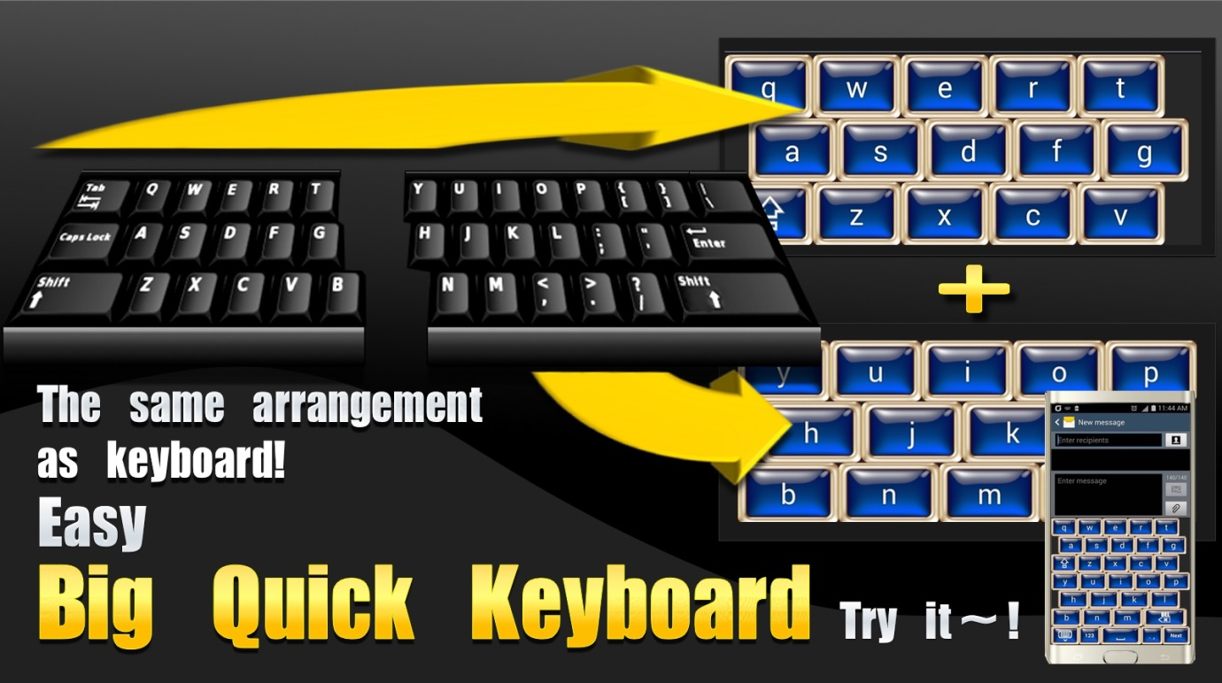

Big Quick Keyboard
A New Method App Arrives in Android Market.
World-wide (PRWEB) August 08, 2015

The Big Quick Keyboard is now available globally on the Android Market. Keyboards are important. The computer keyboard arrangement is very easy to use.This keyboard not only has big buttons but also the same arrangement as a keyboards by a new method, as shown in the following picture. A keyboard is divided into the left and the right parts. Then the left parts are put on the upper side and the right parts are put on the underside. Then the upper side and the underside are merged into one. The very wide buttons are made possible by this method. It was invented by the developer YoungJae Lee. The inventor’s ideas have been selected and supported two times by regional supporting organizations.
Instead of the traditional QWERTY keyboard, this mobile keyboard app, after users get used to it, can exceed users' current typing speed on the traditional layout. The Big Quick Keyboard is one of the best keyboards Android users could ever use on their device.
Try it. Big buttons are very easy to use. This smartphone app is very, very easy to use. This app is now available world-wide on the Android Market for smart touch phones. The full version was added to the Android app store. Android users can download a free version by visiting:
https://play.google.com/store/apps/details?id=mobile.keyboard.nowdo.bicquickenlite.
Android users can download a full version (4.5$) by visiting :
https://play.google.com/store/apps/details?id=mobile.keyboard.nowdo.bicquickkeyboard.
Also anyone can find it, if they type into a search box the 'big Quick Keyboard' in Google's Android market.
Please visit http://bigquickk.blogspot.kr for more information, including videos and screenshots of the app and https://youtu.be/3USAj2-ZMpU for Youtube video. Also a few simple tips users can follow for easy touch are there.
Keyboards are very important. In smart phones, keyboards are really important. If you’re looking for a essential app, this application will do the job.
……………………………………………………………………………………………………..

Email- lee90229022@gmail.com

