PRO SOUND EFFECTS® ANNOUNCES FREE FALL SEMESTER FOR SCHOOLS

Gives 50 Schools Online Library Access to 50,000+ Royalty-Free Sounds

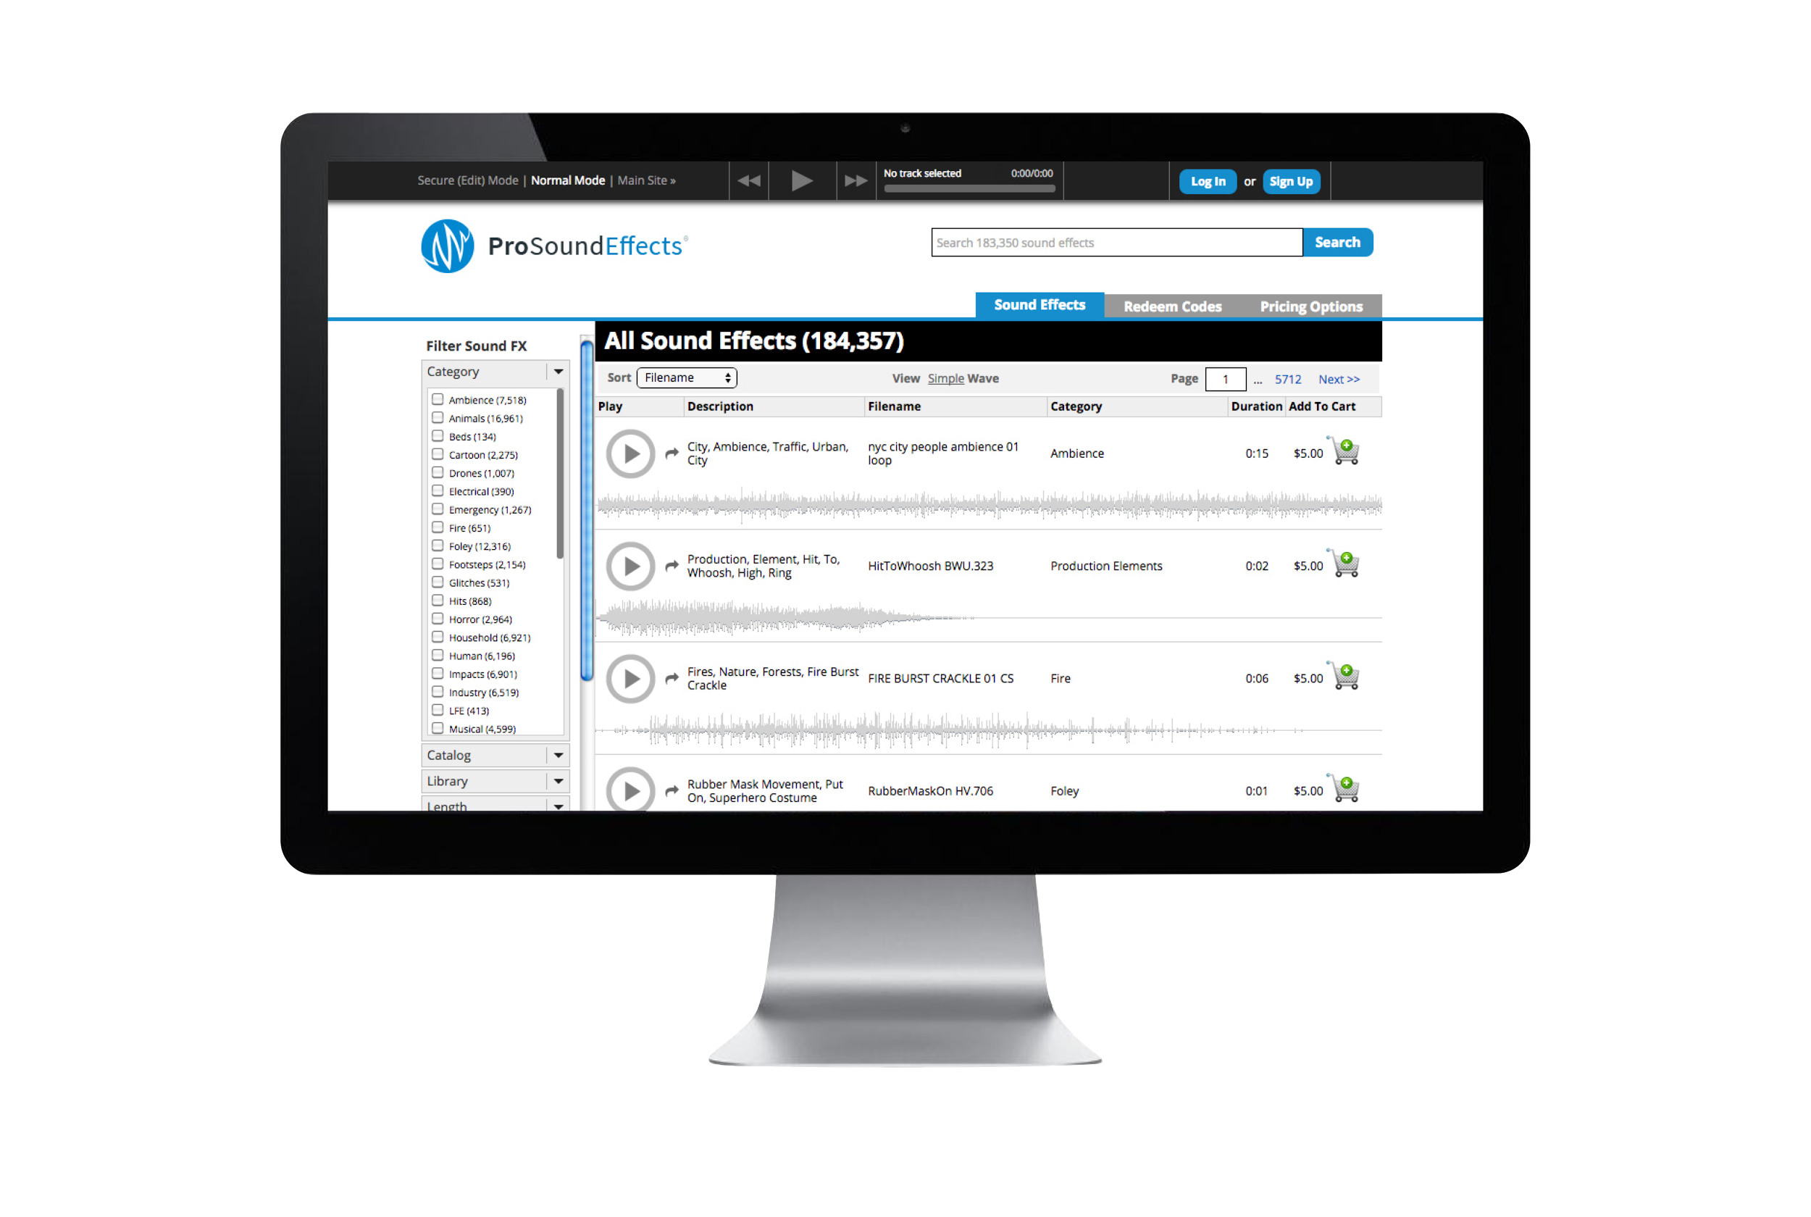
BROOKLYN, NY, Aug. 20, 2015: Pro Sound Effects®, the next level sound library company, has announced a free semester of Online Library Access for 50 schools who apply by September 15th. Any school with a Media Arts or Audio Program is welcome to apply. Once approved, students will receive access to 50,000 royalty-free sound effects via the Pro Sound Effects Online Library and can then use the sound effects in an unlimited number of films, videos, audio productions, apps or creative arts projects. After the Fall Semester, schools will have the choice to continue allowing their students access by paying for additional semester licenses.

“We are offering 50 sound effects ‘scholarships’ for reasons beyond simply making sure students have access to the same resources used by professional media production companies,” says Douglas Price, Founder & President of Pro Sound Effects. “The ultimate goals of the program are to engage the next generation of media professionals, help them successfully transition from the dorm to the big stage, and shape future development at the same time.”

Since 2004, schools all over the world such as The University of North Texas, Elon University, George Mason University, The Art Institutes and more have been using Pro Sound Effects Library to enhance their curriculum and student production resources.

FREE SEMESTER FEATURES:

- Unlimited Online Access to 50,000 sounds from any computer through the Pro Sound Effects Online Library
- Spans the Sonic Spectrum A to Z: Categories include Ambiances, Animals, History, Nature, Science Fiction, Technology, Warfare and beyond
- 100% Royalty-Free, Non-Commercial Usage
- Unlimited users, Unlimited Access
- Create Projects & Share Playlists
- Continually Updated
- Licensing Quote with Free Semester Setup
- Application Deadline: September 15, 2015

Apply Now for your Free Semester of Online Library Access

See www.prosoundeffects.com/EDU for more information.

ABOUT PRO SOUND EFFECTS®:

Pro Sound Effects® curates and delivers the Next Level sound effects library for media producers worldwide. The Pro Sound Effects Library is 175,000+ royalty-free sounds effects available both online and on hard drive. The Library spans the entire sonic spectrum and is continually updated. Founded in 2004, Pro Sound Effects is relied upon by top freelancers and big media production companies around the globe.

Watch video & learn more about Pro Sound Effects

Media Contact:

Martina McConnon
Music Marcom
martina@musicmarcom.com
610-577-4892

