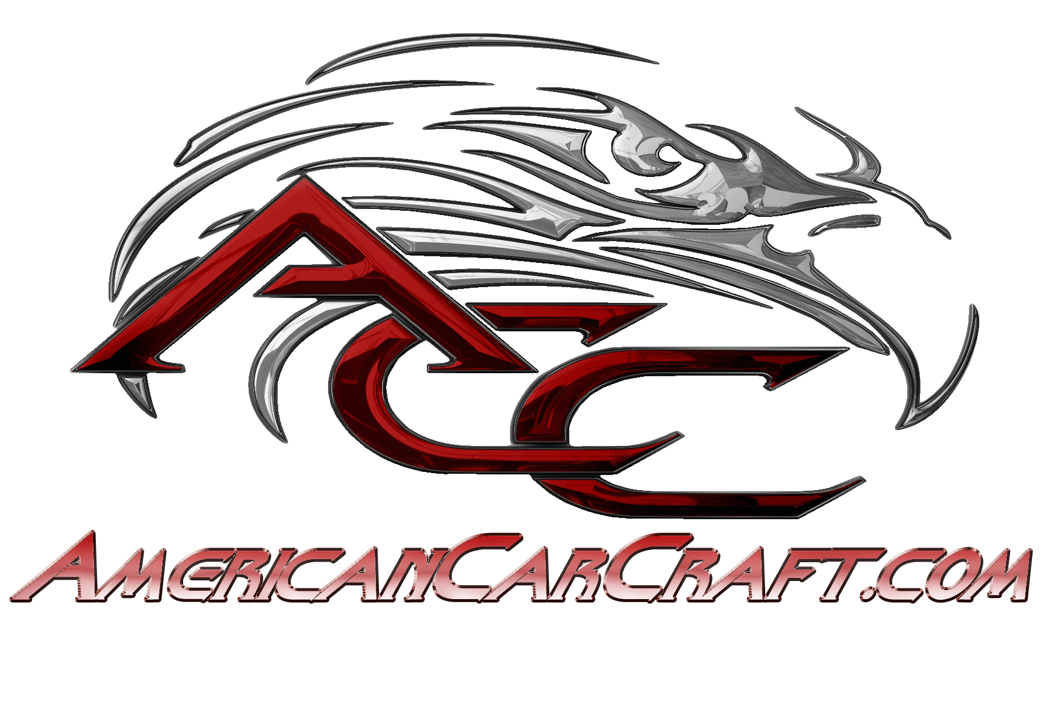
Contact Matthew Books  Telephone 727-861-1500  Cell 352-650-4439  Email matt@americancarcraft.com  Website Americancarcraft.com | FOR IMMEDIATE RELEASE  October 1, 2015

American car craft takes over performance tv

Airing on Velocity, MavTV & Rev’n Networks October 16th & 17th at 9:30am & 4:30pm
Hudson, FL, October 1, 2015– Find out what happens when the #1 automotive accessory manufacturer, American Car Craft, takes over an entire episode of the hit automotive show, Performance TV. Airing on Saturday the 17th at 9:30am on Discovery Networks’ Velocity channel. As well as Friday the 16th at 9:30am and 4:30pm on MavTV and all week long on the Rev’N broadcast network.
“With over 1500 products we have something for just about any car enthusiast who wants to dress up their vehicle,” said Rick Rivera, co-owner and lead designer for American Car Craft. “We’re excited to get out there and show everyone what we’re creating daily here.”
Focusing on one customer’s desire of customizing the engine of his classic ’61 Corvette racecar, the episode will follow the process from design to installation of how these one of a kind parts are all handcrafted in the USA. Featuring co-owner and lead designer Rick Rivera, with his 30 years’ experience in the automotive customization industry and his part designing, car modifying son, Cameron, who have taken the auto accessory world by storm. The entire episode takes place on location at the company’s headquarters in Hudson, FL. where they manufacture made to order custom stainless steel and carbon fiber accessories for a wide variety of muscle and luxury cars, trucks and more.
Customer and ’61 Corvette owner, Harry Fedoryk said, “I’m so thrilled to be a part of all this. It’s been a dream come true, really.”
American Car Craft is a design and manufacturing company dedicated to developing unique, high quality products. With more than thirty years of experience customizing all manner of late Model Muscle Cars, Classic Hot Rods, Exotics, Limousines, Vans and more. Our product design concepts are based on flat 304 stainless steel sheet materials that are laser cut and then hand formed and crafted to produce truly amazing, high quality accessories you just won’t find from any other company.
Our product line specialty extends from the interior to the exterior of your ride and into the engine bay. We also create state of the art vinyl decals and can create one of a kind custom etched windows and laser etched stainless steel products.
We pride ourselves in the fact that the majority of our car show going customers have achieved top awards such as best of show, best in class, best engine bay, best interior and more. Our success is due to the dedication of you, our customers, and the unique nature of our product line. We have a commitment to develop hot new products at any available opportunity and offer an extensive new car prototype product design program for our customers.
All of Our Products Are Handmade in The USA!

# # #
If you would like more information about this topic, please contact Matthew Books at 727-861-1500 or email at matt@americancarcraft.com.

