A Brief History of the Lei
by Jonathan Howery
February 28th, 2015

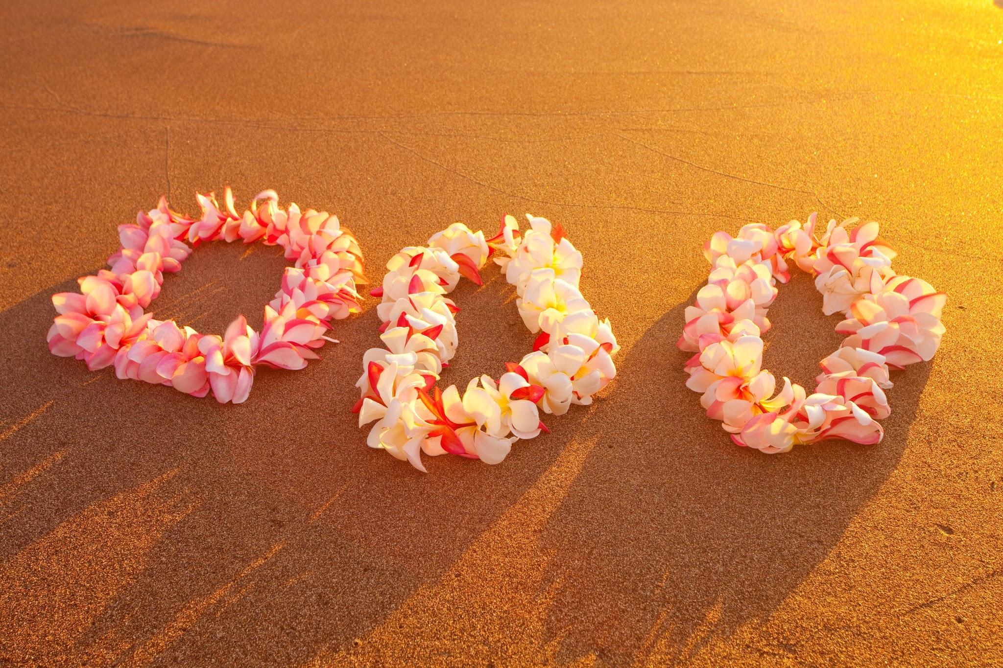
Leis on the Beach

What better greeting can you get than when you first step off of a plane, after hours of being thousands of feet in the air, and you get draped around the neck with a lei of fresh, sweet smelling flowers and a kiss on the cheek by friendly islanders. A lei can come in the form of a garland or wreath but can also be anything sewn together and adorned on someone. The most popular lei nowadays is that of a string of flowers given to new arrivals to the islands. This concept was widely popularized by the many tourists that came visiting in the 19th and 20th centuries.

The early history of lei making begins with the polynesian migrations throughout the polynesian islands from 600 ACE to the 1300s. Throughout the pacific, polynesians would wear strings of flowers and vines and wreaths to honor their gods. When these travelers arrived to Hawaii, in addition to the plants that they brought with them, they also brought ginger used for fragrant decoration and adornment. Leis were also made from whale and seal bones as well as shells found along the beaches and in the ocean. When the long voyaging ceased, the Hawaiians’ lei making started becoming more richer and unique.

Most leis today are made out of commonly used flowers such as: plumerias, orchids, carnations, kukui, maile leaves, tuberose, and pikake. Kukui leis were traditionally only work by the ali’i or royalty of Hawaii. Leis, however, can be made out of anything from fish teeth to candy and from paper to feathers. Each island even has its own specific lei. Hawaii has lehua, Maui has lokelani, Kahoolawe has hinahina, Lanai has kaunaoa, Molokai has kukui, Oahu has ilima, Kauai has mokihana, and Niihau has pupu.

Leis can be given, received, or worn for any occasion in Hawaii. From birthdays to promotions and anniversaries to graduations, they are seen everywhere. They can even be worn for the pure joy of smelling their fragrance. Or even just to celebrate the aloha spirit. Yet there is one thing you must not do when it comes to lei etiquette, you must not refuse to receive a lei from someone. The only instance when you should is if you have an allergy to flowers, in which case you would say so and decline politely. For more history of the lei, please read on here.

Well there you have it folks, a brief history of the Hawaiian lei. For tour and activities around the islands, please visit HawaiiDiscount.com. If you have any questions about this blog please feel free to email me at comments@hawaiidiscount.com.

Loa’a wale lā!

word count - 463

