Motion plastic solutions for the fabricating and metalworking industries
A range of high-strength, reliable solutions from plastics expert igus on display at FABTECH 2015 in Chicago
East Providence, RI – November 3, 2015 - At the upcoming 2015 FABTECH trade show, November 9-11 at Chicago’s McCormick Place, motion plastics specialist igus will have a wide range of products and solutions for the fabricating and metalworking industries. A number of cables and cable carriers, as well as a selection of high-strength plastic bearings will be exhibited in booth N19103.
On display
At the show, igus will demonstrate a number of their industrial solutions, including their innovative Triflex R multi-axis cable carrier, along with optional retraction system, in action on an industrial robotic arm. Triflex R’s unique design allows for flexible movements on robotic arm systems, while providing excellent protection for cables and hoses. The Triflex RSE retraction system integrates igus’ DryLin linear guide systems to create a lightweight and cost effective retraction system for robotic cable packages.
High-strength Energy Chain cable carriers will also be on display at the show, along with samples and product information. igus E-Chains are able to withstand high temperatures and forces, and offer resistance to dirt, debris, and chemicals.
Also in the igus booth will be a selection of dry-tech self-lubricating bearing solutions, including iglide PRT slewing ring bearings, DryLin linear slide tables, and range of barstock material options available for prototyping or creating custom bearings.
About igus®
igus® develops industry-leading Energy Chain® cable carriers, Chainflex® Motion Cables, DryLin® linear bearings and linear guides, iglide® plastic bushings, and igubal® spherical bearings. These seemingly unrelated products are linked together through a belief in making functionally advanced, yet affordable plastic components and assemblies. With plastic bearing experience since 1964, cable carrier experience since 1971 and Motion Cables since 1989, igus provides the right solution from over 100,000 products available from stock. No minimum order required. For more information, contact igus at 1-800-521-2747 or visit www.igus.com.

Photos:
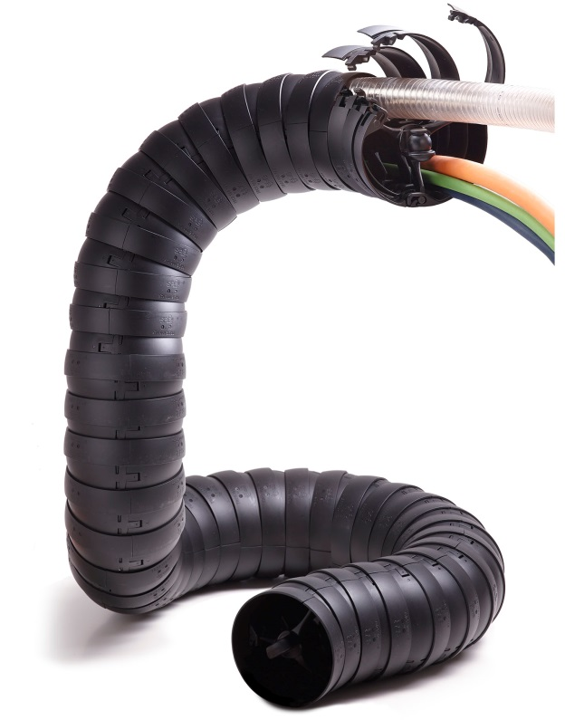
Picture 1315-01, igus Inc.
The Triflex R cable carrier offers multi-axis movement for robotic arm systems
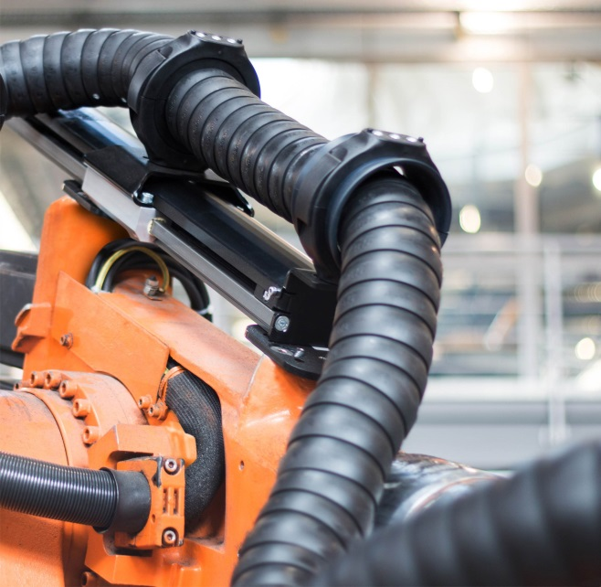
Picture 1315-02, igus Inc.
Lightweight, affordable Triflex RSE guides and retracts cable management systems on robotic arm applications.

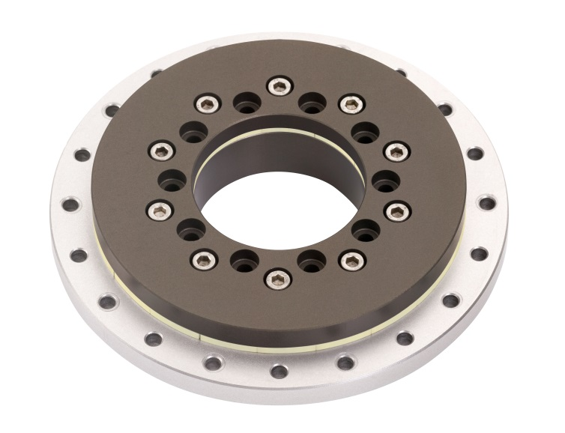
Picture 1315-03, igus Inc.
iglide PRT slewing rings integrate self-lubricating sliders into a high-strength design

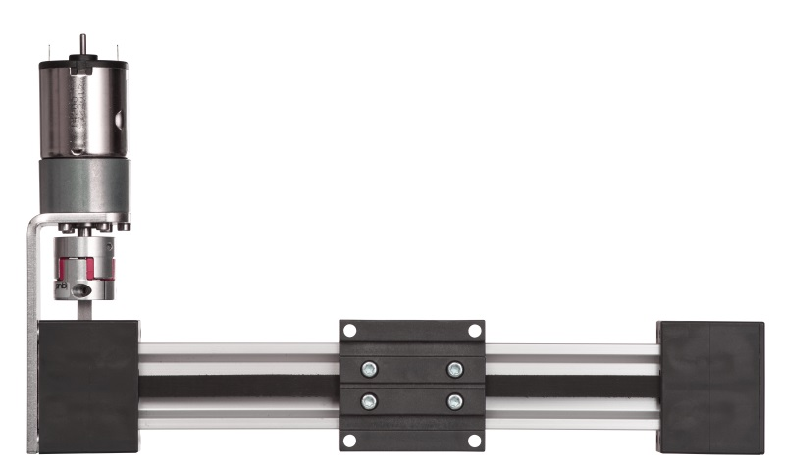
Picture 1315-04, igus Inc.
DryLin linear guide systems are now available with optional motor.

CONTACT:  igus® Inc.  PO Box 14349  East Providence, RI, 02914  Tel.: 800.521.2747  Fax: 401.438.2200  sales@igus.com  www.igus.com  PRESS CONTACT:  Ellen Rathburn  Public Relations Specialist  PO Box 14349  East Providence, RI, 02914  Tel.: 800.521.2747 x. 288  erathburn@igus.com  www.igus.com | igus, Energy Chain, DryLin, Chainflex, iglide, dry-tech, and igubal are registered trademarks of igus Inc. All other company names and products are trademarks or registered trademarks of their respective companies.

