Salt Lake City, UT – 5 January 2016

Beijer Electronics guarantees availability, support and delivery of E1000 operator panels

Following the Mitsubishi Electric end-of-life announcement, Beijer Electronics is proud to inform that the popular E1000 panels are still in full production and will continue to be available through Beijer Electronics directly and via Beijer Electronics’ distributor network.

The E1000 series operator panels have been manufactured by Beijer Electronics for many years and there are no actual EOL plans regarding the E1000 panels from Beijer Electronics, who conduct a policy of a 2-year EOL notification on all products.

Same product – no differences
Customers will experience no differences – technical, mechanical or whatsoever – in the E1000 operator panels and the software, except for the labelling, which now will wear the Beijer Electronics brand. No E1000 panels with Mitsubishi Electric brand labelling will be offered after November 2015.

The E1000 panels, as well as Beijer Electronics entire range of iX HMI panels, are now available from Beijer Electronics directly and via Beijer Electronics’ distributor network.

Reliable service and support
To guarantee a continued successful use of the panels, Beijer Electronics are happy to offer customers their commercial, technical and logistical services through their presence globally and via Beijer Electronics’ distributor network.
For further information, please visit beijerinc.com (Americas) or beijerelectronics.com (EMEA)

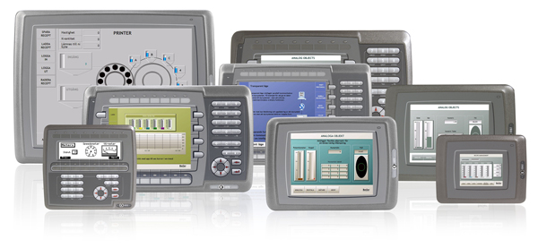
About Beijer Electronics
The E1000 series operator panels have been manufactured by Beijer Electronics for many years with great technical and commercial success.

Beijer Electronics is a fast growing technology company with extensive experience of industrial automation and data communication. The company develops and markets competitive products and solutions that focus on the user. Since its start-up in 1981, Beijer Electronics has evolved into a multinational group present in 19 countries with sales of US$180 million in 2014. The company is listed on the NASDAQ OMX Nordic Stockholm Small Cap list under the ticker BELE. www.beijerelectronics.com | http://www.beijerinc.com

Contact
Jeff Hayes, Americas Product Manager, +1 801 924 5435, e-mail: Jeff.Hayes@BeijerInc.com

Web Links
E1000 Landing Page - http://beijerinc.com/product/industrial/e1000-panels.php

Images
E1000_group_low.jpg
E1000_group_print.jpg

