Malmö 2016-02-16

Beijer Electronics launches cost-effective iX TxF-2 series of HMIs
Beijer Electronics is proud to present the cost-effective iX TxF-2 series of HMIs, including 5, 7 and 10 inch operator interface panels designed for industrial environments.
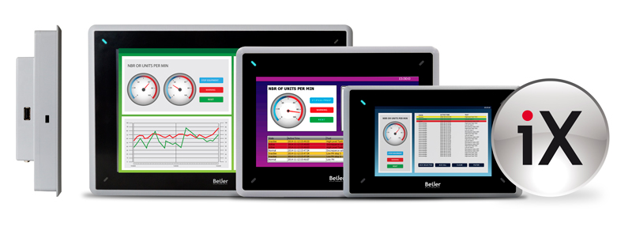

A cost-effective yet advanced HMI
The iX TxF-2 series offers three cost-effective industrial HMIs with high-resolution touch-screen and modern design. The UL-approved iX TxF-2 panels combine IP65 plastic housing with the full version of the iX HMI Software, making it a cost-effective yet full-featured HMI. All iX TxF-2 panels come standard with Ethernet, serial and USB ports.

Smart iX HMI Software
The iX HMI Software features all basic HMI functions such as alarms, data logging, trends, security as well as more advanced functions. It combines best-in-class vector-based graphics and smart functions that allow for intuitive operation on the spot. iX HMI software guarantees almost limitless connectivity to PLCs and other equipment with an extensive list of more than 70 drivers.

Features:
- High resolution TFT-LCD touch-screen
- 10″, 800 × 480 pixel (16:9), 7″, 800 × 480 pixel (16:9), 5″, 800 × 480 pixel (16:9)
- Application storage 200 MB
- 1 × Ethernet, 4 × serial, 1 × USB as standard
- Operating temperature -10° to +50°C
- UL / cUL, CE, FCC and KCC certifications
- IP65 protected corrosion-resistant plastic housing
- iX HMI Software with universal connectivity

About Beijer Electronics
Beijer Electronics is a fast-growing technology company with extensive experience of industrial automation and data communication. The company develops and markets competitive products and solutions that focus on the user. Since its start-up in 1981, Beijer Electronics has evolved into a multinational group present in 19 countries with sales of 1,402 MSEK 2014. The company is listed on the NASDAQ OMX Nordic Stockholm Small Cap list under the ticker BELE. www.beijerelectronics.com or www.beijerinc.com.

Contact
For more information please contact: Jeff Hayes, Regional Product Manager, +1.801.466.8770, jeff.hayes@beijerinc.com
Pictures
- Group_image_TXF-2_low.JPG

