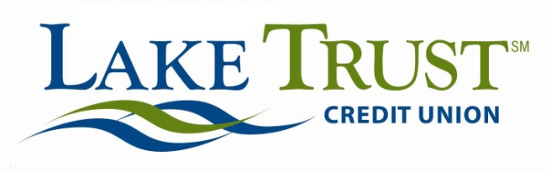

Press Release
For Immediate Release
Website: laketrust.org

Contact: Lori Anderson
landerson@laketrust.org
734.626.0319

Lake Trust Credit Unions’ Foundation to Award $20,000 in College Scholarships
High School Seniors Accepted to a Michigan College Encouraged to Apply

Brighton, Michigan – Lake Trust Foundation is accepting applications for its 2016 Community Scholarship award. High school graduating seniors accepted at a Michigan college are encouraged to apply. The Credit Union has awarded scholarships through its Foundation since 2012, and this year, the individual award has increased from $1,000 to $5,000. Applications will be accepted online through March 4, 2016 at laketrust.org.

“Our young members have worked hard, and that really comes through in the experiences they’re sharing with us,” says David Snodgrass, Lake Trust Credit Union President and CEO. “These students are not only working hard in the classroom, they’re making an impact in their communities. They’re more than deserving of this award.”
Scholarship recipients are community-minded students who exemplify the Lake Trust’s core values of trust, teamwork, adaptability, learning and making a difference.

“We’re proud to be part of our college-bound members’ journey to achieve their dreams,” says Chris Pearson, Lake Trust Vice President of Community Development. “Education plays a tremendous role in their future success and we’re honored to be a partner in helping them along the way.”

The Lake Trust Foundation is a 501(c)3 dedicated to making a difference by investing volunteer support and financial resources in Michigan counties served by Lake Trust Credit Union. The Foundation’s mission is to bring people and organizations together to create strong, diverse, vibrant communities through, contributions, grants and Team Lake Trust volunteerism. Learn more at laketrust.org.

Lake Trust Credit Union lives up to their name, with branches that stretch from Lake Michigan to Lake Huron. With over 167,000 members and $1.6 billion in assets, they’re the fourth largest credit union in Michigan. By participating in and supporting over 100 local events, they reach across the state to create stronger communities. Membership is open to anyone who lives, works, worships or attends school in their 35 county service area.
Follow Lake Trust Credit Union on Facebook or on Twitter @laketrust

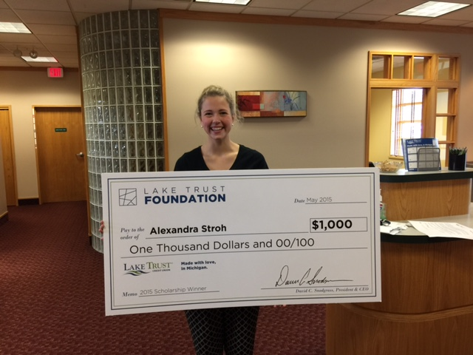
Alexandra S. of Hudsonville, MI, a 2015 Lake Trust Community Foundation scholarship recipient

#

