Media Release May 10 2016

VIBES HI-FIDELITY EARPLUGS AND THE HEAR THE WORLD FOUNDATION FORM A CHARITABLE PARTNERSHIP TO PROMOTE HEARING HEALTH

Vibes will contribute part of its revenues to give the gift of hearing through projects of the Hear the World Foundation, while providing hi-fi earplugs to concert goers which maintain sound quality and reduce the decibels.

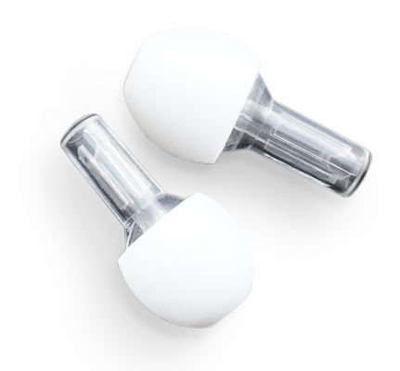
Vibes Hi-Fidelity Ear Plugs of Minnesota, USA and Swiss based charitable Hear the World Foundation are pleased to announce their charitable partnership to enable access to hearing healthcare for children in need. By promoting Hi-Fidelity ear plugs at live music venues and festivals, Vibes also wants to raise awareness for hearing health and the importance of good hearing with the general public. The volume of live music at concerts and festivals is a growing problem which can lead to serious hearing damage - often irreversible. This has been verified in a recent report from the World Health Organization, which estimates that 440 million people worldwide are subjecting themselves to volumes of live music which can lead to hearing loss.

Giving the gift of hearing while protecting your own hearing
In the interest of hearing health, Vibes will contribute part of its revenues to the work of the Hear the World Foundation. “We are so impressed by the work of the Hear the World Foundation worldwide and their commitment to making a sustainable difference in the communities they serve.” says Jackson Mann, Vibes Founder. "It is the perfect virtuous circle for all of us – by protecting your own hearing with Vibes, you are given the opportunity to provide someone else with the gift of hearing - possibly for the first time.” The Foundation has supported over 70 projects on 5 continents so far. It has a special focus on projects that support children in reaching their development milestones and realizing their full potential in life regardless of their hearing loss. The charitable Hear the World Foundation has been founded in 2006 by Sonova, leading manufacturer of innovative hearing care solutions headquartered in Switzerland. Vibes will feature the work of the Hear the World Foundation in its promotional activities.

Hearing protection that offers good sound quality
Vibes increases hearing safety by reducing decibels at concerts while also maintaining good sound quality. Specifically designed for live music, Vibes uses a unique acoustic filter which allows the music to come through clean, clear and controlled. Although foam earplugs have been widely distributed, their overall use by concert-goers remains low as the sound clarity is greatly diminished. The introduction of Vibes Hi-Fi Earplugs will increase the overall use of hearing protection for concert-goers as they no longer have to make the choice between hearing health and sound quality. “Vibes provides a very real solution to the dilemma faced by those who want a powerful concert experience but also can no longer tolerate the negative effect on their hearing that often results. The use of these products will improve the concert experience while protecting the precious sense of hearing and helping those in need – so it’s a perfect partnership”, Elena Torresani, Head of Hear the World Initiative adds.
About the Hear the World Foundation
By supporting the charitable Hear the World Foundation, Sonova is campaigning for equal opportunities and a better quality of life for people with hearing loss. As a leading manufacturer of hearing care solutions, the company feels socially responsible for contributing towards a world where everyone has the chance to enjoy good hearing. For instance, the Hear the World Foundation supports disadvantaged people with hearing loss around the world and gets involved in prevention and providing information. It focuses particularly on projects for children with hearing loss, to enable them to develop at the appropriate rate for their age. More than 90 famous ambassadors, including celebrities such as Plácido Domingo, Annie Lennox, Sting and Joss Stone, champion the Hear the World Foundation. For further information, go to www.hear-the-world.com.

About Vibes
Vibes of Minneapolis, Minnesota USA are a line of high-fidelity earplugs which utilize an acoustic filter to enhance the live music experience while protecting hearing health. Vibes is currently available online at www.discovervibes.com, in retail stores, at concert venues and select music festivals.

For further information or images please contact:

Hear the World Foundation
Elena Torresani
E-Mail: elena.torresani@hear-the-world.com
Phone: +41 58 928 01 01

Vibes
Jackson Mann
Email: jack@vibesllc.com
Phone: +1 952 393 2783

http://www.who.int/mediacentre/news/releases/2015/ear-care/en/

