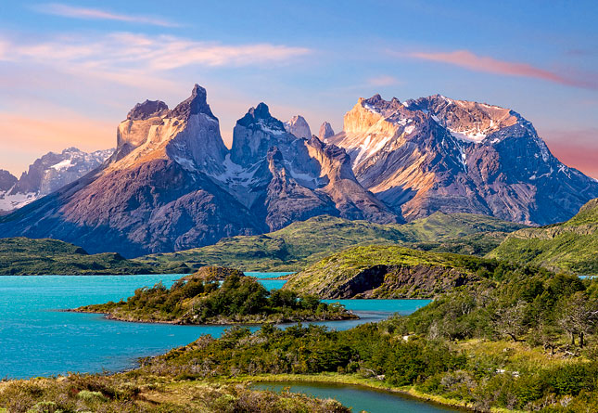

Patagonia!
Vast Landscapes, Glaciers and Mountains

Buenos Aires, Argentina – Class Adventure Travel celebrates twenty years hosting guests in Latin America with a Big Date to Patagonia – the birthplace of the region’s adventure travel. This experience will begin in Argentina’s bustling capital of Buenos Aires before you head south to discover the magnificent landscapes of Patagonia in both Argentina and Chile. This itinerary is available for bookings through December 31, 2016.

Class Adventure Travel began with a dream - to share with others the incredible experience of discovering South America, and to do so with heart, providing unique adventures and authentic experiences to each and every person. They’ve grown, learned and added destinations to their portfolio which allow travelers to experience the iconic places of Latin America – Argentina, Chile, Peru, Colombia, Brazil, Bolivia, Ecuador, Galápagos, Costa Rica, Belize, Guatemala.

In planning vacations, Class Adventure Travel stay true to their priorities of building relationships both with guests and local providers. They attain authenticity by crafting incredible itineraries customized to the traveler’s desires while balancing this with ensuring both travelers and locals have a good experience. These relationships assure a sustainable and memorable trip.

Traveling to Patagonia with Class Adventure Travel, takes guests to two countries united at the far southern end of Latin America. As well as taking you to the world-class capital cities of Buenos Aires and Santiago de Chile, it is the huge creaking glaciers of El Calafate and the wild, untamed landscape of Torres del Paine National Park that will capture the heart of all those who visit this magical corner of the world with Class Adventure Travel.

Destinations on this “Big Date to Patagonia” include Buenos Aires, El Calafate and Perito Moreno Glacier, Torres del Paine NP and Santiago. For full details: https://www.classadventuretravel.com/tour/highlights-chiles-patagonia/
For complete info on all itineraries check out https://www.classadventuretravel.com/

# # # # #

Class Adventure Travel
Media Contact: Nancy Harrison
Adventure Media
nharrison@adventuremedianews.com
307.421.4473

About Class Adventure Travel

Class Adventure Travel is headquartered in Austin, Texas, where they’re big believers in supporting local business. Class Adventure Travel has been partnered with Global Encounters for close to 15 years, who has grown to have 6 regional offices throughout Latin America, almost 20 years experience, and providing customized vacations for over 160,000 travelers. Class Adventure Travel brings you the experience of over 60 passionate travel experts throughout the region, ready to help plan your tailor-made vacation. Working together to bring the traveler closer to authentic experiences and local people. Their mission, to share with others the incredible experience of discovering Latin America, and to do so with heart, providing unique adventures and authentic experiences to each and every person trusting them with their dream.

