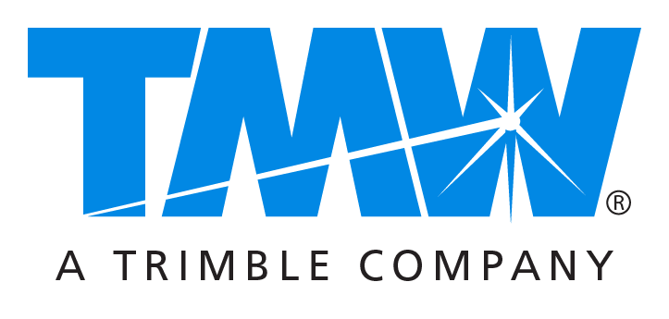
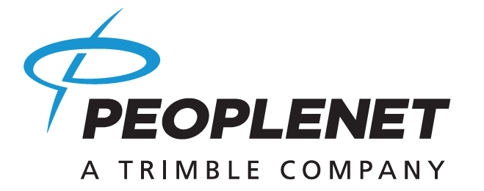

Media contacts: Ellie Walradth at ewalradth@peoplenetonline.com or 952.908.6193
Caroline Lyle at clyle@tmwsystems.com or 440.721.2260
Kara Turtinen at kara@maccabee.com or 612.337.0087
Drew Shippy at drew@pinnmedia.com or 330.687.4053

PeopleNet and TMW Unveil Several Collaborative, Connected Transportation Technologies on Day One of Inaugural in.sight Conference

Combined fleet mobility and TMS solutions designed to enhance communication,
operational efficiency and profitability

NASHVILLE, TN – September 26, 2016 — Thousands of representatives of for-hire and private fleets, brokers, 3PLs, heavy duty repair centers and other transportation businesses were introduced to an array of collaborative and seamlessly connected telematics and TMS solutions during today’s opening session of the inaugural PeopleNet and TMW Systems in.sight User Conference // Expo. PeopleNet (www.peoplenetonline.com) and TMW (www.TMWsystems.com) are Trimble (NASDAQ: TRMB) Companies and part of its international Transportation and Logistics (T&L) Division.

in.sight 2016 is an exclusive opportunity to explore the latest connected transportation technologies spanning Trimble’s broad T&L portfolio. TMW President David Wangler and PeopleNet President Brian McLaughlin demonstrated this extended value to customers by previewing a number of innovative multi-platform solutions. These included a powerful new driver-facing mobile app; the industry’s first comprehensive “journey management” application; and a universal, cloud-based solution that enables fleets to quickly and easily integrate PeopleNet data into their TMWSuite® software. They also highlighted a new integration that will allow users of the web-based PeopleNet solution to simultaneously access critical information from their TMS software.

“This conference reflects an exciting new era for our companies and for transportation technology,” McLaughlin told the audience. “PeopleNet and TMW have long delivered significant business value on a solution-specific basis. Now we have connected critical tools and information within several solutions to provide a far more impactful user experience in terms of driving improved communication, efficiency and, ultimately, profitability.”

Wangler cited the elimination of traditional “swivel chair integration” – whereby users must switch between multiple applications and interfaces – as key to making better, faster decisions. “Being able to simultaneously view business-critical information from multiple platforms helps every member of a transportation enterprise save time while making choices that contribute to improved business performance,” he said.

McLaughlin and Wangler also pointed to the increased importance of integrating advanced business intelligence into transportation management systems (TMS) and fleet mobility solutions. “We are partnering with an ever expanding range of transportation businesses to collect and analyze operational data, define industry benchmarks and track emerging trends that can impact productivity and competitiveness,” Wangler said.

“Our connected solutions enable users to access many of these insights at the point of decision, whether it’s at the executive level, in dispatch, within a service bay or in the cab of an over-the-road tractor,” McLaughlin added.

Connected solutions previewed during today’s opening session included:

ConnectedDriver™ Mobility App
A driver-facing application that provides custom, bi-directional messaging; dispatch and stop data; hours of service availability; driver pay; driver time-off; and other information. The cloud-based app, which has been available to drivers as a companion to the PeopleNet system, is now integrated with the TMWSuite platform.

TripInsight™ Solution
A comprehensive, cloud-based journey management solution that provides proactive decision support and uniquely accurate ETA and PTA to the back office and driver. The application manages around multiple variables influencing trip outcome, including hours of service calculation, route restrictions, over-the-road purchasing and rest stops.

TMW FleetConneX™
A cloud-based universal solution that enables fleets to integrate their mobile communication platforms into TMWSuite software without the need for costly on-premise servers or custom coding. FleetConneX is now available for fleets using TMWSuite software in conjunction with the PeopleNet solution.

PeopleNet Fleet Manager SSO Integration
The companies now offer a single sign-on (SSO) capability that enables dispatchers using TMWSuite software to view PeopleNet driver log hours within a unified interface. This information is displayed in the context of other important data related to driver management.

The in.sight User Conference // Expo continues through Wednesday with a schedule comprising more than 350 educational sessions, technology exhibits from over 70 solutions providers, “Peer2Peer” roundtable discussions and several networking events. PeopleNet and TMW will present the 2016 Innovator of the Year awards during Tuesday night’s Customer Appreciation Dinner.

For more information regarding in.sight, visit: http://insightuserconference.com.

About PeopleNet
PeopleNet provides solutions to help fleets improve safety and compliance and reduce costs. PeopleNet’s network communications, mobility and analytics products are used by more than 2,000 truckload, LTL, private, and energy services fleets throughout North America. PeopleNet was established in 1994 and is headquartered in Minnetonka, Minnesota, with an office in Ontario, Canada. PeopleNet is a Trimble (NASDAQ: TRMB) Company and part of its international Transportation and Logistics Division. To learn more about PeopleNet and its products, visit www.peoplenetonline.com or call (888) 346-3486.

About TMW Systems
TMW is a leading transportation software provider to commercial and private fleets, brokerage and 3PL organizations. Founded in 1983, TMW has focused on providing enterprise software to the transportation industry, including asset-based and non-asset-based operations as well as heavy-duty vehicle service centers. With offices in Cleveland, Dallas, Indianapolis, Nashville, Oklahoma City, Raleigh, and Vancouver, the company serves over 2,000 customers, including many of the largest, most sophisticated and complex transportation service companies in North America. TMW is a Trimble Company (NASDAQ: TRMB) and part of the international Transportation and Logistics Division.

###

