Press Release Contacts:
For Immediate Release Vinitaly International
International Media Dept.
+39 045 8101447
media@vinitalytour.com
www.vinitalytour.com
Twitter: @VinitalyTour
Join Vinitaly International Network on LinkedIn

The Vinitaly International Academy aims to become the gold standard for Italian Wine education as it attracts top-tier wine experts for the next VIA Certification Course in 2017

The VIA Certification Course, conducted by Ian D’Agata, Scientific Director of VIA, represents a one and only opportunity for wine professionals to gain extensive knowledge on the vast subject of Italian grape varieties and wines. Currently, no International certification program offers this kind of comprehensive study of Italian wines. Understandably so, as the wines made from native grapes remain largely obscure, often within the growing region itself. Even for the Master of Wine or the Master Sommelier, Italy, despite ranking as the world’s largest wine producing country, remains somewhat of an enigma and an untapped resource for the discovery of intriguing new wines.
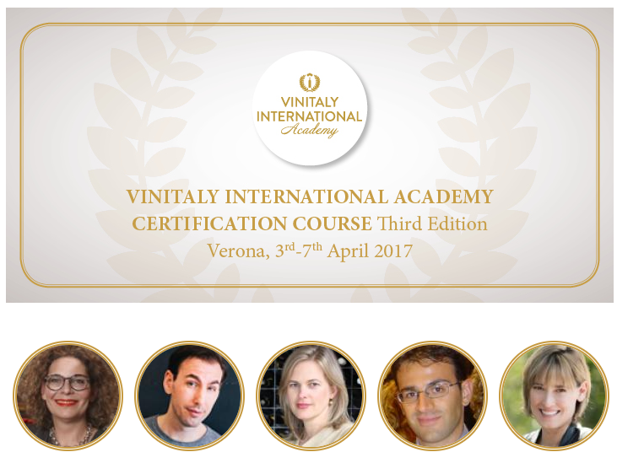

Candidate, Natasha Hughes MW, from the UK, explains, “Italy remains a gap in my knowledge and I relish the opportunity to understand the diversity of wines made in this country, both in terms of theory and tasting.” In a market that is rapidly shifting toward millennial wine consumers, current international knowledge of Italian wines is, in fact, largely relegated to the most prestigious and largest wine growing areas, giving an unbalanced view of Italian wines today. In a recent 2014 Wine Market Council High Frequency Wine Drinker Survey, American millennials show interest in novelty, delve into the wine stories, and look for authenticity in the glass. They are more inclined to drink imported wines and enjoy experimenting with wines served by the glass.

An affirmation of the strategic interest in Italian wines can be seen in the calibre of candidates selected for the 2017 edition, and the influential roles they occupy in international markets: Natasha Hughes MW (UK), Levi Dalton (USA), Deborah Parker Wong DWSET (USA), Robin Kick MW (Switzerland), Nicholas Paris MW (USA), Laura DePasquale MS (USA), Kathy Morgan MS (USA). See full bios at www.vinitalyinternational.com/vinitaly-international-academy/candidates.

Vinitaly International Academy (VIA) is an educational initiative aimed at simplifying the vast diversity of Italian grape varietals by explaining, divulging and broadcasting the characteristics of Italian wine around the world. VIA was first launched back in February 2014 by Stevie Kim (Managing Director of Vinitaly International) and Doctor Ian D’Agata (Scientific Director of VIA). Today, VIA already counts on the support of 4 Italian Wine Experts and 55 Italian Wine Ambassadors from around the world and is looking to further expand its community.

Until the December 16th deadline, Vinitaly International Academy will continue to recruit and select the 50 candidates who will have the opportunity to become the next VIA Italian Wine Ambassadors and Experts during the third edition of the VIA Certification Course to be held in Verona from the 3rd to the 7th of April 2017. The dates allow students to also attend the 6th edition of OperaWine (8th of April 2017) and the 51st edition of Vinitaly (9th–12th April 2017).
For more information and to apply to the course you can visit www.vinitalyinternational.com/vinitaly-international-academy

About:

Veronafiere is the leading organizer of trade shows in Italy including Vinitaly (www.vinitaly.com), the largest wine and spirits fair in the world. During its 50th edition Vinitaly counted more than 4,100 exhibitors on a 100,000+ square meter area and 130,000 visitors from 140 different countries. The next edition of the fair will take place on 9 - 12 April 2017. The premier event to Vinitaly, OperaWine (www.operawine.it) “Finest Italian Wines: 100 Great Producers,” will unite international wine professionals on April 8th in the heart of Verona, offering them the unique opportunity to discover and taste the wines of the 100 Best Italian Producers, as selected by Wine Spectator. Since 1998 Vinitaly International travels to several countries such as Russia, China, USA and Hong Kong thanks to its strategic arm abroad, Vinitaly International. In February 2014 Vinitaly International launched an educational project, the Vinitaly International Academy (VIA) with the aim of divulging and broadcasting the excellence and diversity of Italian wine around the globe. VIA this year launched the second edition of its Certification Course and today counts 54 Italian Wine Ambassadors and 3 Italian Wine Experts.
###

