Press Release Contacts:
For Immediate Release Vinitaly International
International Media Dept.
+39 045 8101447
media@vinitalytour.com
www.vinitalytour.com
Twitter: @VinitalyTour
Join Vinitaly International Network on LinkedIn

THE WINE MARKET, SEEN THROUGH STORYTELLING, A TENDER TASTING AND SUCCESS STORIES

Germany, United States, Sweden, China, and Singapore were the major themes during the first day of the third edition of wine2wine, that took place yesterday in Verona. A return to the heart of Europe with the morning dedicated to one of the most important markets in the world, Germany.
Germany, is indeed, when it comes to Italian wine, the first European partner in terms of volume and value, but it’s also “a functioning market that leaves us unsatisfied: frustration when demand and supply dictate the market”, as suggested by the title of the first seminar. To kick-start the beginning of this wine2wine edition was Hermann Pilz, Editor in Chief of “Weinwirtschaft”, one of the most reliable and well-known German magazines for professionals in the wine sector.

The seminar offered attendees useful data to understand the future trends of the Giant of Central Europe. Many sector professionals are convinced that they know this market but often make mistakes and are not aware of the changes, that are instead, always taking place. This was the major reason for this session that was presented through a careful study of demographics, customer structure, and behaviour. Mr Pilz unmasked, with numbers in hand, the stereotypes that see Germany as a market for cheap wine. The market share of a discount retailer range by 20% in volume and less than 10% in value. Germany, Pilz reminds the public, is a highly attractive market because of the increasing demand. It is very competitive on quality, price, and promotion with a complex and large diversity of distribution channels.

During the course of the same morning there was a second session focused on a nearby country, Austria, led by Master of Wine Josef Schuller, centred on the importance of wine education and the necessity for producers and sector professionals, in particular from the “Old Europe”, to understand the level of production worldwide.

Just a few minutes later, one of the most anticipated sessions of wine2wine: a fake tender organized in collaboration with Sweden’s Systembolaget. For the first time outside of Sweden, their Quality Control Manager Jonas H. Röjerman held a tender tasting in order to demonstrate to participating wineries how wine suppliers are chosen for import into the market. In less than an hour, Röjerman guided attending producers to identify what are the factors that are and are not taken into account in order to ensure the sale of the product in a monopoly market for alcoholic beverages such as Sweden.

It was, then, the turn of two large Countries: USA and China. The former, the world number one in the Italian wine market, and the latter, the Country of the hopes for Italian producers. The USA has become of great importance for many companies and entities such as ICE are ensuring the opportunity is given with promotions such as USA: “Vino-Italian Wine Week 2017”, supported by specific sessions that were dedicated to the American market. Ludovico Bongini, a lawyer specialised in M&A from the Diacron Group, and Giuseppe LoCasio an expert of “Fine Wine Brand Management” spoke about importing strategies and distribution. Steve Raye of Bevology confirmed this vision by explaining the necessity of preparation in order to ensure these strategies are effective.

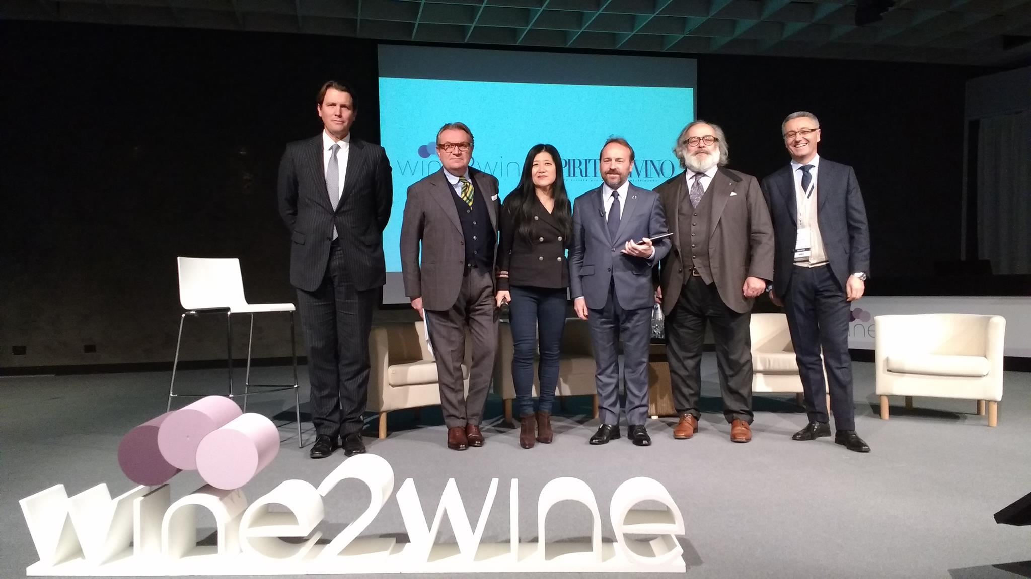

China, then followed, with two seminars, the first entitled “The wine market in China: which developments”, with special Chinese guests, Zuming Wang, general vice-secretary of the Chinese Alcoholic Bureau (the governmental department responsible for the legislation of alcoholic beverages in China) and Tao Weng, head of the Shanghai Dawen Information Development, founder of the Shanghai Wine & Dine Festival, the most important b2c event dedicated to food and wine of the whole of China. “China is still far away, it is a market where Italy can and must grow fervently”, this was the bottom line of both sessions. But, we have to learn to know the Chinese culture, and it is necessary to communicate and promote Italian wine in a united way. How to communicate in China, was instead the focus of the second session held by two giants of the Italian Fashion Industry in China, Stefano Ricci and Salvatore Ferragamo. The speakers pointed out some winning strategies adopted by the Italian Fashion Industry in China that stand as an example to follow in order to be successful in the wine market. “Magic and quality are necessary to have a successful brand in China” commented Stefano Ricci during the session.
To round up the first day of wine2wine a special session in the main auditorium Alison Napjus, senior editor of “Wine Spectator”, presented the 104 companies that will be pouring their selected wines at OperaWine 2017 (www.operawine.it), the only tasting ( 6th edition to be held on 8th April 2017) organized by the important American magazine out of the USA, in collaboration with Vinitaly International. The session was followed by an evening official inauguration of Vinitaly International’s new space, wine2digital, where authorities presented the new industrial plan of Veronafiere after its transformation into a privatized company. Amongst the speakers, Stevie Kim, Managing Director of Vinitaly International, the President and CEO of Veronafiere Maurizio Danese and Giovanni Mantovani respectively, the ICE CEO Piergiorgio Borgogelli as well as the Presidents of Federvini, Sandro Boscaini, and of Unione Italiana Vini, Antonio Rallo,

For further information visit wine2wine.net

About:

Veronafiere is the leading organizer of trade shows in Italy including Vinitaly (www.vinitaly.com), the largest wine and spirits fair in the world. During its 50th edition Vinitaly counted more than 4,100 exhibitors on a 100,000+ square meter area and 130,000 visitors from 140 different countries. The next edition of the fair will take place on 9 - 12 April 2017. The premier event to Vinitaly, OperaWine (www.operawine.it) “Finest Italian Wines: 100 Great Producers,” will unite international wine professionals on April 8th in the heart of Verona, offering them the unique opportunity to discover and taste the wines of the 100 Best Italian Producers, as selected by Wine Spectator. Since 1998 Vinitaly International travels to several countries such as Russia, China, USA and Hong Kong thanks to its strategic arm abroad, Vinitaly International. In February 2014 Vinitaly International launched an educational project, the Vinitaly International Academy (VIA) with the aim of divulging and broadcasting the excellence and diversity of Italian wine around the globe. VIA this year launched the second edition of its Certification Course and today counts 54 Italian Wine Ambassadors and 3 Italian Wine Experts.

