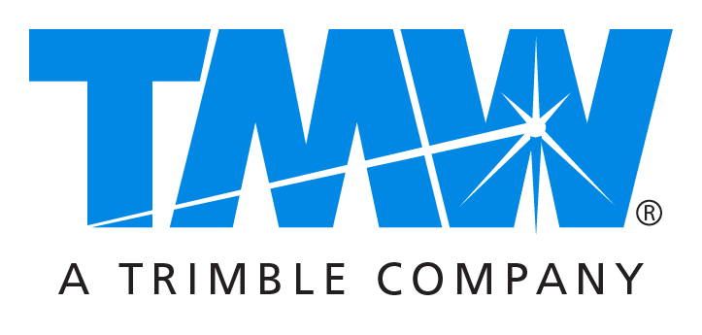

Media contacts: Caroline Lyle at clyle@tmwsystems.com or 440.721.2260
Drew Shippy at drew@pinnmedia.com or 330.687.4053

Appian DirectRoute Solution Now Offers Enhanced End-to-End Planning Capabilities,
Access to Historical Commercial Travel Time Data

Latest version streamlines planning process, from territory building to scheduling to routing,
for increased speed, accuracy, ease of use

CLEVELAND, OH – December 12, 2016 — TMW Systems introduced the latest version of its Appian DirectRoute® routing and scheduling solution, providing seamless, end-to-end planning capabilities and deep integration with extensive new mileage and mapping information. The new version (2016.3) streamlines each step in the planning process – from territory building to scheduling to routing – and offers optional access to historical traffic and travel time data.

Rather than require the user to toggle between multiple applications, DirectRoute provides a seamless workflow that saves time and enables users to optimize daily execution while offering access to real-time reporting and analytics. The solution now includes ALK PC*Miler® Version 30 maps and related information updated to include bridges and tunnels, border crossings, highway exits, truck stops, state weigh stations, CAT Scale weigh stations, all five-digit U.S. ZIP codes (as of 2016), U.S. Department of Defense military installations, highway junctions, commercial truck restrictions, and more.

Also now available is a powerful new integrated traffic data mileage and travel time calculator that leverages historical commercial travel time estimates and real-time traffic data to increase route-planning accuracy.

Other key enhancements are additional route selection options within the embedded optimization tool, new map display options, support for additional file types when exporting the Distance File, and the ability to reset route start times for a range of routes.

“We continue to introduce innovative features that help streamline the planning process,” said Brian Larwig, vice president and general manager, TMW Systems. “DirectRoute is helping fleets and 3PLs save time and money both in the office and on the road while dramatically improving customer service levels.”

To learn more about Appian DirectRoute and other TMW Systems solutions for commercial and private fleets and third-party logistics providers, please contact your TMW representative or call (800) 401-6682.

About TMW Systems
TMW is a leading transportation software provider to commercial and private fleets, brokerage and 3PL organizations. Founded in 1983, TMW has focused on providing enterprise software to the transportation industry, including asset-based and non-asset-based operations as well as heavy-duty vehicle service centers. With offices in Cleveland, Dallas, Indianapolis, Nashville, Oklahoma City, Raleigh, and Vancouver, the company serves over 2,000 customers, including many of the largest, most sophisticated and complex transportation service companies in North America. TMW is a Trimble Company (NASDAQ: TRMB) and part of the international Transportation and Logistics Division.
###

