*** FOR IMMEDIATE RELEASE ***
Stephanie Chergi, Producer
Stephanie@GamesThatWork.com - (404)806-5428

Virtual Reality Toothbrush Training - Just in Time for Children’s Dental Health Month
Atlanta - Feb 1, 2017

Virtual reality can turn a daily chore into hilarious fun. Brush Up VR puts you in a life-size cartoon with a giant toothbrush. You must brush all the green gunk from Budd’s teeth before your time runs out. You will work up a sweat brushing, as you learn just how many tooth surfaces need cleaning.

“Kids only brush what they see in the mirror, and many adults aren’t much better” says Dr. Bob Jacobson, the family dentist behind Brush Up. “They spend two minutes polishing the front teeth and scrubbing the easy side. That won’t work in Brush Up VR. You must clean the inner, outer and biting surface of every tooth.”

GamesThatWork is releasing Brush Up VR on February 1st, just in time for the National Children’s Dental Health Month. This Vive-exclusive title is available for $0.99 as early-access on Steam and on Viveport. It is designed for ages 5 through adult.

In December, the beta game was awarded the “Kid’s Choice” award at the Entertainment Software Association. Children selected it from a field of 80 top games curated by the US Education Department’s learning game experts.

Brush Up VR is a spinoff of the well-respected brush-along mobile game, Brush Up. NIH-funded studies show that Brush Up dramatically improves children’s toothbrush performance, even a year after playing the game. It has won awards from the National Academy of Medicine and other leading scientific panels and is played daily by children around the world. Brush Up is available now in the App Store and Google Play.

National Children’s Dental Health Month is February. It is supported by the American Dental Association, dental hygiene schools, and individual dental practices all over the United States.
More information: https://www.nidcr.nih.gov/NewsAndFeatures/Announcements/ChildrensDentalHealthMonth.htm

Dr. Bob Jacobson hosts a new web series “Brush Up with Dr. Bob”, which offers dental health advice to young parents. https://www.youtube.com/channel/UCY3nOoO4LTG430uBryunz3g

GamesThatWork is an Atlanta studio that makes games where players learn real-world skills. Drawing on success in the entertainment industry and on evidence based training techniques, the studio makes games that are fun and functional. It serves innovative clients in the education, research, corporate, military and intelligence communities.
-more-

PREVIEW CODES | PLEASE CONTACT US FOR PRE-RELEASE CODES
VIDEO | https://youtu.be/Wbs7lrlJyOI  Contact us for 360 video
IMAGES | Virtual reality images are highly recommended
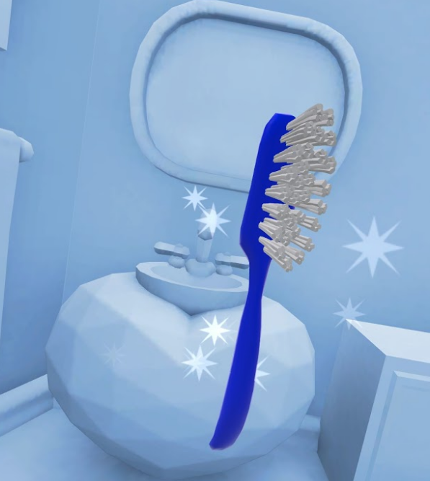 | Screenshot 0  - High Rez  - VirtualReality (3D Stereo)
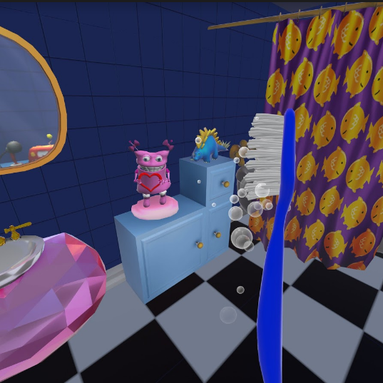 | Screenshot 1  - High Rez  - VirtualReality (3D Stereo)
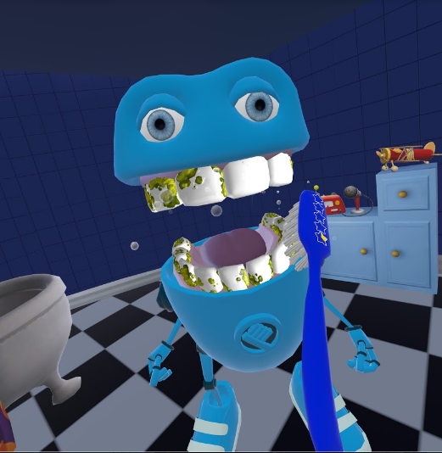 | Screenshot 2  - High Rez  - VirtualReality (3D Stereo)
Game Logo
- High Rez
Company Logo
- High Rez
Brush Up awarded first prize by US Education Department (ED) and Entertainment Software Association (ESA)
From left: Kevin O’Hanlon (ESA), Dov Jacobson and Jesse Jacobson (GamesThatWork), Ed Metz (ED) and children
Photo: Cynthia Cephas
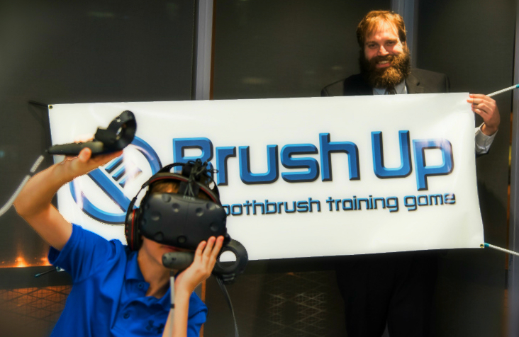
Young Virtual Reality player brushes Budd’s teeth, watched by Jesse Jacobson of GamesThatWork.
Photo: Cynthia Cephas

Contact:
Stephanie Chergi, Producer
Stephanie@GamesThatWork.com
(404)806-5428

###

