Texans show love on their bumper!

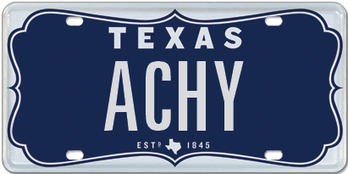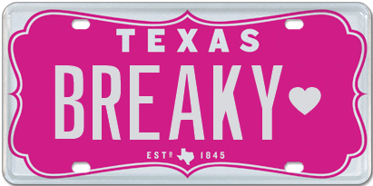

13 February 2017 (Austin, TX) – February is known for being the month of love and with Valentine’s Day just around the corner, many Texans are rushing around placing their last-minute orders for flowers and chocolates for that special person in their lives. Some Texans on the other hand are turning to expressing their love on their bumper and making a more personal statement for all to see.

In fact, the “heart” is the most beloved Texas symbol chosen when ordering personalized plates from My Plates, the official vendor for Texas license plates.

Over the last 12-months, more than 2,600 Texans entered a long-term relationship with the Heart, making it Texas’ favorite symbol! In second spot was the Texas Silhouette with just over 2,000 orders and coming in third was the Star, recording 1,344 orders. There are five symbols/special characters available in Texas, with the Dash and the Period rounding out the selection.

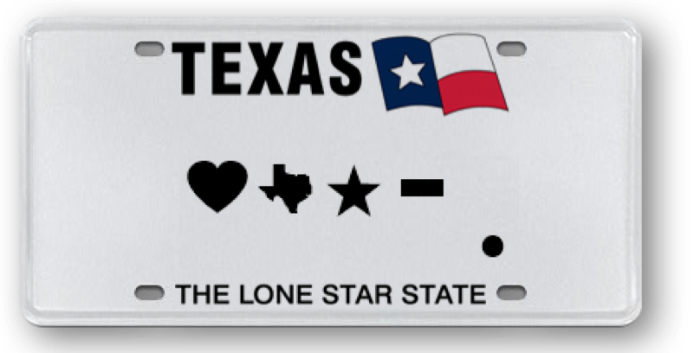

My Plates: 2016 Special Character Use
- Heart symbol 2606
- Texas Silhouette 2008
- Star 1344
- Dash 1151
- Period 399

The way Texans’ showed their hearts on their bumpers, instead of their sleeves, varied in many ways. They declared soulmates, adored family and pets, showed a deep bond with their cars, were head-over-heels for their sport or college, loved their profession, state, country, faith and president and even had a deep crush on their body ink.
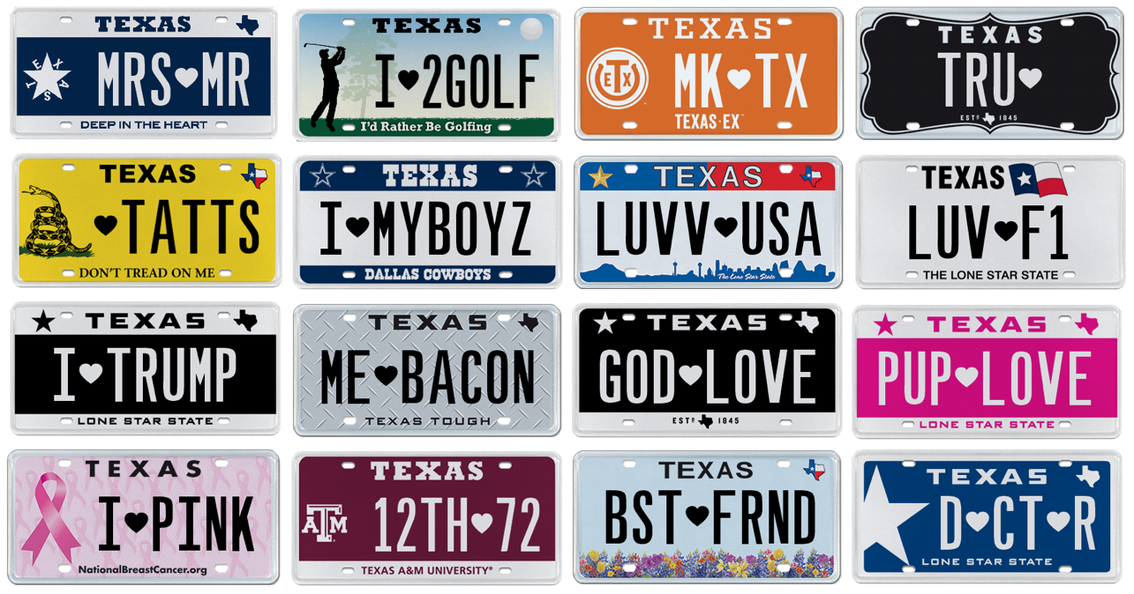

If you want to make a love connection, the heart symbol (and other four special characters) is allowed on all Texas personalized license plates and will take up one full character space. So, if you’d like to put more “heart" and soul on your bumper, Texas has you covered.
____________________________________________________________

My Plates designs and markets new specialty license plates as a vendor for the Texas Department of Motor Vehicles. Texans have bought more than 300,000 My Plates since November 2009, putting more than $48M in the state general revenue fund. My Plates’ goal is to create a long-term, mutually beneficial relationship designed to maximize revenues for the state through the sale of My Plates specialty plates. www.myplates.com.

The Texas Department of Motor Vehicles (TxDMV) serves protects and advances the citizens and industries in the state with quality motor vehicle related services. For every $1 it spends, the TxDMV returns $11 to the state. The agency currently registers 24 million vehicles; issues more than 7 million vehicle titles; licenses more than 38,000 motor vehicle dealers and distributors; credentials nearly 60,000 motor carriers; issues more than 800,000 oversize/overweight permits; investigates more than 15,000 complaints against dealers and motor carriers; and awards grants to law enforcement agencies to reduce vehicle burglaries and thefts. Learn more at www.TxDMV.gov.
____________________________________________________________

Image download:
ACHY plate: https://ce9a9387e1bc258c3cfa-af7906f4e771b24864bbfa3048e4a635.ssl.cf2.rackcdn.com/ACHY.jpg

BREAKY plate: https://ce9a9387e1bc258c3cfa-af7906f4e771b24864bbfa3048e4a635.ssl.cf2.rackcdn.com/BREAKY.jpg

For more information, contact Steve Farrar at (512) 633-7978 or steve@myplates.com

