XENO - The only cable protector and organizer you will ever need. Never fumble with wires again.

XENO is designed specially to protect your charging cables and earphones from frayed broken edge and keep them safe. XENO fits majority of mobile phone charging cables and earphones so they can remain protected from frayed edges. The elastomer band has been thoroughly tested for expansion and contraction for strength, shape and shine. The band returns back to its original shape after use and maintains its shine even after repeated use time and again.

XENO - Never find a tangled earphone again

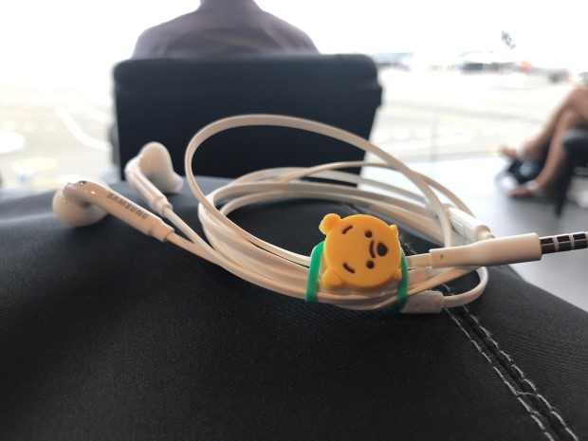

XENO prevents cables from fraying
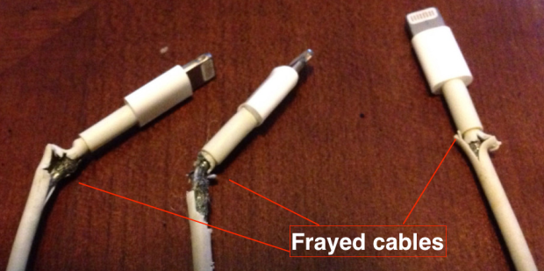
With XENO you will never face frayed cables. XENO attaches to the edge of the cables and prevents them from fraying.
XENO seamlessly organizes your cables and makes them tangle free. No more hassles of sorting out jumbled laptop or phone charging cables and headphones.
Organize Macbook cable with XENO
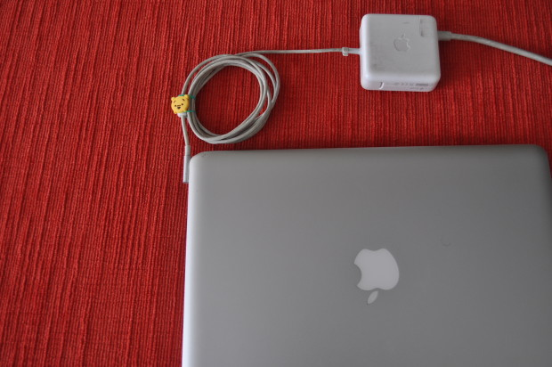

Wrap big headphone cables
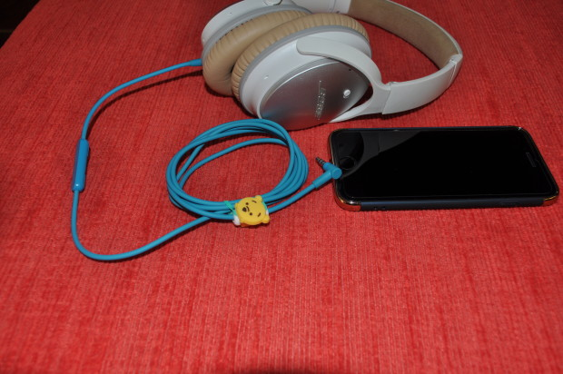

With Xeno you may also wrap long laptop cables to organize it.
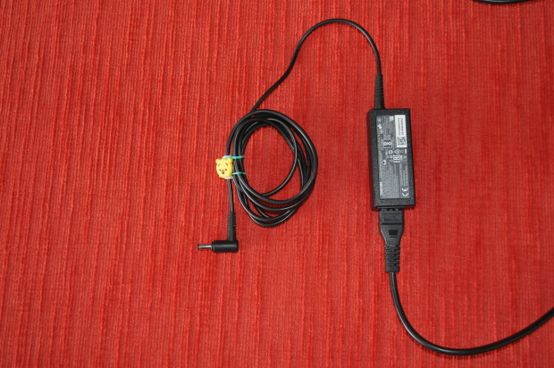
XENO - Adds character to your cables
With XENO, your cables now have an identity and character of their own, look different and unique than other cables out there.
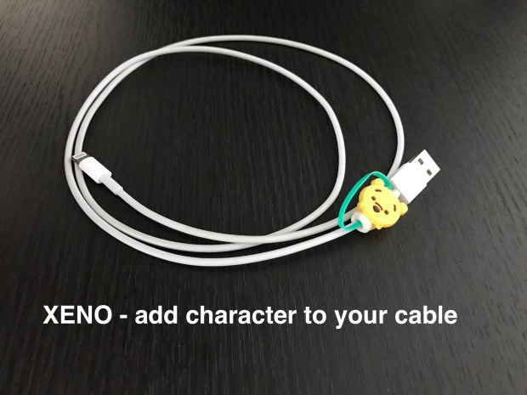

XENO - Matches style
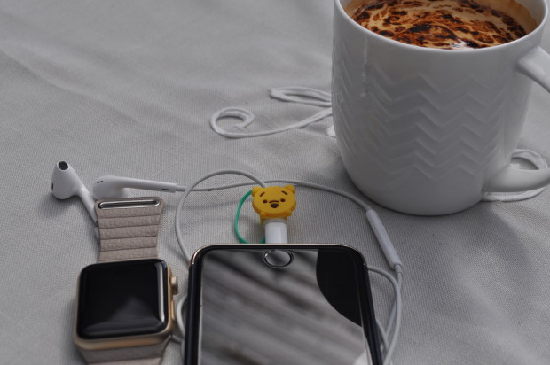

The Working Prototype
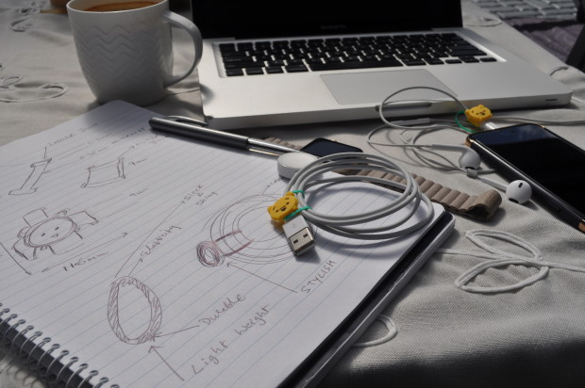
Closeup Looks
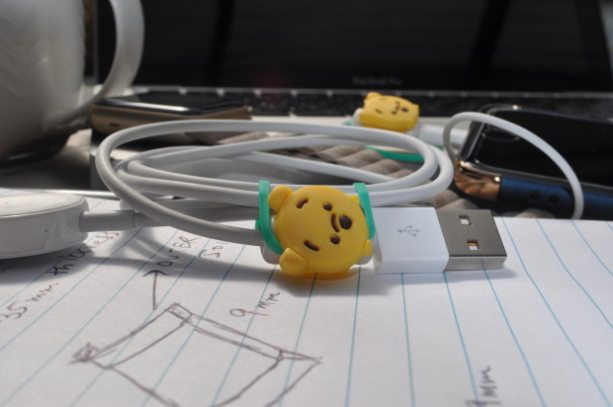
Big headphones like Bose, Sennheiser or Beats have long cables which keep dangling while you put the headphones on. With XENO, its easy to wrap the dangling cables and keep them handy instead of dangling.
XENO is available on Kickstarter as below : https://www.kickstarter.com/projects/2011266461/xeno-cable-protector-and-organizer

Give XENO a try. We are sure you would love it !

Links:
Website Link | http://yupsmart.com/xeno/
Kickstarter Campaign Link | https://www.kickstarter.com/projects/2011266461/xeno-cable-protector-and-organizer
Youtube promo Video | https://youtu.be/9Ndqv4i8Q8Y
Facebook page | https://www.facebook.com/XenoCableProtectorOrganizer/
Google Drive media pack link | https://drive.google.com/drive/folders/0B0E5ECgpIsU4eWMtQmpsZnJwR0k

Website Link | http://yupsmart.com/xeno/
Kickstarter Campaign Link | https://www.kickstarter.com/projects/2011266461/xeno-cable-protector-and-organizer
Youtube promo Video | https://youtu.be/9Ndqv4i8Q8Y
Facebook page | https://www.facebook.com/XenoCableProtectorOrganizer/
Google Drive media pack link | https://drive.google.com/drive/folders/0B0E5ECgpIsU4eWMtQmpsZnJwR0k

