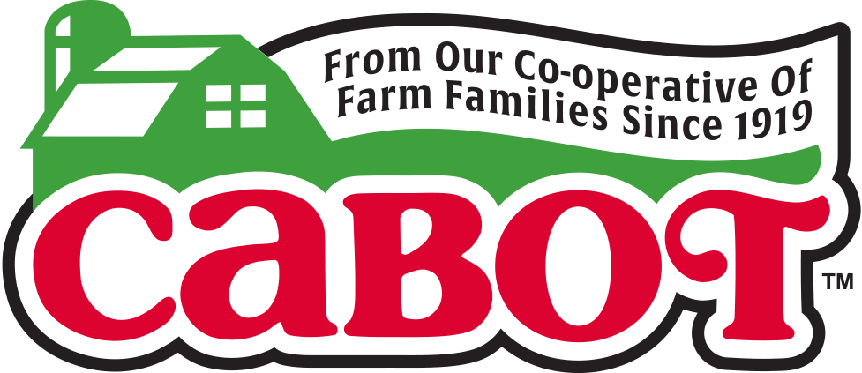

World’s Largest Smoothie

FOR IMMEDIATE RELEASE
Contact: Mary Lou Janson, At The Table PR
Cell: (813) 361-1061
Email: wordmssmith@gmail.com

CABOT CREAMERY CO-OPERATIVE
SETS GUINNESS WORLD RECORDS™
MARK FOR WORLD’S LARGEST SMOOTHIE

The 1,000 Gallon Drink Eclipsed The Former
GUINNESS WORLD RECORDS Title By Nearly 200 Gallons to Benefit
United Food Bank of Plant City & Feeding Tampa Bay

Plant City, FL (March 7, 2017) — In an effort that was part ballet and part organized chaos, a team of more than 100 employees and volunteers from Cabot Creamery Co-operative, United Food Bank of Plant City, Feeding Tampa Bay and United Way Suncoast, came together at the 82nd Annual Florida Strawberry Festival this past Friday to recapture the GUINNESS WORLD RECORDS title for the world’s Largest smoothie. A little more than seven hours later, the team created a behemoth 1,000-gallon smoothie, eclipsing the former record of 824.7 gallons, held by McGill University of Toronto, Canada.

Once completed, the team quickly began selling the massive Smoothie to festival attendees for a suggested donation of one dollar or more, for a serving of the delicious creation in a Cabot keepsake cup. One hundred percent of the donations benefitted the two food banks. All remaining leftovers were filled and shipped to Feeding Tampa Bay in hundreds of specialized 2.5-gallon food grade containers donated by CKS Packaging. Cabot’s record attempt enabled the company to raise and contribute nearly $10,000 in cash and product to the food banks, and the remaining Smoothie product will help feed thousands of people in need throughout Central Florida. In addition to the money raised through the sale of the Smoothie at the event, Cabot also donated more than 500 pounds of Cabot Seriously Sharp Cheddar and Cabot Alpine Cheddar to the food banks.

The Cabot Smoothie prep team created the healthy and delicious Smoothie using more than 250 gallons of Cabot Vanilla Bean Greek Yogurt, ceremoniously representing more than 1,100 two-pound tubs of Cabot Greek Yogurt for every one of Cabot’s 1,100 farm families; 2,000 pounds of fresh Florida strawberries; 3,375 pounds of ice and 265 pounds of Cabot Whey protein powder.

The Cabot Smoothie Team previously set the GUINNESS WORLD RECORDS mark of more than 400 US gallons of smoothie on Friday, May 3, 2013 at the Bike Expo New York event held at Pier 36 in Basketball City in New York City.

“Our farmers are happy to recapture the GUINNESS WORLD RECORDS title for the world’s Largest Smoothie to benefit United Food Bank of Plant City and Feeding Tampa Bay,” said Roberta MacDonald, Senior Vice President of Marketing for Cabot Creamery Co-operative. “The 1,100 farm families who own Cabot Creamery are dedicated to supporting communities where we sell our dairy products, and funding and undertaking this colossal effort to raise money for United Food Bank of Plant City and Feeding Tampa Bay is one of the many ways our farm families give back to those in need.”

"We are grateful to be the recipient for this record-breaking event with our partners at Cabot,” said Thomas Mantz, Executive Director of Feeding Tampa Bay. “The enormity of this record reminds us of the enormity of the hunger issue in our community, with 700,000 of our neighbors not having stable access to food. The fresh and healthy ingredients used in this smoothie are perfectly aligned with Feeding Tampa Bay’s goal to deliver more fresh, nutritious foods to those in need every year,”

Cabot’s famous Greek Yogurt took home top honors as “Best In Class” in the competition’s first-ever High-Protein Dairy category at the 2016 World Championship Cheese contest in Madison, WI. Available in convenient two-pound tubs, Cabot Greek Yogurt can be used for baking, and Cabot Plain Greek Yogurt makes a great substitute for sour cream or cream, or as a base for dips and sauces.

The record-setting Smoothie was made using two human-powered Vitamix bicycle blenders, as well as four commercial and eight residential Vitamix blenders, and continuously poured into a 1,000 gallon food-grade holding vessel packed in ice.

ABOUT CABOT CREAMERY CO-OPERATIVE: Cabot Creamery Co-operative has been in continuous operation in Vermont since 1919 and makes a full line of cheeses, yogurt, sour cream, cottage cheese and butter. Best known as makers of “The World’s Best Cheddar and The World’s Best Lowfat Cheddar,” Cabot is owned by 1100 dairy farm families located throughout New England and Upstate New York. For additional information on Cabot Creamery Co-operative, please visit http://www.cabotcheese.coop
ABOUT THE FLORIDA STRAWBERRY FESTIVAL: The Florida Strawberry Festival is an 11-day community event celebrating the strawberry harvest of Eastern Hillsborough County. Each year, nearly 600,000 visitors enjoy the festival’s headline entertainment, youth livestock shows, exhibits of commerce and, of course, its strawberry shortcake. The 2017 Florida Strawberry Festival where “We’re Playing Your Song!” takes place March 2-12 in Plant City, Fla. For more information, visit www.flstrawberryfestival.com.
###

