Press Release Contacts: For Immediate Release Vinitaly International
International Media Dept.
+39 045 8101447
media@vinitalytour.com
www.vinitalytour.com
Twitter: @VinitalyTour
Join Vinitaly International Network on LinkedIn

Vinitaly International Academy partners with China’s leading liquor supplier 1919 to foster new opportunities for Italian wine in China

CHENGDU, 14 March 2017

A new chapter opens up for Italian wine in China, in the same city where Vinitaly International invested four years ago. Chengdu will be again the focus of the Italian wine rebirth as the Chengdu metropolis is where 1919, the giant of O2O liquor distributor, is headquartered. After the newly-signed agreement finalized on March 10th, 2017, the Chinese business colossus has become educational partner of Vinitaly International Academy—the Academy launched by Stevie Kim and its scientific director Ian D’Agata in 2014 that now has 55 Italian Wine Ambassadors and 6 Italian Wine Experts worldwide.

On the agreement, the general manager of 1919’s purchasing subsidiary, “Shanghai 1919 Global procurement CO., LTD”, Andrew Tan comments: “We chose Vinitaly International as our partner as they are the leaders of Italian wine in China. I can tell Vinitaly is always looking for innovative and useful tools to foster b2b connections. They were the first to set up the Italian wine pavilion during the ‘International Wine and Spirits Show’ in Chengdu. This partnership with 1919 and the fabulous Gala Dinner with Italian wine producers celebrate Vinitaly’s long-lasting commitment to Chengdu and we are looking forward to what future collaborations will bring.”

The 1919 O2O platform numbers over 1,000 physical stores in 500 cities in China, being present also in every Chinese province. The 1919 is the largest O2O open platform for wine and spirits and the third biggest liquor open platform next to Tmall and JD, attracting more than 1500 well-known brands (e.g Maotai, Wuliangye, Luzhou Laojiao and Penfolds) to join. In November 2015, 1919 announced its strategic merger with GJW.com. On the Singles’ Day 2015 (also known as Double 11), the sales volume of 1919 was 157million, ranking it first in the industry. In 2016, Double 11,1919 won the first line of liquor sales, with overall sales of 451 million.

The focus of the agreement between Vinitaly International and 1919, this time, is on the most innovative ways of distribution, relying on traditional distribution, on online distribution, and on distribution through App. At the core of it, are also over 100 distributors orbiting around 1919 that will meet Italian wine producers and importers to exhibit in Chengdu from 19 to 22 March during Vinitaly Chengdu.

To celebrate this new partnership, Vinitaly Chengdu’s fourth edition will include a fabulous Gala Dinner as one of the most important events of this year’s edition. On March 20th in the evening, Vinitaly International Academy and 1919 will join forces at the elegant Intercontinental Hotel in Chengdu. The guests of honor for this fabulous event will be Italian wine producers and Chinese importers. The dinner will feature specialty Chinese food — Chengdu being one of the food capitals of China and the second most visited city by Chinese food and wine tourists according to the latest study by e-booking travel agency C-trip.

Chengdu is also the capital of the Sichuan province and is mentioned several times in Marco Polo’s travel book Il Milione (The Milllion). At the dinner, 40 producers and 100 distributors will seat together divided up in 20 tables with ten people per table. At every table, two Italian wine producers will showcase their wines to the Chinese distributors. This dinner will be the perfect occasion to combine the excellence of Italian wine with that of Chinese cuisine.

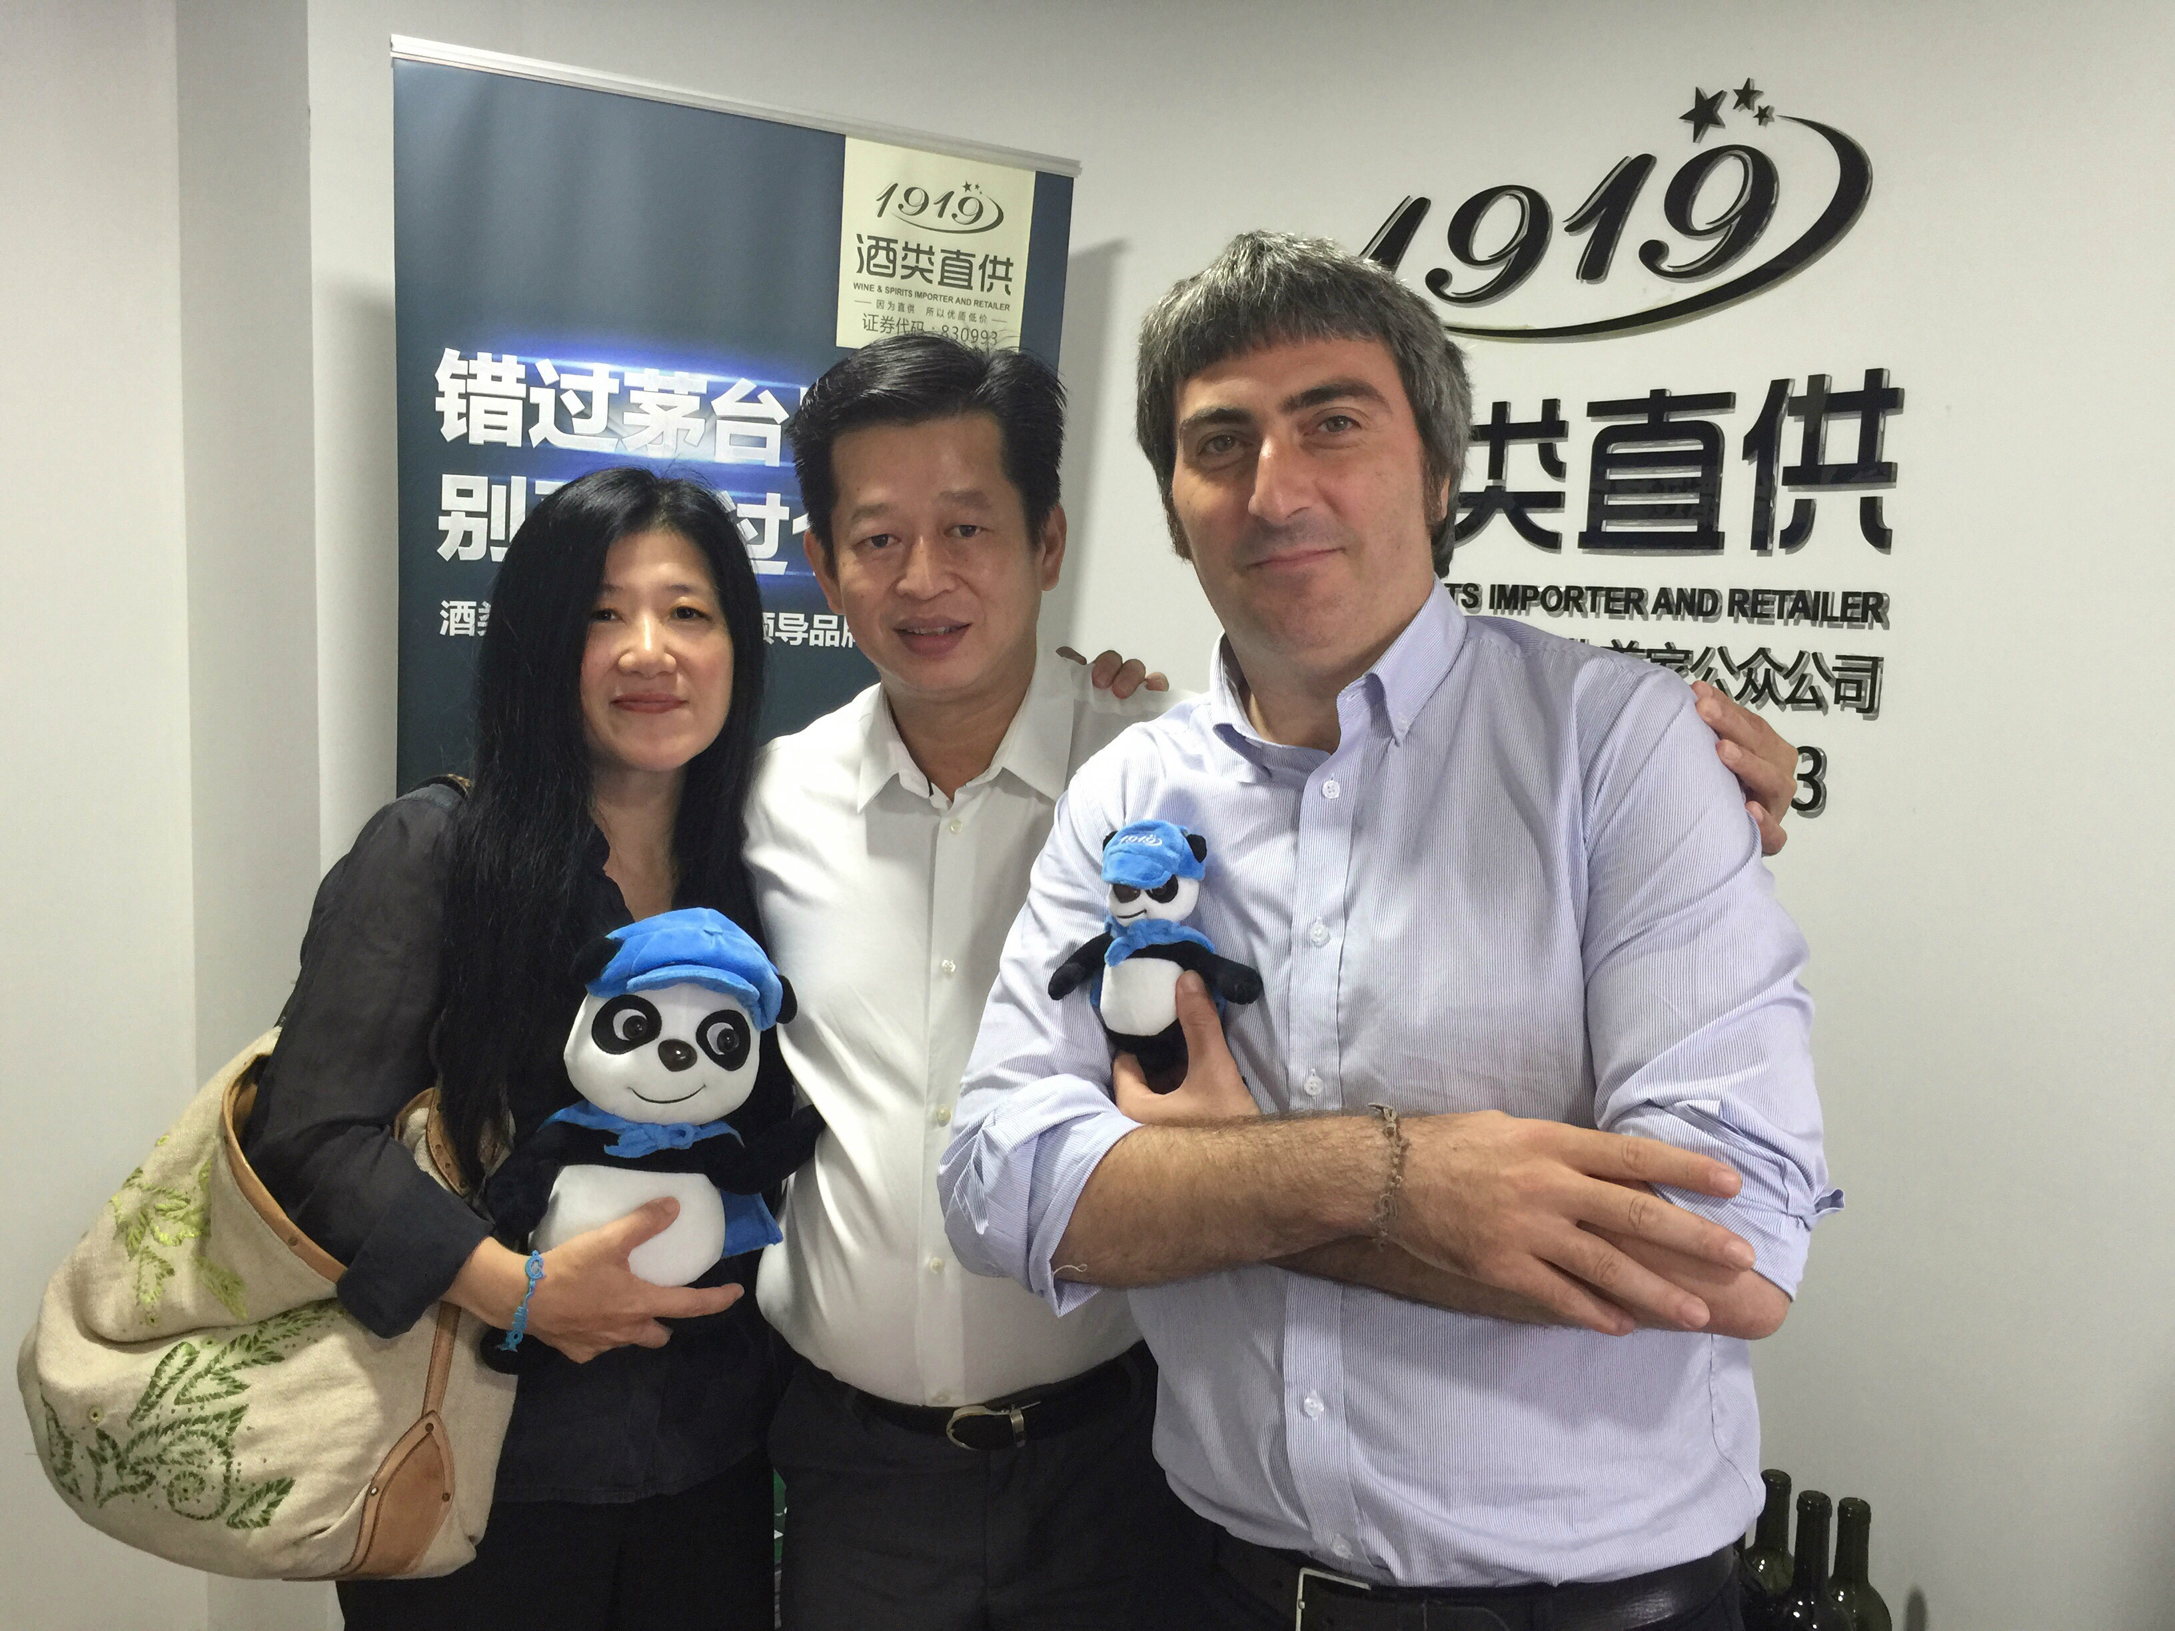
Stevie Kim, Vinitaly International’s managing director states: “This isn’t the first time 1919 has appeared on our agenda. Andrew Tan, Managing Director of Shanghai 1919 Global procurement CO., LTD, highlighted the importance of an effective logistics system in the successful on-line/off-line business, 1919 at our Vinitaly showcase wine2wine Asia last year. At the time, Mr Tan revealed that an average of just 60 square meters of retail space with 600-700 wine labels, 1919 can deliver a bottle of wine, chilled, within 19 minutes in 500 cities throughout China. Today, they are present with over 1,000 stores, in 500 cities distributed throughout all provinces. The projected growth for 1919 is exponential and 1919 seems to be a solid choice for us to extend the knowledge of Italian Wine through our Vinitaly International Academy and we are honoured.”

Vinitaly Chengdu will take place for the second year in the Shangri-la Hotel with a more numerous representation compared to 2014. In that year, Vinitaly International had made its way back to China to attend Tangjuhui, the most important week for wine and spirits distribution in China, in an event that took place in the Kempinski Hotel, the temple of wine distribution and import in China. Last year together with partners Shenzhen Pacco Cultural Communication who devised the Kempinski Hotel showcase, Vinitaly International decided to open up a new chapter at the Shangri-La Hotel for four days of B2B quality events with fine wines and wine education.

This year three Vinitaly International Academy seminars will take place, starting from the inauguration, a masterclass dedicated to wines such as Brunello and Amarone with Vinitaly International Academy’s Italian Wine Expert Jinglin Zhang.

Vinitaly International is committed to put education at the center, and the b2b aspect at the service of Italian wine to help it find a main role in a difficult market.

The agreement between Vinitaly International and 1919, the Chinese leaders in distribution, signed on March 10th marks the beginning of future collaborations. Retracing Marco Polo’s Silk Road, 1919 will also be present beside Vinitaly International in Verona on April 8th for OperaWine and a special session dedicated at Vinitaly on the 10th of April. The collaboration will continue also in May in China.

CAPTION: Left to right: Vinitaly International Managing Director Stevie Kim, Managing Director of Shanghai 1919 Global procurement CO., LTD Andrew Tan and Vinitaly International Shanghai Bureau Chief Simone Incontro at 1919 Shanghai Office.

About:

Veronafiere is the leading organizer of trade shows in Italy including Vinitaly (www.vinitaly.com), the largest wine and spirits fair in the world. During its 50th edition Vinitaly counted more than 4,100 exhibitors on a 100,000+ square meter area and 130,000 visitors from 140 different countries. The next edition of the fair will take place on 9 - 12 April 2017. The premier event to Vinitaly, OperaWine (www.operawine.it) “Finest Italian Wines: 100 Great Producers,” will unite international wine professionals on April 8th in the heart of Verona, offering them the unique opportunity to discover and taste the wines of the 100 Best Italian Producers, as selected by Wine Spectator. Since 1998 Vinitaly International travels to several countries such as Russia, China, USA and Hong Kong thanks to its strategic arm abroad, Vinitaly International. In February 2014 Vinitaly International launched an educational project, the Vinitaly International Academy (VIA) with the aim of divulging and broadcasting the excellence and diversity of Italian wine around the globe. VIA this year launched the second edition of its Certification Course and today counts 55 Italian Wine Ambassadors and 6 Italian Wine Experts.

