Press Release Contacts:
For Immediate Release Vinitaly International
International Media Dept.
+39 045 8101447
media@vinitalytour.com
www.vinitalytour.com
Twitter: @VinitalyTour
Join Vinitaly International Network on LinkedIn

Vinitaly International Academy hosts a unique vertical tasting of Austrian wines

During Vinitaly, the second day of the Vinitaly International Academy seminars introduces wine professionals to one of the most long-standing grapes of Austria, the Riesling of Heiligenstein, and to one of its foremost producers, the Weingut Bründlmayer situated approximately 70 km north-west of Vienna. The seminar entitled “A 21-year journey with the Austrian Riesling of Heiligenstein and the Weingut Bründlmayer” is a vertical tasting which will take place on Monday 10 April at 10am in the new Vinitaly International multifunctional space wine2digital, in the PalaExpo of Veronafiere.
The VIA seminar, convened by Weingut Bründlmayer general manager and MW Andreas Wickhoff and by VIA Scientific Director Ian D’Agata, feature a sampling of the Riesling of Heiligenstein across 8 vintages from 1994 to 2015. This fascinating vertical tasting will cover specifically the 1994, 1995, 1998, 2003, 2008, 2010, 2014, and 2015 vintages, allowing seminar attendees to experience the evolution of flavor in one of the most distinctive white grape varieties that gives birth to wines with a great aging potential. The seminar will be a unique event in its kind, being the first vertical tasting of Heiligenstein to be held at such scale in Italy. Wickhoff, who is also the third Master of Wine for Austria, explains: “We only make these special Heiligenstein verticals once in a while since the stocks from the older vintages come from the family reserve, stocked in a 700-year old ‘Vinothek’ in the winery. A clear focus on one vineyard, in this case the most famous and historic vineyard site in the Kamptal and certainly among the top 3 terroirs for Austrian Riesling, makes this tasting also unique. I look forward to the diversity of the vintages but also the homogeneity of the vineyard character sites and most importantly, of holding such a tasting of Heiligenstein at this capacity for the very first time in Italy. I am anxious to get some feedback from the participants about the wines!”
It is the great geologic diversity of notable cru like the Heiligenstein, the Steinmassel, and the Berg-Vogelsang to contribute to a number of wines which age incredibly well. On the Heiligenstein, Wickhoff states: “There are many very unique components to the Heiligenstein (aspect, overall topography, history, biodiversity….) but probably the one which stands out is the truly unique soil type of the Zöbinger Heiligenstein which is called Zöbinger Perm, a volcanic desert sandstone which dates back to the Perm period–270-250 million years of age–lending the wines from this cru a particular smokiness and spiciness.” D’Agata further explains: “One of Austria's two or three best wine domaines, a master of Gruner Veltliner and Riesling but of other varieties as well, we are especially lucky to be able to sit through and taste a vertical of Rieslings from the famous Heiligenstein site, which will show just how great Austrian Riesling wines can be in their complex minerality, savory texture and floral personalities.”

Austria is generally renowned for the grandeur of its alpine landscape, for Vienna’s buzzing coffee houses, opera houses and classical music scene. However, recently rising to international acclaim is also Austrian wine. Often deemed as “the Austrian wine wonder,” Austrian wines have been celebrated by wine journalists and experts due to their superb quality and their thousand-year-old relationship with the territory. The Bründlmayer Winery is a prime example of the growing success experienced by Austrian wine producers on the international market. Located in Langenlois in the Lower Austrian Kamp Valley upstream along the “Blue Danube,” the Weingut Bründlmayer is considered one of the two or three best wineries in Austria. It has proven to be a benchmark for fine Grüner Veltliner and Riesling from the Kamptal over the past decades. Willi Bründlmayer has been awarded important domestic and international recognitions testifying to the high quality of their wines, which are prized in numerous guide books and sought-after by collectors all over the world. Wickhoff notes: “At Bründlmayer, the orchestration of great wines is aspired to be in the most diverse instrumental constellations. The simple varietal wines deliver crystal-clear interpretations of the grape and its origin. The interplay of soil with the fruit of the grape is the focal point of the classic single vineyard ‘Erste Lagen’ wines. And the complex reserves from the famous vineyards resound with all the resources of the terroir in the most profuse sense of the word.”

The seminar on the Riesling of Heiligenstein and the Bründlmayer winery on Monday 10 April at wine2digital aligns with VIA’s educational priorities, which include not only the promotion of Italian wine at home and abroad, but also the training and education of specialists about prestigious international wines.

About:

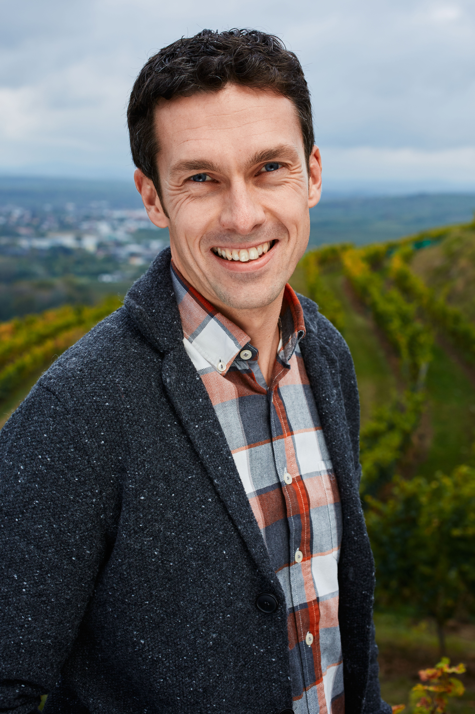
Veronafiere is the leading organizer of trade shows in Italy including Vinitaly (www.vinitaly.com), the largest wine and spirits fair in the world. During its 50th edition Vinitaly counted more than 4,100 exhibitors on a 100,000+ square meter area and 130,000 visitors from 140 different countries. The next edition of the fair will take place on 9 - 12 April 2017. The premier event to Vinitaly, OperaWine (www.operawine.it) “Finest Italian Wines: 100 Great Producers,” will unite international wine professionals on April 8th in the heart of Verona, offering them the unique opportunity to discover and taste the wines of the 100 Best Italian Producers, as selected by Wine Spectator. Since 1998 Vinitaly International travels to several countries such as Russia, China, USA and Hong Kong thanks to its strategic arm abroad, Vinitaly International. In February 2014 Vinitaly International launched an educational project, the Vinitaly International Academy (VIA) with the aim of divulging and broadcasting the excellence and diversity of Italian wine around the globe. VIA this year launched the second edition of its Certification Course and today counts 55 Italian Wine Ambassadors and 6 Italian Wine Experts.

