For Immediate Release
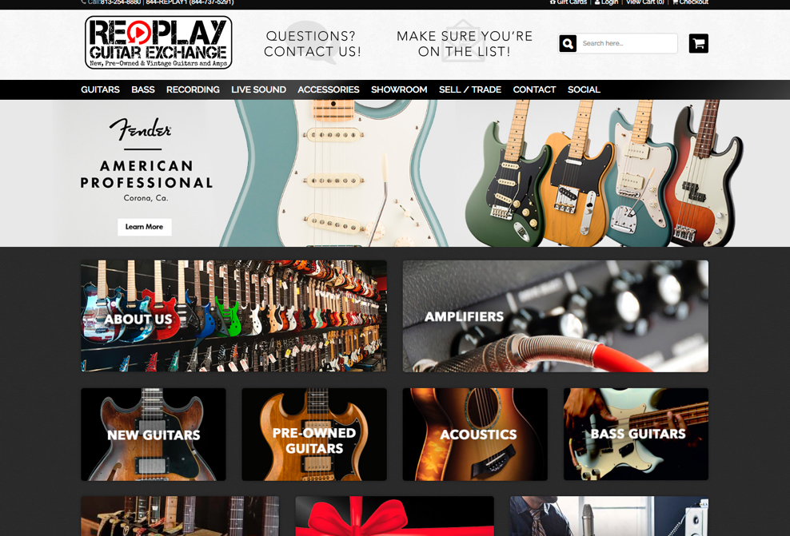
New Guitar-Centric
Retailer Launches
Ecommerce
Division.
Replay Guitar Exchange offers New, Pre-Owned, and Vintage products on-line.

March 27, 2017, Tampa,

A new independent musical instrument retailer, Replay Guitar Exchange, based in Tampa, FL, and focusing primarily on guitars, launches www.replayguitar.com. The full service website offers customers a comprehensive array of guitars, amps, and related accessories from many major brands and boutique outfits.

Marketing Director John Palumbo, a guitarist himself, says, ”Our main focus is always going to be the guitarists’ buying experience. Our staff is comprised of some of the most knowledgeable and respected industry professionals in the U.S.; all players, from many different genres. We wanted to ensure that our customers get the absolute best gear at the best prices, and enjoy a shopping experience that big-box stores can’t compete with.”

Offering quality pre-owned guitars, in addition to new products, the website is geared to find that special hard-to-get piece or staple item, for aficionados, working musicians, or hobbyists alike. Added customer service features like live chat, and the ability to submit for a trade through the web portal, are part of the on-going site upgrades.

Expansion is including vintage guitars. The expert staff has hand-picked highly collectible guitars of the highest quality and provenance, and will make them available for purchase online.

About Replay Guitar Exchange
Replay Guitar Exchange is an independently owned and operated guitar store in South Tampa offering new, pre-owned and vintage guitars, amplifiers, and related pro-audio gear. Instruments are accepted daily for cash or upgrades. Also offered are acoustic guitar, electric guitar, electric bass guitar, keyboard and drum lessons to students of all ages. Their full-service repair shop can handle any type of adjustment or repair. Replay carries all of the top guitar, amp, and audio brands such as Fender, Gibson, Martin, Taylor, Marshall, Vox, Dr. Z, Supro, Mackie, Behringer, Turbo-Sound, Shure, and many more. For more information on our showroom, events/clinics, new guitars, used guitars, vintage guitars, guitar amps, guitar effects, or guitar accessories, visit: www.ReplayGuitar.com

Key contact:
Kyle Bailey, President & Owner
Replay Guitar Exchange
3944 Britton Plaza
Tampa, FL 33611
kyle@replayguitar.com
813-254-8880
www.ReplayGuitar.com
Facebook

Media contact:
John Palumbo – Marketing & Creative Director/Industry Relations
john@replayguitar.com
813-284-6315

