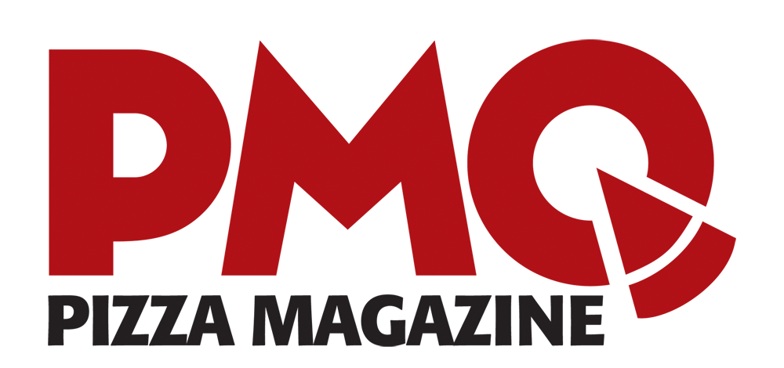

FOR IMMEDIATE RELEASE
Heather Wilson May 19, 2017
(662) 234-5481 ext. 137
Heather@pmq.com

U.S. Pizza Team’s Dan Uccello Captures Top American Honors
at the 2017 World Pizza Championship in Parma, Italy
Former Lamborghini model Ali Haider of Los Angeles also emerges as a champion in the global competition, while a Chinese pizza acrobat makes history for his country.
Parma, Italy, May 18, 2017 — The U.S. Pizza Team, sponsored by PMQ Pizza Magazine, returned home with multiple awards from the 2017 World Pizza Championship, held May 8-10 in Parma, Italy.
USPT rookie Dan Uccello, owner of Flo’s Pizzeria in Grand Rapids, Mich., won 1st Place USA, meaning he outscored all other individual American competitors this year. He earned 744 points in the Classic category and 865 points with partner Alex Garcia, the manager at Flo’s Pizzeria, in the Pizza for Two competition. Uccello was also promoted to a “black coat” chef by the U.S. Pizza Team.
Earning top American honors “was totally unexpected,” Uccello said. “There was a lot of good competition out here, so I’m just very thankful. I love this team, so I’m really, really happy to represent them.”
Ali Haider, owner of 786 Degrees in Los Angeles and a former Lamborghini model, won 1st Place India. Although a member of the American team, Haider was also categorized under WPC rules as an Indian competitor because he grew up in that country. Born in Kuwait, Ali is the first Muslim USPT member. 786 Degrees is an all-halal Neapolitan-style pizzeria. “My approach to pizza is inspired by my heritage, but updated to bridge taste trends across the globe,” Haider said.
Tusheng Huang of Shanghai made history as the first competitor from China to win in a category at the WPC. Co-sponsored by PMQ China, Huang won first place in Freestyle Acrobatics. This gives PMQ back-to-back gold medals in the Freestyle Acrobatics category after USPT member Jamie Culliton of St. Petersburg, Fla., won the competition last year.

About the U.S. Pizza Team
Celebrating its 20th anniversary this year, PMQ Pizza Magazine, the world’s authority on pizza, created the U.S. Pizza Team in 2000. The team is sponsored by Grain Craft, California Milk Advisory Board, Gordon Food Service, Sofo Foods, LaNova, Paradise Tomato Kitchens, American Baking Systems, Bag Solutions, Fontanini Meats, Lillsun, Marsal and Sons, Univex, Presto Foods, Pivetti and Lloyd Pans.
For more information about the team, events, pictures or video, contact Heather Wilson, Digital Media Specialist, via email at heather@pmq.com, or Brian Hernandez, USPT Coordinator at 662-234-5481 x129 or by email brian@pmq.com

