Texas license plates celebrate 100 years!
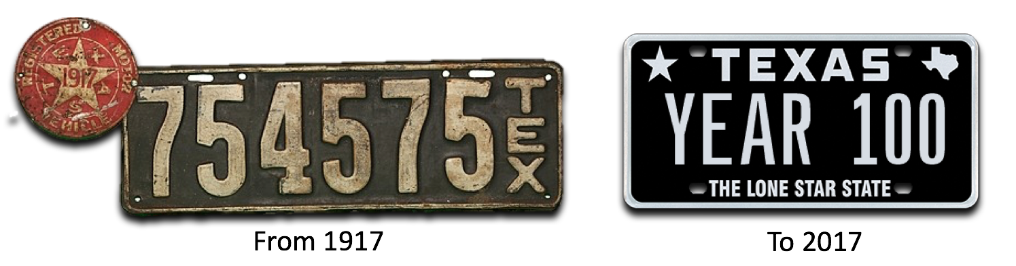
(Austin, TX) July 5th, 2017 – Rewind one hundred years to 1917, a time when horses and buggies were still visible on streets and farms in Texas and the modern era had not completely arrived. This was the year Texas began issuing the first official license plates on July 1st, 1917. Back then, it was the State Highway Department who was responsible, now one hundred years later, it is the Texas Department of Motor Vehicles.

In the early days, license plates were issued to register “horseless carriages”. Registration fees were collected to help fund desperately needed highway improvements to transform quiet country lanes and dusty cattle paths into modern thoroughfares to accommodate the increase in motor vehicle traffic.
The first plates issued were made of sheet iron with white numbers on a dark blue background. The numbers were embossed on the iron plates. Down the right-hand side, each depicted a vertically placed “TEX” abbreviation. These first plates were manufactured by the Adams Stamp and Stationary Company of St. Louis, Missouri.
In past years, just like today, Texas license plates serve two basic purposes. The plates identify the vehicle and the owner, and provide proof that the owner has paid registration fees for the privilege of using the State’s roadways.
Records show that around 300,000 pairs were initially made, measuring 5-7/16" x 16" a little longer in comparison to today’s 6” x 12” size. To validate the license plates in 1917, the department issued round “white on red radiator seals”, essentially these were the first ever “registration” stickers. These first seals included the Lone Star emblem with the year printed within the star. By the end of 1917, there were a total of 194,720 vehicles registered.
In subsequent years, the same 1917 base license plate design was used through 1922, revalidated each year by a round (17-19) or rectangular (20-22) “radiator seal”. Each year, the color of the seal changed, from blue on white in 1918, to white on blue in 1919 and so on to distinguish between the years.
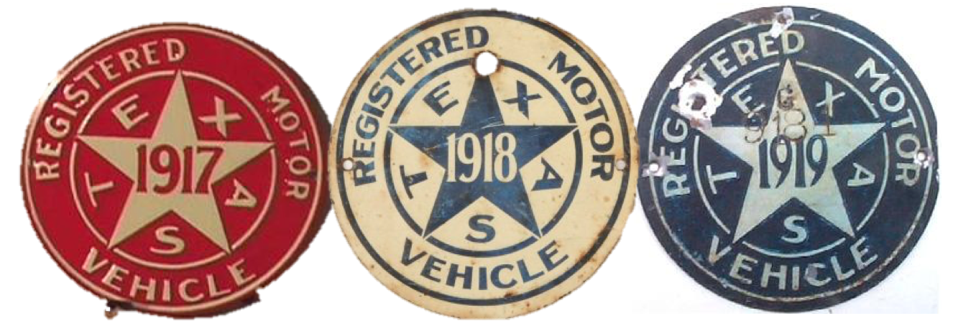

The year 1925 brought the first Texas license plate bearing the year of issuance. The embossing of the issuance year on license plates would continue up until 1976.

Other key milestone dates:
- 1931: First license plates in Texas that included both numerical and alpha characters.
- 1932: Plate dimensions were reduced to 5” x 13”.
- 1936: To honor the 100th birthday of Texas, plates were manufactured with the word Centennial printed on them.
- 1941: As part of the war effort, citizens were encouraged to hand in their license plates due to a metal shortage. As a result, much smaller license plates were produced for many years.
- 1956: The American Association of Motor Vehicle Administrators established a uniform national policy for a 6” x 12” sized license plate.
- 1965: Texans were now able to “personalize” their Texas license plates.
- 1976: The design of the plate changed to display a registration validation sticker. These stickers would be issued each year at renewal time.
- 1987: The slogan “The Lone Star State” was added to the plate design bringing favorable recognition to Texas.
- 1991: Introduction of a broader range of Specialty license plates that continued to grow over subsequent years.
- 2009: The first digitally printed, general issue license plate featuring a seven-character plate number was launched.
- 2009: Current My Plates.com program launched, featuring full color background specialty license plates.
- 2011: My Plates releases the first 7-letter personalized plates via auction.
- 2013: My Plates auctions 12THMAN for a record $115,000.
- 2016: My Plates releases the “Classic Black” plate, a full black background design featuring white characters, reflecting an era of the 1960’s.

Today there are approximately 24 million vehicles registered in Texas compared to the 194,000 in 1917. Texas has certainly grown over the past 100 years and to celebrate, My Plates is offering up to a $100 rebate on the purchase of a new My Plates design by using promotion code TEX100. My Plates has set up a special landing page for the offer that can be found at: http://myplates.com/tex100.
____________________________________________________________

My Plates designs and markets new specialty license plates as a vendor for the Texas Department of Motor Vehicles. Texans have bought more than 300,000 My Plates since November 2009, putting more than $52M in the state general revenue fund. My Plates’ goal is to create a long-term, mutually beneficial relationship designed to maximize revenues for the state through the sale of My Plates specialty plates. www.myplates.com.

The Texas Department of Motor Vehicles (TxDMV) serves protects and advances the citizens and industries in the state with quality motor vehicle related services. For every $1 it spends, the TxDMV returns $11 to the state. The agency currently registers 24 million vehicles; issues more than 7 million vehicle titles; licenses more than 38,000 motor vehicle dealers and distributors; credentials nearly 60,000 motor carriers; issues more than 800,000 oversize/overweight permits; investigates more than 15,000 complaints against dealers and motor carriers; and awards grants to law enforcement agencies to reduce vehicle burglaries and thefts. Learn more at www.TxDMV.gov.
____________________________________________________________

For more information, contact Steve Farrar at (512) 633-7978 or steve@myplates.com

Sources:
TxDMV: The History of Texas Licesne Plates – 80th Anniversary Edition
ftp://ftp.dot.state.tx.us/pub/txdot-info/vtr/plate_history.pdf

The Bolt Hole: http://www.thebolthole.com/texas/pass/20.html

