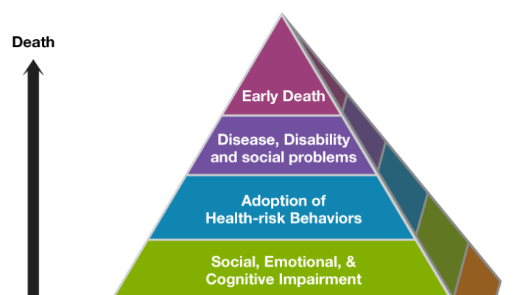

The Most Compelling and Largest Health Study You Never Heard Of
The Adverse Childhood Experiences (ACE) Study is one of the largest and most interesting assessments of health and its relationship to early trauma. Perhaps the most unusual aspect of the ACE Study is how it all began.
Unexpected Results
The Center for Disease Control and Prevention’s Adverse Childhood Experiences Study was developed following nonsensical and frustrating experiences in a San Diego weight loss clinic. Dr. Vincent Felitti began noticing that half of his patients were dropping out of their successful weight loss programs – a dramatic statistic that was both disappointing and difficult to understand. After diving further into these patients’ health histories, Dr. Felitti realized that adverse experiences during childhood were commonplace among dropout patients.
In fact, patients seemed to be dropping out of the weight loss program as a form of self-preservation. It was later found that after experiencing sexual abuse as children, these patients were gaining hundreds of extra pounds, which was basically a subconscious layer of protection against future violations. For these patients, weight control and eating was not the problem, it was their solution – their way to cope. Only after interviewing patients and asking targeted questions did Dr. Felitti truly build connections between present behavior and adverse events during childhood.
This concept would later be applied to the CDC’s study of 17,000 patients – and the resulting data would become known as the ACE Study.
Who is at Risk?
The final findings of the ACE Study indicate that adverse childhood experiences create risk factors for both physical and mental illness later in life. In order to properly identify and treat a mental or physical health condition – it is important to know if an ACE is involved.
The most common examples of ACEs include childhood physical, emotional and sexual abuse. Neglect and maltreatment can also lead to the development of physical or mental health issues in the future. Patients from all social and economic backgrounds seem to share in the ability to suffer later in life following an adverse childhood experience. However, those with inconsistent caregiving early in life are likely most exposed.
Why is the ACE Study Important?
In your role as a School Psychologist understanding adverse events that may have occurred during a student's childhood is critical to understanding how they feel today, not only from a physical health perspective, but also from a mental health perspective. Later in life early childhood trauma and stress, such as the experiences defined in the ACE study, create unique side effects and coping mechanisms, including: high anxiety and stress, inability to form and maintain healthy relationships, a strong sense of shame, substance abuse, fear, anger, bouts of depression, ADHD, and controlling behaviors.
Years after traumatic events occur, people may begin to develop unhealthy coping mechanisms to escape, soothe and comfort their anxious body and mind. People with high ACE scores are typically stuck in flight, fight or freeze response patterns. Therefore, these coping mechanisms are all natural and logical human responses to early childhood trauma. The unconscious brain and body is constantly figuring out how to react to that reality.
Interpret the Results
The higher the total ACE's Score, the more likely someone will suffer from certain conditions as a teenager or adult, including alcoholism, depression, and even heart or liver disease.
What Can I Do About It?
The higher the ACE's score, the higher the likelihood that those early experiences are causing the issues that an individual is now struggling with today. Equipped with this information, it is important to focus on the root cause: healing the underlying trauma. It is also important to seek out professionals that understand the ACE Study and are familiar with interventions that are trauma based and neurobiologically informed, such as: EMDR, Trauma Sensitive Yoga, Brain Spotting, Neurofeedback, and Heart Rate Variability Biofeedback.
Test Yourself Today
Take the test and get your ACE Score here: https://acestoohigh.com/got-your-ace-score/
If you know someone experiencing symptoms such as fear, ADHD, control issues and significant and recurring relationship trouble – it may be time to look back to their childhood for the cause. In fact, everyone should take the mere minutes necessary to perform an ACE test on themselves and their children. Know that things start to get serious around an ACE score of 4.

