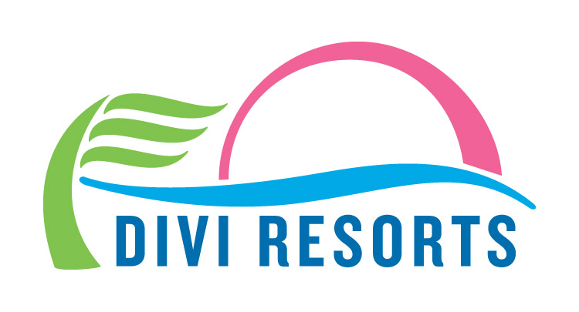

Contact: Alyssa Smith
Phone: (919) 419-2039
Alyssa.smith@diviresorts.com

Divi Resorts Assists Hurricane Irma Relief FEMA Workers in St. Croix
Divi Carina Bay Resort providing housing, meals for 72 Airmen from New Mexico

CHAPEL HILL, N.C., September 15, 2017 – As the Hurricane Irma clean up process begins in The US Virgin Islands, representatives at Divi Carina Bay All-Inclusive Beach Resort & Casino in St. Croix are lending a helping hand by providing housing and meals to relief workers.

Divi Carina Bay and the island of St. Croix escaped Hurricane Irma’s damage mostly unscathed, allowing the resort to reopen for business mere days after the storm. Due to its close proximity to St. Thomas and St. John, St. Croix has quickly become the command center for the recovery process on those islands.

“After Hurricane Irma hit nearby islands, we knew we needed to do our part to help in any way possible,” said Divi Resorts President & COO, Marco Galaverna. “Whether it’s a place to stay or a full belly to start the day, we’re happy to open our doors to these brave men and women, while we continue to host guests.”

Lieutenant Colonel Matt Bartlett, mission commander of the 27th Special Operations Wing force from Cannon Air Force Base in New Mexico, says the outstanding support he’s received from the Resort has been invaluable to his team and their recovery efforts.

“Divi’s help has ensured that our force has adequate rest and nourishment as we aggressively work to help our fellow Americans and neighbors impacted by Irma's devastation,” said Bartlett.

The 72 Airmen on site are assisting those in need by providing capabilities such as search and rescue and personnel recovery, airlift of humanitarian supplies, medical care and aeromedical evacuation - capabilities Bartlett says wouldn’t be possible without Divi’s help and hospitality.

“We would be unable to provide this support if it was not for Divi Resorts and its staff allowing us to get the rest we need to continue to do this work every day that we are here in St. Croix,” Bartlett explained.

Galaverna added that Divi Resorts provides a 20% military discount to all members of the military throughout the year.

"Divi proudly offers one of the largest military discounts in the industry, 365 days a year,” Galaverna said. “Active or retired, and we extend our offer to firefighters and police officers, too."

Divi Carina Bay Resort remains open for business to guests and will be on hand to help as needed while cleanup continues on St. Croix’s sister islands.
About Divi Resorts

Divi Resorts is the vacation expert of the Caribbean, with a collection of eight premium resorts spanning the five stunning Caribbean islands of Aruba, Barbados, Bonaire, St. Croix, and St. Maarten. For more information on Divi Resorts, call 1-800-367-3484 or visit www.diviresorts.com.
###

