Press Release Contacts: For Immediate Release Vinitaly International
International Media Dept.
+39 045 8101447
media@vinitalytour.com
www.vinitalyinternational.com
Twitter: @VinitalyTour
Facebook : @VinitalyInternational
Instagram : @vinitalyinternational
Join Italian Wine Community on LinkedIn

wine2wine is the new go-to wine forum for wine business, and now with an App

With latest market insights and strategic network opportunities for the evolving business in the wine world, the fourth edition of wine2wine will be held at Veronafiere Congress Center on December 4th and 5th, 2017 and, given last year’s turnout of more than 1,500 people is expected to further grow. The 2017 edition showcases an entirely new website (www.wine2wine.net) and a dedicated App (Linkry) where both speakers and attendees will be able to network before, during, and after the event.
The two-day conference wine2wine is the only event in Italy specifically dedicated to the wine business. Italian wine producers, suppliers, international journalists and professionals from all spheres of the wine business will gather for a unique opportunity to participate in educational and thought-provoking discussions, seminars, and workshops—19 different theme tracks in total—with a golden line-up of speakers (https://www.wine2wine.net/relatori/?lang=en). The second edition of wine2wine, the two-day forum on the business of wine organized by Veronafiere in collaboration with the Italian Trade Agency (ICE),

After three consecutive editions in the past, Stevie Kim, Managing Director of Vinitaly International has decided to revamp the format completely. The sessions will predominantly consist of a single speaker with a 20-minute presentation followed by a five-minute Q&A. “The single speakers have been the best performing sessions from the past editions. To truly deep dive into one theme, one voice can really do the job. This year’s speakers will highlight practical ‘takeaways' at the end of each session. We wanted to give all speakers and attendees the opportunity to network as mush as possible, so we translated all into the App, where all content, session details, and contacts linked to one’s Linkedin account can be found, with the aim to carry out an effective and efficient two-day conference” states Kim.

The forum will open with a debate entitled “Media vs. Sales Platform for Millennials: Who matters the most?,” where Adam Teeter, Co-Founder of VinePair, one of the fastest growing media on wine, beer and spirits, and Logan Lee, Co-Founder and CEO of Wine Awesomeness, an exclusive wine membership club will share their respective insights. “In this new digital age, content can be published in a flash, but with so much content available on so many platforms, only truly good content rises to the top and when it does, those that publish it become the new influencers” explains Adam. The seminar will explore the rise of VinePair and the new concepts that Wine Awesomeness brings to the plate in order to explain how wineries can best work with digital publications both from both a PR and a Marketing perspective. Steve Raye, President of Bevology Inc will moderate the session.

In the digital arena, this year the conference welcomes Wine-Searcher, world’s most successful price comparison website for wine, and Vivino, one of the most popular wine communities and the most downloaded mobile wine app. Both will share insights from their database as to how wine consumers are engaging digital technology in their palms. Digital Marketing is more complex than ever, yet offers unrivaled opportunities to build brands. Elia Blei, Managing Director of VICE Media in Italy will reveal best practices on coverage of food and beverages by introducing case studies from Munchies, the world-known media on food. Claire Hennessy, lead account for Italian wines at Colangelo & Partners Public Relations, will sort through tips on if and how to best interact with Wine Influencers on social media platforms in the session “The Top 20 US Wine Influencers You Need to Know”. The digital agency A-Quest, will introduce the how the wine sector can benefit from innovative technologies such as Augmented Reality.

New technologies are a driving force in distribution as well. In the session “From Grape to Glass - demystifying the Blockchain”, award winning wine writer Paul Howard will introduce Blockchain, the new digital technology that has already attracted billions of dollars of venture capital. “While it started out in the finance industry, Blockchain applications are emerging in many other global industries, including wine” explains Howard. The session will use Blockchain examples to verify wine quality, authenticity and safety—from Grape to Glass. Cruz Liljegren, a wine broker and consultant will outline basics and macro trends specifically on Private Label Strategy. Has private label matured into something more than brands? What are the risks and benefits for the producers? "Studies show that brand loyalty is decreasing and that there is a growing consumer acceptance of private label products,” shares Liljegren.

Wine tourism has become an essential element in wine marketing yet it remains as elusive as it did when it came in vogue. Felicity Carter, editor-in-chief for the German-based Meininger Wine Business International magazine looks at how wine tourism is evolving internationally, and how producers at every level can make it part of their business. Legal and financial matters cannot be forgotten as well. Luca Castagnetti from Divino Management will focus on important questions such as “How to develop collaboration strategies and company networks?,” “How to optimize tax burden?,” and “How to attract investments?”, in the session “Efficient company, finance and taxation networks”.

On the market side, this year’s focus is on the next potential market, China, but not only. A great emphasis has been put on emerging markets such as Japan, Denmark, and those up and coming US states in the wine sector (Colorado, South Carolina, Pennsylvania), along with the ever-growing Australian market and the well established monopoly, Canadian market. Gill Gordon Smith, Roddy Ropner, Kevin Gagnon, who are also Vinitaly International Academy certified Italian Wine Ambassadors from all over the world, will share their unique insights and case studies from their local country.

Last but not least, Alison Napjus, Senior Editor and Tasting Director, at Wine Spectator will reveal the 100 Finest Italian wine producers selected by Wine Spectator for the seventh edition of OperaWine 2018, to be held on Saturday, April 14th 2018.

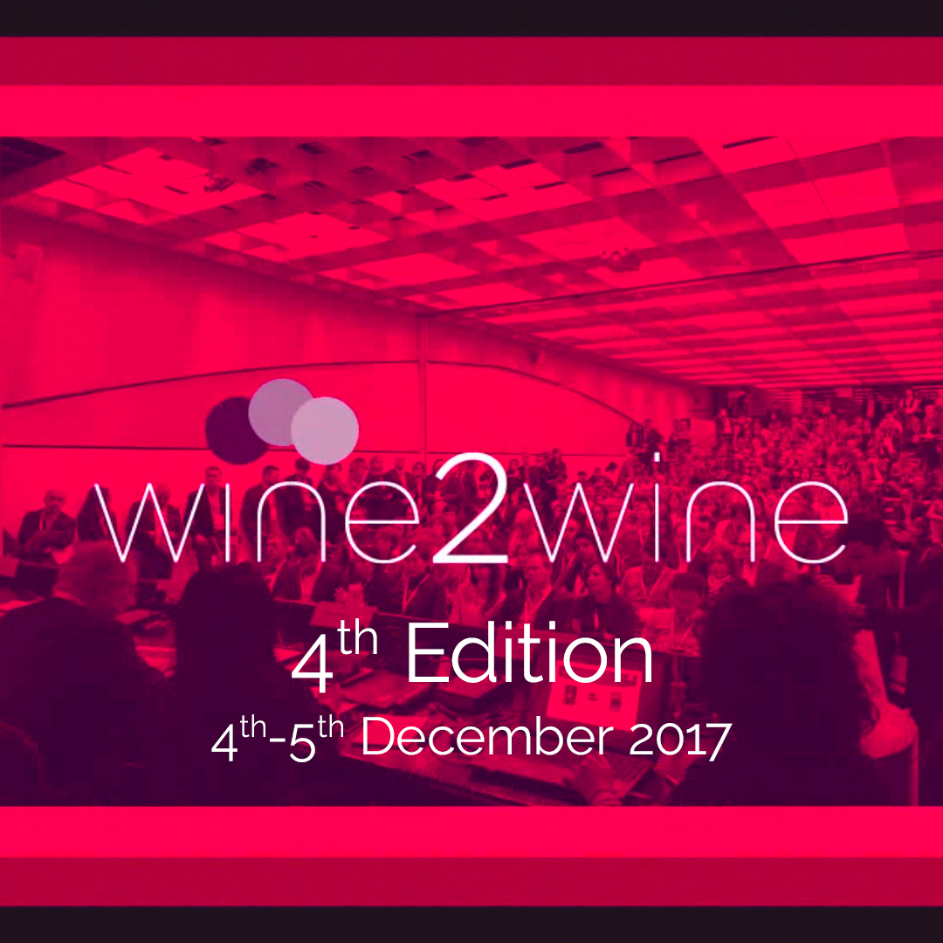
Other theme tracks will also cover the following topics:
- Digital and Social Media Marketing
- Experiential Marketing
- The Emerging Presence of Wine Influencers
- Innovation in Distribution
- Legal and Financial Matters
- Focus on Emerging Markets
- Focus on the Chinese Market
- Focus on the Canadian Market
- Wine Tourism
- New tools and ideas to value wine
- Women of the Vine & Spirits focused track
The entire wine2wine program can be found online at www.wine2wine.net/agenda/

On December 3rd, one day prior to the event there will be an exclusive Tasting Panel organized by Vinitaly International Academy (VIA) under the direction of its Scientific Director, the internationally renowned wine critic Dr. Ian D’Agata. The tasting will be open to a restricted number of invitees including international wine experts and journalists as well as Italian Wine Experts and Ambassadors from various countries certified by VIA.

The entire wine2wine program is online at www.wine2wine.net/agenda/
For further information, please kindly send an email at info@wine2wine.net.
Share your experience by using the hashtag #wine2wine
Facebook: www.facebook.com/wine2wine
Twitter: www.twitter.com/wine2wineVerona
Instagram: www.instagram.com/wine2wineverona/

wine2wine would like to thank technical partner AQuest srl, and media partners Wine Searcher, Meininger’s Wine Business International, Spirito di Vino and Wine Meridian. A special thank you goes to ICE, the Italian Trade Agency and the Ministry of Economic Development for having supported and financed this fourth edition of wine2wine with the aim of supporting the promotion of Italian wine.

About:
Veronafiere is the leading organizer of trade shows in Italy including Vinitaly (www.vinitaly.com), the largest wine and spirits fair in the world. During its 51th edition Vinitaly counted more than 4,270 exhibitors on a 100,000+ square meter area and 128,000 visitors from 142 different countries with more than 30,000 top international buyers (up by 8%). The next edition of the fair will take place on 15 - 18 April 2018. The premier event to Vinitaly, OperaWine (www.operawine.it) “Finest Italian Wines: 100 Great Producers,” will unite international wine professionals on April 14th in the heart of Verona, offering them the unique opportunity to discover and taste the wines of the 100 Best Italian Producers, as selected by Wine Spectator. Since 1998 Vinitaly International travels to several countries such as Russia, China, USA and Hong Kong thanks to its strategic arm abroad, Vinitaly International. In February 2014 Vinitaly International launched an educational project, the Vinitaly International Academy (VIA) with the aim of divulging and broadcasting the excellence and diversity of Italian wine around the globe. The VIA Certification Course has been launched also in USA and China this year and today counts 107 Italian Wine Ambassadors and 7 Italian Wine Experts who have achieved the higher certification.

