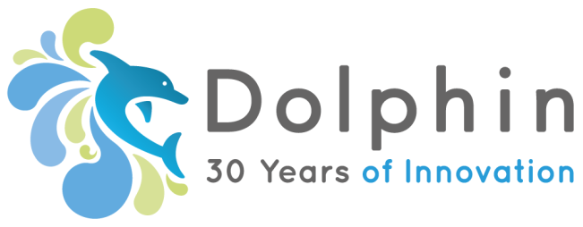

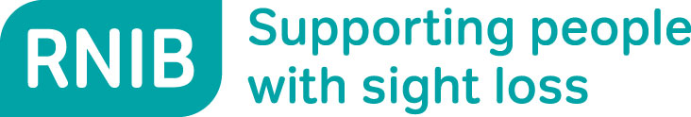

**PRESS RELEASE**

**LONDON, UK – 1st November 2017**

**Bringing braille to developing countries**

Today [1 November] sees the launch of a new app which will help blind and partially sighted people in developing countries to access information in braille, large print and audio formats.

The free app, called EasyConverter Express, has been developed by Dolphin with support from the Royal National Institute of Blind People (RNIB) and grant support from Google.org as a gift to the World Blind Union (WBU) and International Council for Education of People with Visual Impairment (ICEVI).

It is estimated that there are 253 million people worldwide with vision impairment, and it is hoped that this app will reach many of those living in developing countries.

EasyConverter Express will enable the production of braille, large print, MP3 and DAISY talking book formats from Word files through a set of simple menus.

Kevin Carey, Chair of the World Braille Council and outgoing Chair of RNIB, said: “I truly believe EasyConverter Express is a game changing development for the millions of people living with sight loss in developing countries. It is a fabulously simple product, specifically designed to get braille, large print and audio to blind and partially sighted people in the world’s poorest countries. It’s free and immediately available and I hope that it will make a big difference in terms of access to information and literacy.”

EasyConverter Express is available in English, French & Portuguese and is a free download from [www.YourDolphin.com/easyconverter-express](http://www.YourDolphin.com/easyconverter-express) for individuals with sight loss or organisations working with blind and partially sighted children and adults in developing countries.

**-ENDS-**

**Notes to Editor**

EasyConverter Express is available worldwide excluding:

* EU countries
* Norway
* Switzerland
* Iceland
* United States
* Canada
* Australia
* New Zealand
* Singapore
* Hong Kong
* Brunei
* South Korea
* Saudi Arabia
* United Arab Emirates
* Qatar
* Russia
* Israel

**About Dolphin Computer Access**

Located in Worcester, England, Dolphin offers a wide array of products that enable people with varying levels of technology experience—who are blind or partially sighted to do everyday things easily on computers and tablets. Dolphin has grown to become a global market leader, with more than 40 staff worldwide. The company has expanded to include offices in New Jersey USA and Falköping Sweden.

[www.YourDolphin.com](http://www.YourDolphin.com)

**About RNIB**

Every six minutes, someone in the UK begins to lose their sight. We are the Royal National Institute of Blind People (RNIB) and we're here for everyone affected by sight loss – that's over 2 million people in the UK. If you, or someone you know, has a sight problem, RNIB can help. Call the RNIB Helpline on 0303 123 9999 or visit [www.rnib.org.uk](http://www.rnib.org.uk)

**About Google.org**

Google.org supports nonprofits that innovate to address humanitarian issues. Since launching in 2005, Google.org has sought out nonprofit innovators that apply radical, data-driven innovation to solving the world's biggest challenges. These are the believers-turned-doers that have made the biggest impact on the communities they represent, whose work has the potential to produce meaningful change that can scale. We want a world that works for everyone–and we believe technology and innovation can move the needle in three key areas: education, economic opportunity, and inclusion.

# Contacts

### Media contact at Dolphin:

Hazel Shaw, Marketing Director

[hazel.shaw@yourdolphin.com](mailto:hazel.shaw@yourdolphin.com)

www.YourDolphin.com

+44 1905 754 577

+44 7989 444 541