Press Release Contacts: For Immediate Release Vinitaly International
International Media Dept.
+39 045 8101447
media@vinitalytour.com
www.vinitalyinternational.com
Twitter: @VinitalyTour
Join Italian Wine Community on LinkedIn

Vinitaly International quenches the thirst for Italian Wine in Hong Kong
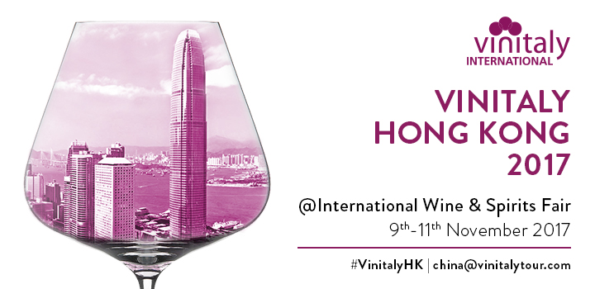

As the international wine hub and gateway to the Asian market, Hong Kong is ever increasingly one of the most important wine scenes in the world. Vinitaly Hong Kong will be back at the International Wine & Spirits Fair from the 9th to the 11th of November, offering the 20,000 buyers and visitors an even more valuable B2B experience: the traditional walk around tastings will be enhanced by a series of private B2B meetings as well as 20 exclusive educational classes held by Italian Wineries, Consortiums, Vinitaly International Academy and many others.

The #B2BHongKong meetings, organized in collaboration with HKTC, are a brand new initiative of Vinitaly International aimed at supporting Italian wine companies in their effort to grow their business in the Asian market. There will be a succession of 110 meetings between Italian wine producers and chief executive officers, general managers, marketing directors and buyers from 14 different countries such as Chinese Mainland, USA, Indonesia, Taiwan, Philippine, Singapore, Vietnam, Australia, Cambodia, Monaco, Brazil and Thailand. 14 different Italian wineries that exhibit with Vinitaly International at this edition of Vinitaly Hong Kong have this exclusive opportunity to respond to the high demand in the market.

According to the Hong Kong Trade Development Council’s deputy executive director Benjamin Chau, “In the first eight months of this year, Hong Kong’s wine imports reached HK$ 7.56 billion. Most of the wines were imported from France, the UK and Italy and imports from Italy even recorded a 22% growth”. (The Drinks Business, November,1, https://www.thedrinksbusiness.com/2017/11/hong-kong-international-wine-spirits-fair-returns-next-week/) Hong Kong is thirsty for Italian wine more than ever.

Vinitaly International is ready to quench this thirst. For the eighth consecutive year at the International Wine & Spirits Fair, a rich, informative program has been prepared for the Italian Pavilion covering 1006sqm. From boutique wineries to co-ops to family owned wineries, the wide range of exhibitors display the essence of Italian wines; the diversity of over 590 + native grapes and wines made from them coming from all parts of the country.

A quintessential part of Vinitaly Hong Kong revolves around wine education. The various seminars held by world-known experts on Italian wine are of a very high level yet informative. Vinitaly International Academy (VIA) with its Scientific Director, Ian D’Agata will hold three VIA Executive Wine Seminars, as well as an additional session dedicated to wines selected for the new wine guide, 5StarWines - the Book 2017 encompassing a compilation of wines selected by a panel of International judges the week before Vinitaly (www.5starwines.it/).

Jean Charles Viens, Hong Kong-based wine expert and educator, writer at “Spirito Divino Asia” will be holding 9 masterclasses thus completing a full schedule of educational sessions organized by Vinitaly International in collaboration with the wine website Wine Meridian, Consortium Alto Adige Wines, Consortium Enoteca Regionale Emilia Romagna, Piemonte Land of Perfection and La Collina dei Ciliegi.
Registrations for the masterclasses can be made by following these links:
- Valpantenashire - La Collina dei Ciliegi
(https://lacollinadeiciliegitasting.eventbrite.it)
- Emilia Romagna Wine Tasting - Enoteca Regionale Emilia Romagna
(https://emiliaromagnatasting.eventbrite.it)
- Alto Adige - Wines from the Italian Dolomites - Consortium Alto Adige Wines
(https://altoadigewinestasting.eventbrite.it)
- International Varieties in Italy - Vinitaly International Academy
(https://internationalvarietiesitaly.eventbrite.it)
- The Versatility of Sangiovese, cornerstone of many great wines - Vinitaly International Academy (https://sangiovesewines.eventbrite.it)
- Special Selection from 5StarWines - the Book 2017
(https://5starwines2017.eventbrite.it)
- Italy’s Benchmark Wines - Vinitaly International Academy
(https://italybenchmarkwines.eventbrite.it)
- Have a Sip of Abruzzo with Casal Thaulero Wines - Wine Meridian
(https://winemeridian_casalthaulerowines.eventbrite.it)
- The Wine Net: The Excellence of the Italian Wine Co-op - Wine Meridian
(https://thewinenet.eventbrite.it)
- Excellences of Piedmont: Nebbiolo, Barbera, Moscato - Piemonte Land of Perfection (https://piemontelandofperfection.eventbrite.it)
- Italian Wines In the World - Wine Meridian
(https://italianwinesintheworld.eventbrite.it)
As for the previous editions, every day the Vinitaly Lounge will offer all attendees the opportunity to sip good Italian coffee and taste Italian food thanks to Vinitaly International's partnership with Illy and Casale. Vinitaly International would also like to take this opportunity to thank our partners, Grande Passione, Bellissima Italia, Spirito di Vino Asia, Wines-Info, Wines Times, and SoWine.

About:
Veronafiere is the leading organizer of trade shows in Italy including Vinitaly (www.vinitaly.com), the largest wine and spirits fair in the world. During its 51th edition Vinitaly counted more than 4,270 exhibitors on a 100,000+ square meter area and 128,000 visitors from 142 different countries with more than 30,000 top international buyers (up by 8%). The next edition of the fair will take place on 15 - 18 April 2018. The premier event to Vinitaly, OperaWine (www.operawine.it) “Finest Italian Wines: 100 Great Producers,” will unite international wine professionals on April 14th in the heart of Verona, offering them the unique opportunity to discover and taste the wines of the 100 Best Italian Producers, as selected by Wine Spectator. Since 1998 Vinitaly International travels to several countries such as Russia, China, USA and Hong Kong thanks to its strategic arm abroad, Vinitaly International. In February 2014 Vinitaly International launched an educational project, the Vinitaly International Academy (VIA) with the aim of divulging and broadcasting the excellence and diversity of Italian wine around the globe. VIA this year launched the third edition of its Certification Course and today counts 116 Italian Wine Ambassadors and 8 Italian Wine Experts.

