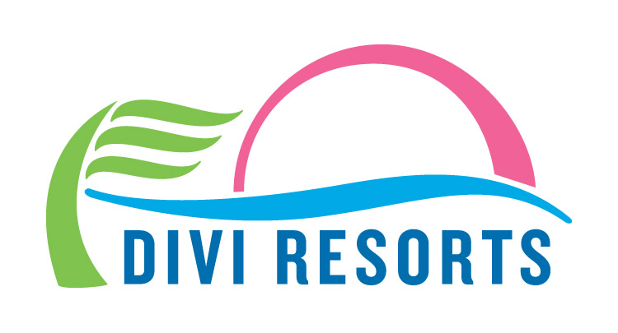

Contact: Alyssa Smith
Phone: (919) 419-2039
alyssa.smith@diviresorts.com

GoFundMe Donations Distributed to Divi Little Bay Beach Resort Employees
Campaign raises more than $50,000 for staff in St. Maarten affected by recent hurricanes

November 7, 2017 – Divi Little Bay Beach Resort staff along with a local union representative gathered Monday, November 6 to receive checks from GoFundMe campaign donations.

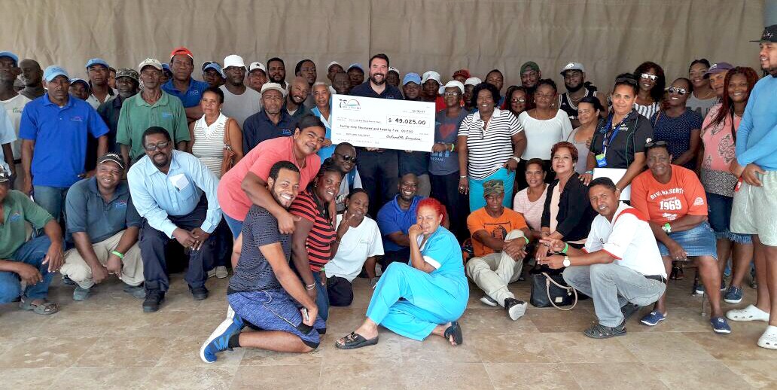

Set up to assist employees in rebuilding their lives on St. Maarten following devastating hurricanes, the GoFundMe campaign has now raised more than $50,000. $49,025 of the donated funds — the amount in the campaign at the time checks were cut — were equally distributed amongst staff, with the exception of upper management, who chose to opt out.

“We thank everyone who donated from the bottom of our hearts,” said Madeleine Jacob, hostess and cashier at Divi Little Bay’s pureocean Restaurant.

Jacob says this money will help her family recover from the catastrophic effects of Hurricane Irma and other storms.

“I lost my roof and lots of my belongings,” Jacobs said. “This will help with the rebuilding of my home. Thank you, thank you, thank you!”

The GoFundMe campaign will remain open for anyone who still wishes to donate to the cause.

The resort is expected to reopen and welcome back guests in May 2018.

About Divi Resorts

Divi Resorts is the vacation expert of the Caribbean, with a collection of eight premium resorts spanning the five stunning Caribbean islands of Aruba, Barbados, Bonaire, St. Croix, and St. Maarten. For more information on Divi Resorts, call 1-800-367-3484 or visit www.diviresorts.com.
###

For more images: http://bit.ly/2znXtH3

