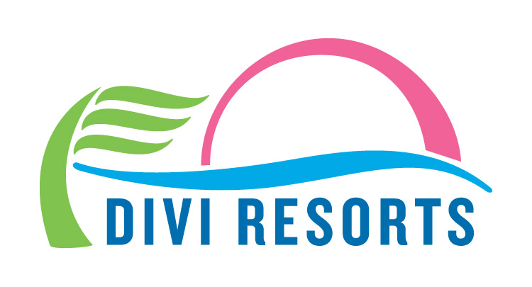

Contact: Alyssa Smith
Phone: (919) 419-2039
Alyssa.smith@diviresorts.com

Divi Resorts Reveals ‘Out of this World’ Savings for Black Friday & Cyber Monday
Starting Thanksgiving Day, travelers can take advantage of 50% off top Caribbean destinations.

CHAPEL HILL, NC—Why wait until Monday to cash in on stellar Cyber savings for Divi Resorts’ stunning Caribbean locations? For five days only, starting this Thursday, November 23 at 12:00 a.m., Divi Resorts is offering room only rates as low as $106 per night and all-inclusive rates as low as $127 per person, per night, with savings of 50%!* This limited time offer runs through Monday, November 27 at 11:59 p.m. EST.

“We think travelers deserve a magical Caribbean getaway that fits in their budget, especially after a long year of hard work,” said Marco Galaverna, Divi Resorts President & COO. “That’s why this holiday season we’re thrilled to offer our absolute lowest rates of the year for five whole days, giving families something to really look forward to in 2018!”

Divi Resorts’ picturesque destinations on Aruba, Bonaire, Barbados, St. Maarten and St. Croix provide a wide variety of on-site amenities, including elegant restaurants with mouthwatering menus, lively bars with unlimited libations, fabulous freshwater pools, sports courts, spas and more, allowing you the freedom to do everything, or nothing at all.

Plus, with Divi’s ‘Kids Stay and Eat Free’ program and complimentary Treasures of the Caribbean kids club, we keep our youngest guests happy, giving you time to relax and enjoy your vacation without breaking the bank.+

For those in search of spectacular savings, Divi’s out of this world 50% off deals on Room Only or
All-Inclusive stays are as follows:

- Divi Village Golf & Beach Resort on Aruba – rates start at $125 per night, room only or $162 per person, per night all-inclusive

- Divi Dutch Village Beach Resort on Aruba – rates start at $120 per night, room only or $143 per person, per night all-inclusive

- Divi Aruba Phoenix Beach Resort on Aruba – rates start at $178 per night room only

- Divi Flamingo Beach Resort & Casino on Bonaire – rates start at $106 per night room only or $127 per person, per night all-inclusive

- Divi Southwinds Beach Resort on Barbados – rates start at $114 per night room only

- Divi Little Bay Beach Resort on St. Maarten – rates start at $135 per night room only or $140 per person, per night all-inclusive**

- Divi Carina Bay Beach Resort & Casino on St. Croix – rates start at $135 per night room only**

This 50% off hot deal is only available from Thursday, November 23 to Monday, November 27. For reservations, book online at www.diviresorts.com/cyber-monday or call 1-800-367-3484 (Toll-free US) or 1-919-419-3484 (International). For group reservations, please call 1-800-801-5550 or email groupsales@diviresorts.com.

*This offer applies to reservations made between the dates of 11/23/17 and 11/27/17 on travel made between the dates of 4/2/18 and 6/29/18 or 8/18/18 and 12/21/18. 3-night minimum stay required.

**Reservations made at Divi Carina Bay All-Inclusive Beach Resort & Casino and Divi Little Bay Beach Resort must be for travel after June 1, 2018. 3-night minimum stay required.

+For more information on Divi’s Stay and Eat Free Program or Treasures of the Caribbean kids club please visit www.diviresorts.com.

About Divi Resorts
Divi Resorts is the vacation expert of the Caribbean, with a collection of eight premium resorts spanning the five stunning Caribbean islands of Aruba, Barbados, Bonaire, St. Croix, and St. Maarten. For more information on Divi Resorts, call 1-800-367-3484 or visit www.diviresorts.com.

