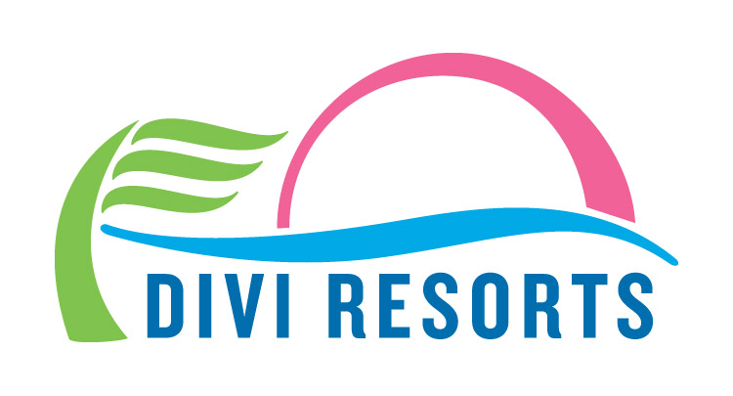

Contact: Alyssa Smith
Phone: (919) 419-2039
Alyssa.smith@diviresorts.com

Divi Resorts Announces Huge Savings with Annual ‘12 Days of Divi’ Holiday Sale
Featuring 12 days of stellar deals and savings revealed each day starting Friday, December 8th

CHAPEL HILL, NC—The holiday season is finally upon us and what better way to celebrate than with 12 stellar days of deals! Kicking off Friday, December 8th, Divi Resorts’ annual ‘12 Days of Divi’ sale features unbelievable savings on travel gifts that will be revealed each day for 12 consecutive days, including room only and all-inclusive stays, room upgrades, free breakfast and even discounts on honeymoon packages. Each deal will remain valid through the 12th day on Tuesday, December 19th.
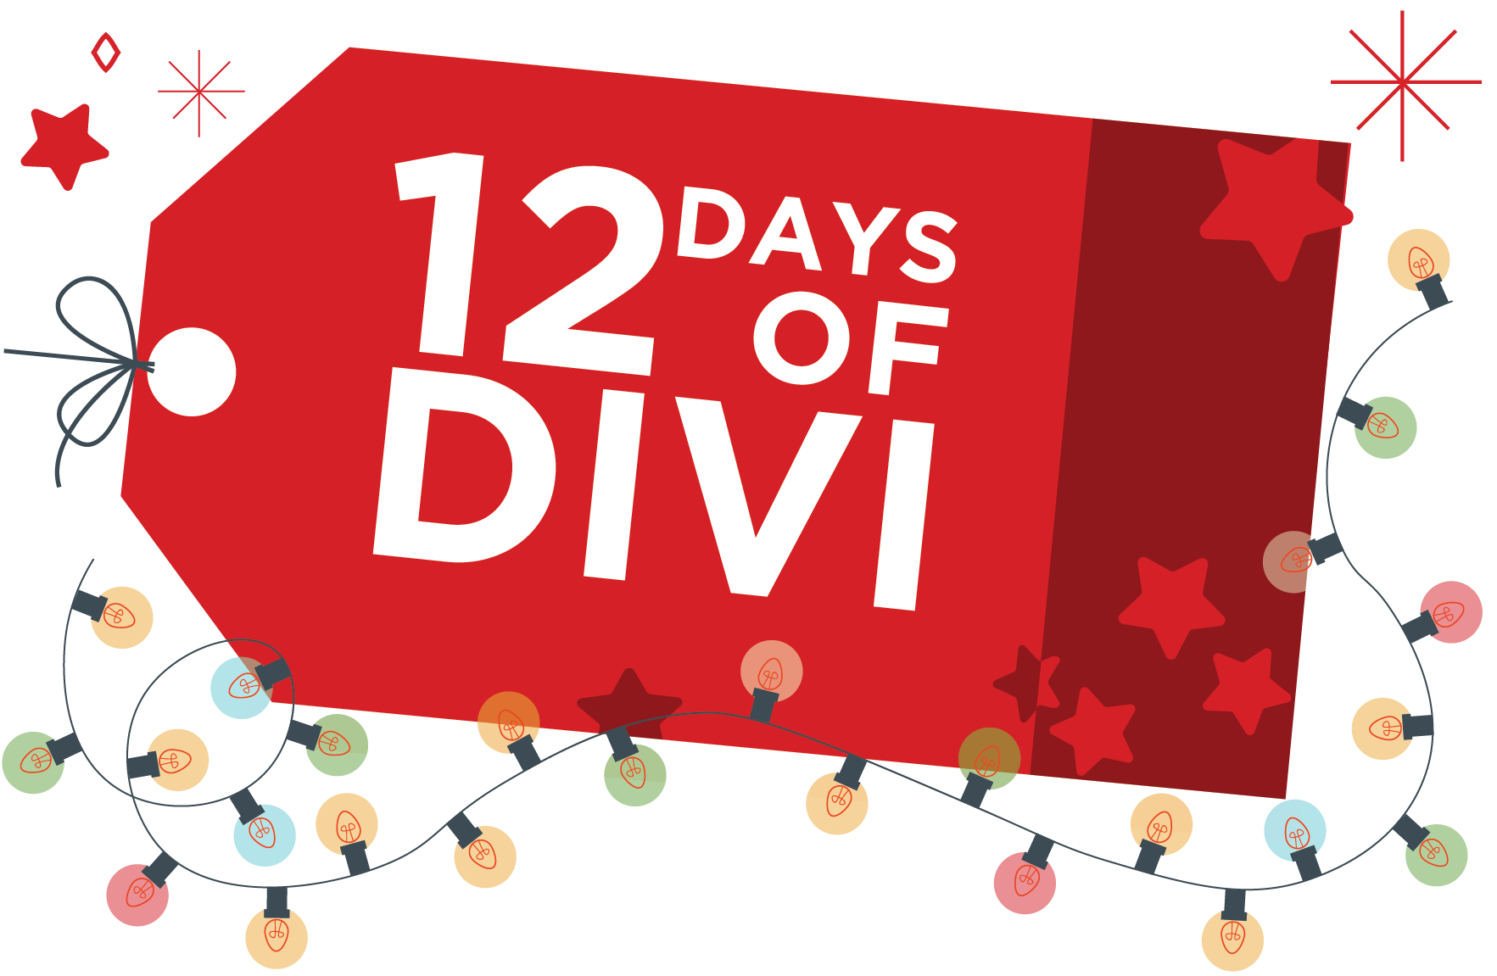
An ideal gift for last-minute holiday shoppers, interested vacationers can avoid the hassle of leaving the house by scoring these great deals online at www.diviresorts.com/divi-days.htm. Travelers can be amongst the first to find out and take advantage of each daily gift by signing up online at: www.diviresorts.com/sale-preview.htm.

In addition, Divi Resorts is also offering an amazing holiday gift for the 12th and final day of deals, of a complimentary all-inclusive stay for two at one if its stunning Caribbean locations!* The contest, which is open to anyone 18 years and older, starts Wednesday, December 6th at 5:00 p.m. EST and ends Tuesday, December 19th at 4:00 p.m. EST, when a winner will be selected. To enter to win, go to www.diviresorts.com/divis-90-day-caribbean-giveaway.htm.

“We’re thrilled to share our holiday cheer with loyal guests and new travelers alike,” said Marco Galaverna, Divi Resorts President & COO. “Best of all, these gifts are guaranteed to bring relaxation, joy and memories that last a lifetime.”

With enchanting Caribbean destinations on Aruba, Bonaire, Barbados, St. Maarten and St. Croix, Divi Resorts provides a wide variety of on-site amenities, including elegant restaurants with mouthwatering menus, lively bars with unlimited libations, fabulous freshwater pools, sports courts, spas and more!

These holiday deals are only available from Friday, December 8 to Tuesday, December 19. For reservations, book online at www.diviresorts.com/divi-days.htm or call 1-800-367-3484 (Toll-free US) or 1-919-419-3484 (International). For group reservations, please call 1-800-801-5550 or email groupsales@diviresorts.com.

*Travel not included. For stays at Divi Village Golf & Beach Resort, Divi Dutch Village Beach Resort, Divi Flamingo Beach Resort & Casino, Divi Little Bay Beach Resort and Divi Carina Bay Beach Resort & Casino. Travel to Divi Little Bay & Carina Bay must be after June 1, 2018.

About Divi Resorts
Divi Resorts is the vacation expert of the Caribbean, with a collection of eight premium resorts spanning the five stunning Caribbean islands of Aruba, Barbados, Bonaire, St. Croix, and St. Maarten. For more information on Divi Resorts, call 1-800-367-3484 or visit www.diviresorts.com.

