Press Release Contacts: For Immediate Release Vinitaly International
International Media Dept.
+39 045 8101447
media@vinitalytour.com
www.vinitalyinternational.com
Twitter: @VinitalyTour
Facebook : @VinitalyInternational
Instagram : @vinitalyinternational
Join Italian Wine Community on LinkedIn

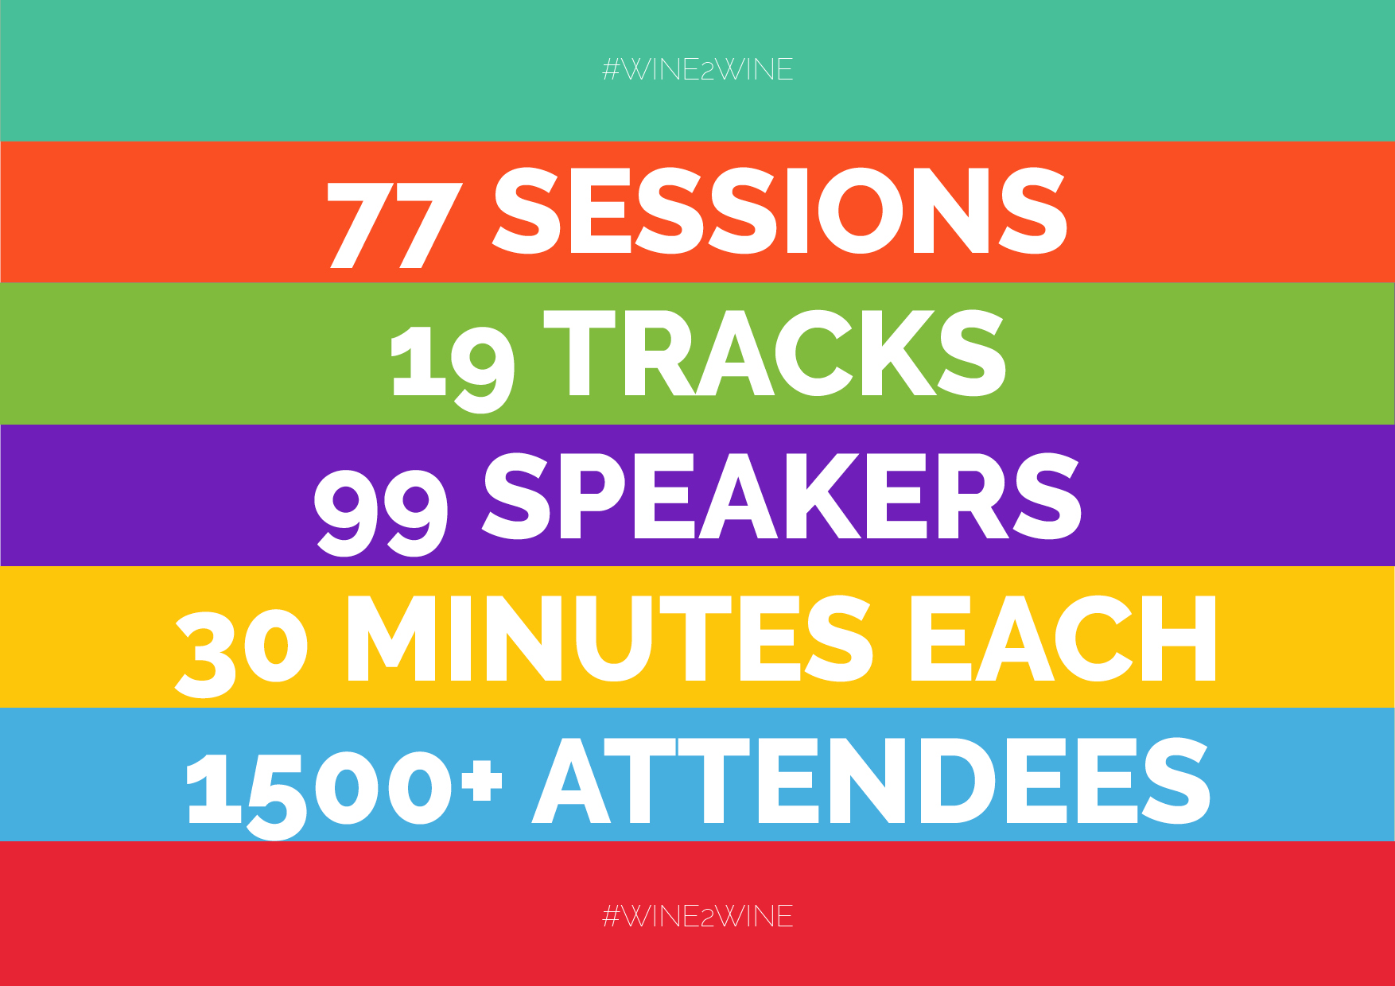
That’s a Wrap! Live Streaming and a brand new App connect all speakers and attendees at wine2wine 2017 the go-to forum for the wine business

With latest market insights and strategic network opportunities for the evolving business in the wine world, the fourth edition of wine2wine wrapped up enthusiastically at the Veronafiere Congress Center on December 4th and 5th, 2017. The 2017 edition showcased an entirely new website (www.wine2wine.net), a new format, all sessions covered by live-streaming and a dedicated App (Linkry) where both speakers and attendees were able to network before, during, and after the event.

The two-day conference wine2wine is the only event in Italy specifically dedicated to the wine business. Italian wine producers, suppliers, international journalists and professionals from all sectors of the wine business gathered for a unique opportunity to participate in educational and thought-provoking discussions, seminars, and workshops— 77 sessions divided in 19 different theme tracks in total—with a golden line-up of 99 speakers from around the globe (https://www.wine2wine.net/relatori/?lang=en).

After three consecutive editions, Stevie Kim, Managing Director of Vinitaly International has revamped the format completely. The sessions predominantly consisted of a single speaker with a 30-minute presentation including a five-minute Q&A. “The single speakers had the best performing sessions from the past editions. To truly deep dive into one theme, one voice can prove to be much more effective in getting the job done. We required from each speaker to include practical takeaways at the end of each session as much as possible. We wanted to give all speakers and attendees the opportunity to network as much as possible, so we translated all into the App, where all content, session details, and contacts linked to one’s Linkedin account can be found, with the aim to carry out an effective and efficient two-day conference” states Kim.

Robert Joseph, wine writer and consultant who held the keynote session The future of wine is not what it used to be comments on the new format, “wine2wine has gotten even better this year. The sessions divided into theme tracks truly did justice in bringing out the essence of the speakers.” Felicity Carter, Senior Editor at Meininger’s Wine Business International who held the session How to sell your wine through words in the Marketing track aside with Rebecca Hopkins from Colangelo & Partners PR also testimonies, “wine2wine is definitely one of the highlights of the wine business calendar”. Attendees gathered from all around the globe as well. Elvira Cascavilla, Export Manager at Planeta Winery from Sicily confirms, “They have been two intense and energetic days. Wine2wine has given me a lot of food for thought. I come back to my office desk with tons of ideas to share and develop with my team, projects to start off, things to delve deeper into. I pack my Export Manager suitcase with additional knowledge to carry around the world.”

The forum opened with a debate entitled Media vs. Sales Platform for Millennials: Who matters the most?, with Adam Teeter, Co-Founder of VinePair, one of the fastest growing media on wine, beer and spirits, and Logan Lee, Co-Founder and CEO of Wine Awesomeness, an exclusive wine membership club who shared their respective insights. “In this new digital age, content can be published in a flash, but with so much material available on so many platforms, only truly good content rises to the top and when it does, those that publish it become the new influencers”, stated Teeter.

In the digital arena, this year the conference welcomed Wine-Searcher, world’s most successful price comparison website for wine, and Vivino, one of the most popular wine communities and the most downloaded mobile wine app. Both shared insights from their database as to how wine consumers are engaging digital technology in their palms. Digital marketing has become more complex than ever, yet it offers unrivaled opportunities to build brands. The digital agency A-Quest, introduced how the wine sector can benefit from innovative technologies such as Augmented Reality and Chat-Bots.

New technologies are a driving force in distribution. In the session “From Grape to Glass - demystifying the Blockchain”, award winning wine writer Paul Howard introduced Blockchain, the new digital technology that has already attracted billions of dollars of venture capital. “While it started out in the finance industry, Blockchain applications are emerging in many other global industries, including wine” explained Howard. The session used Blockchain examples to verify wine quality, authenticity and safety, from Grape to Glass. Cruz Liljegren, a wine broker and consultant outlined basics and macro trends specifically on Private Label Strategy. Has private label matured into something more than brands? What are the risks and benefits for the producers? "Studies show that brand loyalty is decreasing and that there is a growing consumer acceptance of private label products,” shared Liljegren.

On the export side, this year’s focus was on the next potential market, China, but not only. A great emphasis has been put on emerging markets such as Japan, Denmark, and those up and coming US states in the wine sector (Colorado, South Carolina, Pennsylvania), along with the ever-growing Australian market and the well established monopoly, Canadian market. Gill Gordon Smith, Roddy Ropner, Kevin Gagnon, who are also Vinitaly International Academy certified Italian Wine Ambassadors from all over the world, shared their unique insights and case studies from their local country.

Last but not least, Alison Napjus, Senior Editor and Tasting Director at Wine Spectator revealed the 100 Finest Italian wine producers selected by Wine Spectator for the seventh edition of OperaWine 2018, to be held on Saturday, April 14th 2018.

Below are all of the 19 theme tracks from wine2wine:
- Digital Marketing
- Social Media Marketing
- Marketing - New tools and ideas to value wine -
- Internationalization
- Communication
- Focus on Emerging Markets
- Experiential Marketing
- The Emerging Presence of Wine Influencers
- Innovation in Distribution
- Legal and Financial Matters
- Culture and Businesses
- Focus on the Chinese Market
- Focus on the Canadian Market
- Experimentations
- Wine Tourism
- Women of the Vine & Spirits focused track
The entire wine2wine program can be found online at www.wine2wine.net/agenda/

On December 3rd, one day prior to the event, an exclusive Tasting Panel was organized by Vinitaly International Academy (VIA) under the direction of its Scientific Director, the internationally renowned wine critic Dr. Ian D’Agata. The tasting was open to a restricted number of invitees including international wine experts and journalists as well as Italian Wine Experts and Ambassadors from various countries certified by VIA.

VIA Tasting Panels
- Josko Gravner wines with Mateja Gravner
- French Varieties in Trentino, Northern Italy’s most famous Bordeaux style blends
- A 360° journey into Barbaresco and its different terriors

The entire wine2wine program is online at www.wine2wine.net/agenda/
For further information, please kindly send an email at info@wine2wine.net.
Share your experience by using the hashtag #wine2wine
Facebook: www.facebook.com/wine2wine
Twitter: www.twitter.com/wine2wineVerona
Instagram: www.instagram.com/wine2wineverona/

wine2wine would like to thank partners AQuest, H-FARM, Wine Searcher, Meininger’s Wine Business International, Spirito di Vino, WINE TV and Wine & Spirit Education Trust. Special thanks go to ICE, the Italian Trade Agency and the Ministry of Economic Development for having supported and financed this fourth edition of wine2wine with the aim of supporting the promotion of Italian wine.

About:
Veronafiere is the leading organizer of trade shows in Italy including Vinitaly (www.vinitaly.com), the largest wine and spirits fair in the world. During its 51th edition Vinitaly counted more than 4,270 exhibitors on a 100,000+ square meter area and 128,000 visitors from 142 different countries with more than 30,000 top international buyers (up by 8%). The next edition of the fair will take place on 15 - 18 April 2018. The premier event to Vinitaly, OperaWine (www.operawine.it) “Finest Italian Wines: 100 Great Producers,” will unite international wine professionals on April 14th in the heart of Verona, offering them the unique opportunity to discover and taste the wines of the 100 Best Italian Producers, as selected by Wine Spectator. Since 1998 Vinitaly International travels to several countries such as Russia, China, USA and Hong Kong thanks to its strategic arm abroad, Vinitaly International. In February 2014 Vinitaly International launched an educational project, the Vinitaly International Academy (VIA) with the aim of divulging and broadcasting the excellence and diversity of Italian wine around the globe. The VIA Certification Course has been launched also in USA and China this year and today counts 122 Italian Wine Ambassadors and 9 Italian Wine Experts who have achieved the higher certification.

