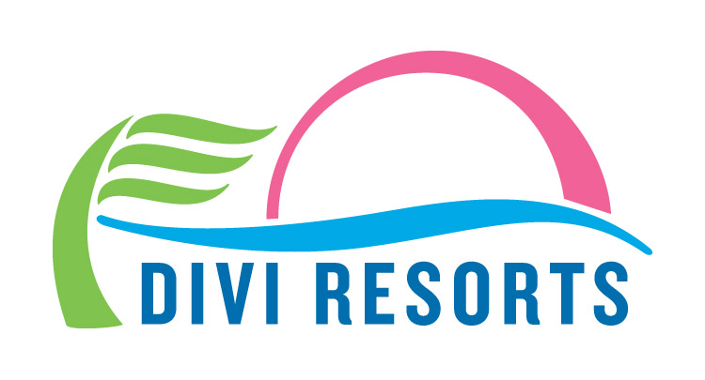

Contact: Alyssa Smith
Phone: (919) 419-2039
Alyssa.smith@diviresorts.com

Thaw Out from Frigid Temperatures with Divi Resorts’ 30% Off Winter Sale
With rates as low as $149, it’s time to swap the mittens and coats for sunglasses and swimsuits!

CHAPEL HILL, NC— The new year is off to a chilly start, but that doesn’t mean you have to bundle up and hibernate from the freeze! Warm up and let your worries melt away with 30% off savings on Divi Resorts’ top Caribbean destinations. With rates as low as $149 per night and all-inclusive rates as low as $178 per person, per night, sea, sun and sand are just a click away!

“It’s been a very chilly winter so far with ‘bomb cyclone’ hitting the eastern United States and snow and ice in Europe, so we hope this fantastic deal will help guests warm up and kick the winter blues,” said Marco Galaverna, Divi Resorts President & COO.

With charming Caribbean locations on the magical islands of Aruba, Bonaire, Barbados, and St. Maarten Divi Resorts provides a wide variety of on-site amenities, including elegant restaurants with mouthwatering menus, lively bars with unlimited libations, fabulous freshwater pools, sports courts, spas and more! Travelers on the hunt for a slice of paradise better hurry, this limited time offer only runs through Wednesday, February 28th at 11:59 p.m. EST.

For those in search of a warm, tropical getaway to escape the winter chill, 30% off deals on room only and all-inclusive stays are as follows:

- Divi Village Golf & Beach Resort on Aruba – rates start at $175 per night, room only or $227 per person, per night all-inclusive

- Divi Dutch Village Beach Resort on Aruba – rates start at $169 per night, room only or $200 per person, per night all-inclusive

- Divi Aruba Phoenix Beach Resort on Aruba – rates start at $249 per night room only

- Divi Flamingo Beach Resort & Casino on Bonaire – rates start at $149 per night room only or $178 per person, per night all-inclusive

- Divi Southwinds Beach Resort on Barbados – rates start at $159 per night room only

- Divi Little Bay Beach Resort on St. Maarten – rates start at $189 per night room only or $195 per person, per night all-inclusive**

This 30% off deal is available until February 28th for all 2018 travel dates. For reservations, book online at www.diviresorts.com/caribbean-promotion.htm or call 1-800-367-3484 (Toll-free US) or 1-919-419-3484 (International). For group reservations, please call 1-800-801-5550 or email groupsales@diviresorts.com.

Travelers can also enter for a chance to win a free 7-night stay at Divi Resorts plus a $250 dining credit as part of Divi’s 90-Day Caribbean Giveaway. A lucky winner will be selected Monday, January 29 at 4:00 p.m. EST.

*This offer applies to reservations made until February 28, 2018 on all 2018 travel dates. 3-night minimum stay required.

**Reservations and travel to Divi Little Bay Beach Resort must be after June 1, 2018.

+For more information on Divi’s Stay and Eat Free Program or Treasures of the Caribbean kids club please visit http://www.diviresorts.com/kids.htm.

About Divi Resorts
Divi Resorts is the vacation expert of the Caribbean, with a collection of eight premium resorts spanning the five stunning Caribbean islands of Aruba, Barbados, Bonaire, St. Croix, and St. Maarten. For more information on Divi Resorts, call 1-800-367-3484 or visit www.diviresorts.com.

