Texas' most classic and clever personalized plates
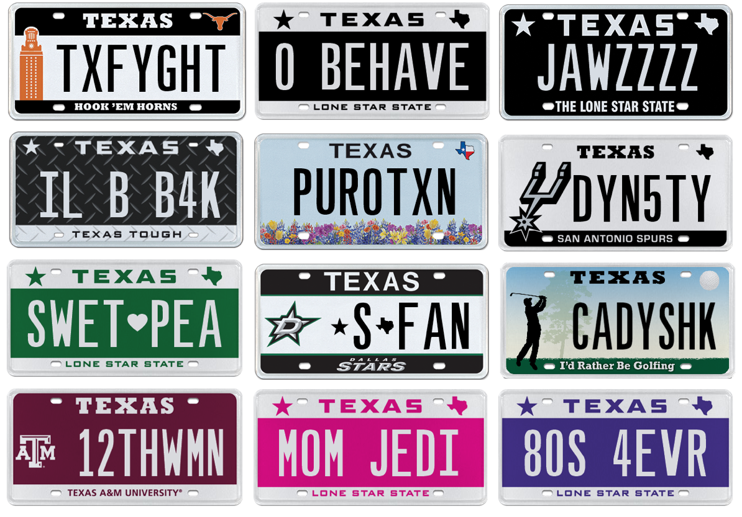
15, January (Austin, TX) - TEXAS’ best, most classic and funniest personalized license plates for 2017 have finally been revealed.

My Plates has named their favorite plate combinations for 2017 in a series of category awards following a big year in personalized plate sales. There was a starting list of over 35,000 different personalized plates that were narrowed down to My Plates’ top 27 plate messages across nine categories.

“Every day across the year we see very creative plate messages coming through, amounting to tens of thousands by the end of the year. We have a lot of fun with our team and sometimes heated debates in order to cut it down to our final selection” said Steve Farrar, President of My Plates.

The popularity of My Plates has continued to grow with now more than 345,000 plates being sold in Texas. More and more Texans are using their bumpers to express humor, individuality, creativity and self-expression.

My Plates Top Personalized Plates for 2017

Best Texas/USA Pride Plates 2017
IMA TXN (I’m a Texan)
M3RRCA (America)
PURO TXN (Pure Texan)
BIGRNTX (Bigger in Texas)
MR. TEXAS

(Notable mentions: I(Love)TEXAS, BFREE, 8 GEN TX)

Best College Plates 2017
TX FYGHT (Texas fight)
12THWMN (12TH WOMAN)
AXMJX (Axe em-jacks)
IAM4ANM (I am for A&M)
1REDR8R (One Red Raider)

(Notable mentions: DIXICKN, HUSK3R, UA4LIF)

Best Plate Speak Plates 2017
IL B B4K (I’ll be back)
WH8T4IT (Wait for it)
MO2V8D (Motivated)
4DABLU (For the Blue)
UR2L8 (you are too late)

(Notable mentions: F33DME, IML4T3)

Best Romantic Plates for 2017
TEAM US
LOV WINS
MY RIB
LV UMOR3 (Love you more)
MI AMORE (My Love)

(Notable mentions: FOR 3V3R, MYMOON, BTR HALF)

Cutest Pet Name Plates for 2017
PUMPKYN
SWET PEA (Sweet pea)
HONEY P
GRAMMA B
FARMWYF

(Notable mentions: MY BBY, MY BELLA)

Funniest Plates 2017
O BEHAVE (From Austin Power’s)
MOM JEDI
GIDEY UP
80S4EVR (80’s for ever)
4BNGOOD (For being good)

(Notable mentions: MILK RUN, NO MON3Y)

Best Movie Themed Plates 2017
JAWZZZZ
SKYWKR
IAM GRUT
D3ADPUL
B4DSMURF

(Notable mentions: JEKL-HYD, DTH V4DR, LOKI, DA FLASH)

Best Sports Related Plates 2017
S FAN (Reads - Star’s Fan)
4D WIN (For the win)
CADYSHK (Caddy shack on the golf plate)
DYN5TY (On a Spurs plate)
2HLSN1(Two holes in one)

(Notable mentions: HOOP4L, TUCHDN)

Best Auto Related Plates 2017
GAS PEDL
LAFN GAS
FXR UP
6.0HYEAH
EFF3FDY (F-350)

(Notable mentions: MOPURRR, F250NV, 1DWN5UP)

My Plates designs and markets new specialty license plates as a vendor for the Texas Department of Motor Vehicles. Texans have bought more than 345,000 My Plates since November 2009, putting more than $58M in the state general revenue fund. My Plates’ goal is to create a long-term, mutually beneficial relationship designed to maximize revenues for the state through the sale of My Plates specialty plates. www.myplates.com.

The Texas Department of Motor Vehicles (TxDMV) serves protects and advances the citizens and industries in the state with quality motor vehicle related services. For every $1 it spends, the TxDMV returns $11 to the state. The agency currently registers 24 million vehicles; issues more than 7 million vehicle titles; licenses more than 38,000 motor vehicle dealers and distributors; credentials nearly 60,000 motor carriers; issues more than 800,000 oversize/overweight permits; investigates more than 15,000 complaints against dealers and motor carriers; and awards grants to law enforcement agencies to reduce vehicle burglaries and thefts. Learn more at www.TxDMV.gov.
____________________________________________________________

For more information, contact Steve Farrar at (512) 633-7978 or steve@myplates.com

Image download:
https://ce9a9387e1bc258c3cfa-af7906f4e771b24864bbfa3048e4a635.ssl.cf2.rackcdn.com/Plate%20Messages.png

