FOR IMMEDIATE RELEASE
Jason Rathbun| Managing Director | marketing@beckerpumps.com
Becker Pumps Corporation
100 E. Ascot Lane
Cuyahoga Falls, Ohio, 44223-3768

PH: 330-928-9966 | FX: 330-928-7065

Becker Pumps Introduces the New SV Series Regenerative Blowers

Cuyahoga Falls, OH (January 2018) – Becker Pumps Corporation announced the US launch of a new line of regenerative blowers, the SV series. The new line of regenerative blowers delivers increased performance and improved features at a lower cost.

In most cases, a regenerative blower, also known as a regen blower or side channel blower, is the most cost-effective method for producing vacuum or pressure. Regenerative blowers are used in industrial, medical, water treatment and material handling applications to move large volumes of air at lower pressure or vacuum levels. Regenerative blowers are ideal for aeration, paper converting, industrial lifting, chip removal, denesting, dryers, pick and place, pneumatic conveying, dental systems, hold down, packaging equipment, and printing presses.

The Becker new SV Series of single and two-stage regenerative blowers is more efficient, compact, and cost-effective. The new blowers have been re-engineered to be lighter, quieter, and cooler running with a more compact design. Even the discharge air is cooler. The new design also generates greater capacities with lower horsepower. This state of the art SV series offers seven compact frame sizes, both single and two-stage, with airflow capacities ranging from 29 to 735 CFM and pressures from 28” to 213” WG.

“We did a soft launch in 2017 to key customers and the response has been great.”, stated Jason Rathbun, Managing Director. “We needed a regen blower that would ‘blow’ away the competition and this is it. The new pricing is truly high-value for the features that come with the pump. Our competitors sell these as upgrades/accessories but are really necessary for the blower to perform well. With our regenerative blowers, our customers now get these features for free.”

Smaller models feature an integrated inlet filter and relief valve which means a clean impeller, cooler running pump, and longer life. The blowers are designed to reduce maintenance with sealed bearings to eliminate greasing, increased corrosion protection, and the exclusive clear filter/valve cover allows for fast visual filter inspection.

For additional information please visit www. beckerpumps.com or contact: Jason Rathbun by email at marketing@beckerpumps.com, or by phone at 330-928-9966, Becker Pumps Corporation, 100 E. Ascot Lane, Cuyahoga Falls, Ohio, 44223-3768.

###

Backgrounder

Becker manufactures a complete line of oil-flooded and oil-free rotary vane, regenerative blowers, rotary screw vacuum pumps, and low-pressure compressors. These pumps are incorporated into complete central systems and variable frequency drive units to offer an economical and environmentally friendly alternative to standard models. Becker has an internationally networked development team to work with customers on providing equipment manufacturers with the appropriate pump for their application. Manufactured to the highest quality standards in Germany, Becker has brought Best in Class engineering to the global marketplace for over 130 years.

Becker pumps can be found on virtually every type of manufacturing and material handling equipment that requires vacuum or pressure. Becker pumps are also predominantly used in many different industries which include food packaging, printing, woodworking, water treatment, paper converting, cosmetic, pharmaceutical, beverage, dairy, chemical, medical device and consumer packaging.

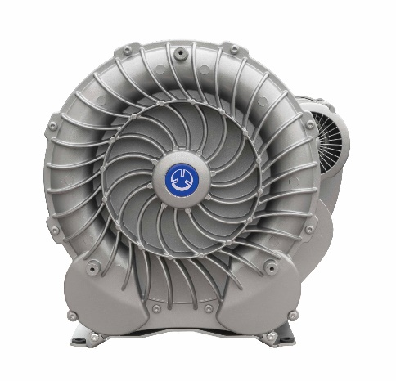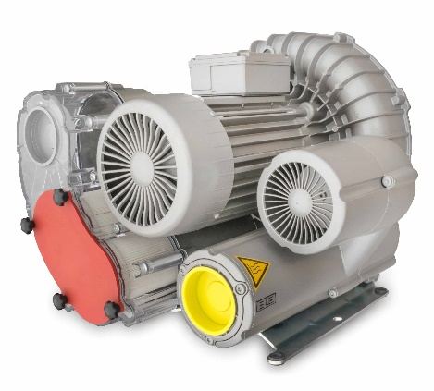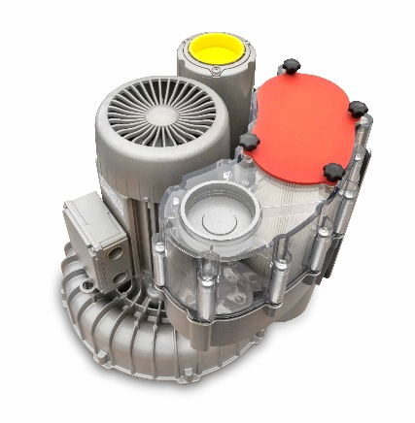
Above images show views of the new Becker SV Series Regenerative Blowers with integrated inlet filter, relief valve, and exclusive clear filter/valve cover. High resolution photos available.

