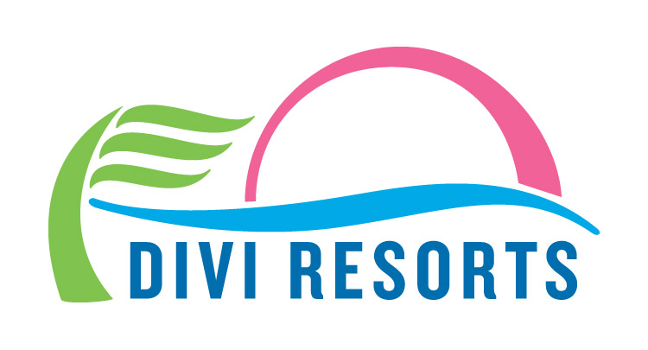

Contact: Alyssa Smith
Phone: (919) 419-2039
Alyssa.smith@diviresorts.com

Divi Resorts Hires New General Manager for Divi Little Bay Beach Resort
Anne-Marie Brooks joins Divi’s St. Maarten property ahead of the resort’s May 2018 reopening

CHAPEL HILL, NC— Divi Resorts is thrilled to welcome back Anne-Marie Brooks as the new General Manager of Divi Little Bay Beach Resort on St. Maarten. Brooks joins the team in February, 28 years after her first internship at Divi Little Bay back in 1990. She replaces Celine Van Meer, who is now the General Manager at Divi Flamingo Beach Resort & Casino on Bonaire.

“We’re overjoyed that Anne-Marie has decided to return to Divi Little Bay,” said Marco Galaverna, Divi Resorts President & COO. “We’re making great progress in getting Little Bay back up and running in May, and we can’t wait to see what fresh and innovative ideas Anne-Marie brings to the table.”

Born in a picturesque village in the southern part of the Netherlands, Brooks grew up right in the middle of a hotel and restaurant region called “Little Switzerland.” From a young age she worked in the family hotel, managing everything from washing dishes to serving 7-course Christmas dinners. Naturally, she decided to further her studies in hotel & restaurant management.

In 1990, Brooks was offered a six-month management internship at Divi Little Bay Beach Resort to learn more about the industry. She had the opportunity to continue her internship in the United States, but opted to stay in St. Maarten as she fell in love with the island and the people. Not long after, she was offered a position as the Guest Service Manager at the resort.

Since leaving Divi Little Bay, Brooks has acquired a vast knowledge of the resort industry, holding management positions at several resorts on the island, and even owning and managing Beau Beau’s Beach Bar & Restaurant with her husband. Most recently, Brooks spent 21 years working for Oyster Bay Beach Resort on St. Maarten, where she served as the Office Manager, Sales Operations Manager and finally, Assistant General Manager. In her position as AGM, she contributed to the resort’s multimillion-dollar success in vacation ownership sales and transient hotel revenue.

“I believe that it takes dedication, hard work, and most importantly, a passion for hospitality. Making sure my guests are happy and all departments of the resort run smoothly is my top priority,” said Brooks. “I take great personal pride in delivering the best vacation experience to vacation club owners and guests.”

Brooks also has a strong bond with the local community. She has assisted in the organization of several neighborhood cleanups, collected donations for a local orphanage and supported food drives for the less fortunate. In addition, she is an active member of Chaine Des Rotisseurs, an International Association of Gastronomy that brings together food enthusiasts who share the same values of quality fine dining and culinary arts.

Brooks is married to Leroy Brooks better known as King Beau Beau, the famous Calypso artist and entrepreneur, and together, they have four children. In her free time, Brooks is an avid reader and Crossfit member.

About Divi Resorts
Divi Resorts are the vacation experts in the Caribbean, with a collection of eight premium resorts spanning the five stunning Caribbean islands of Aruba, Barbados, Bonaire, St. Croix, and St. Maarten. For more information on Divi Resorts, call 1-800-367-3484 or visit www.diviresorts.com.

