Press Release Contacts: For Immediate Release wine2digital
International Media Dept.
+39 045 8101447
Instagram: @wine2digital

What makes a wine influencer a “wine influencer"?
Stevie Kim’s new experiment #openbarstevie at wine2digital gets the discussion started

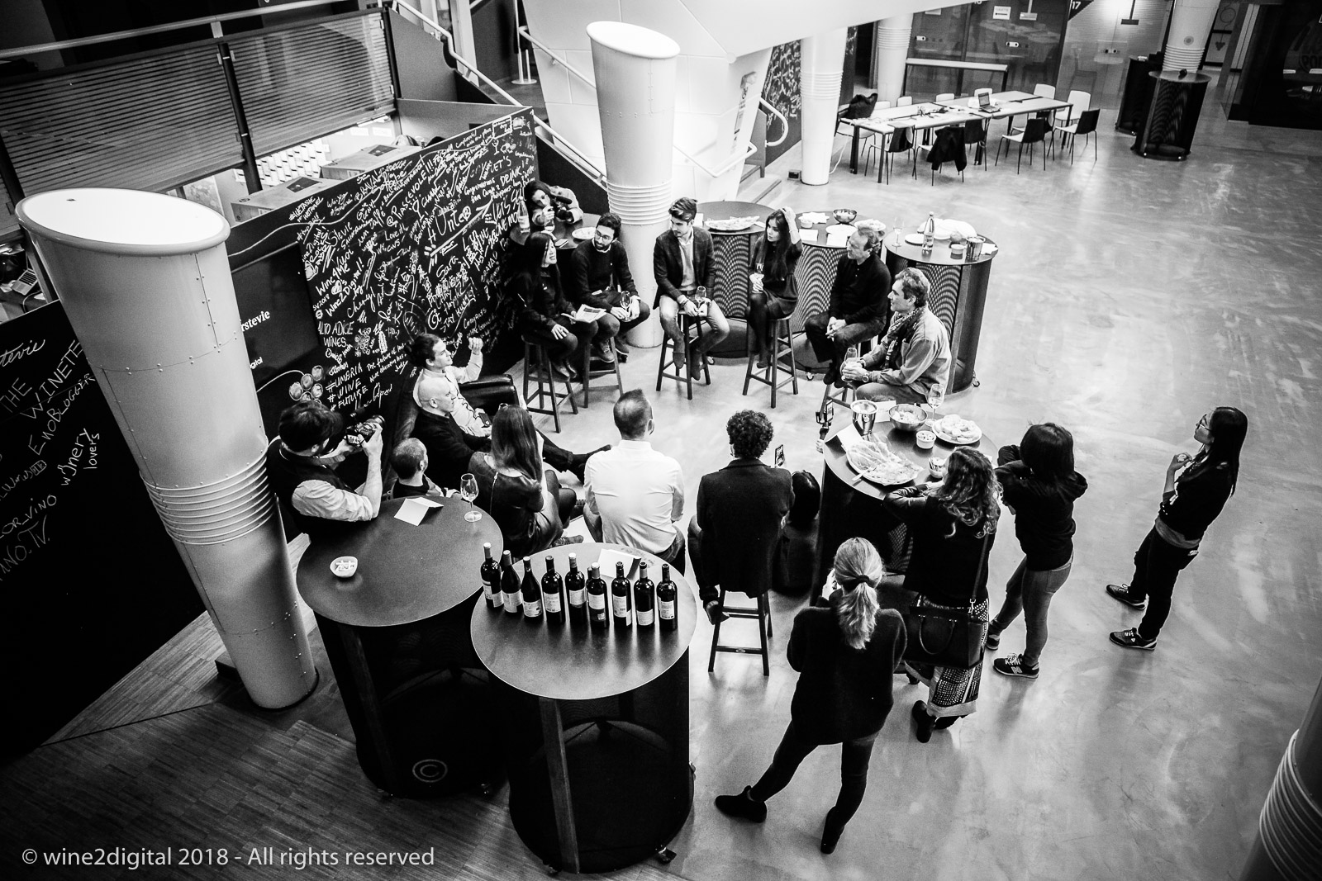
Verona, Italy / February 06, 2018

Influencer marketing is a hot topic these days. In the wine arena, the influencers whose metrics reveal a sheer number of followers’ seem to stand out from the larger Instagram community, despite their short-lived history. More often than not, many will challenge the younger generation of wine Instagrammers as non-experts and question their credentials. But does a wine influencer have to be necessarily a wine expert? Can the younger generation of fledgling social media wine engagers challenge traditional media such as Wine Spectator? Is it all about offer and demand for this type of wine influencers? How has the Italian wine community embraced them both from a trade and a consumer audience perspectives? These were some of the questions discussed openly with a contingent of Italian wine influencers and Stevie Kim, Managing Director at Vinitaly International, during a debate which was part of the new initiative #openbarstevie.

On February 5th, some of the most followed wine Instagrammers in Italy gathered together in Verona at wine2digital, the home to Vinitaly International in the premises of Veronafiere, for an aperitivo and the launch of “#openbarstevie,” Kim’s new endeavour. Using the hashtag #openbarstevie, the project aims to create an informal discussion platform where key players from different fields can come together, open up conversations, debates and, above all, share their ideas. These discussions will all be broadcasted live on social media, uncensored and unedited.

“As the social sphere completely changed the ways of communication, we have learned through our experience that content is king and more and more interest seems to be coming from the ‘behind the scenes’ of any project or event”, says Stevie Kim. “Since interesting people — not only from the wine world — but also from other fields of expertise are constantly popping by at wine2digital, I thought why not livestream some of these raw moments, whether it is a business meeting, an encounter, or an interesting exchange of ideas? We’d love to facilitate an informal chat to share ideas in real time even if it means we will constantly make mistakes. However, what we’ve noticed was that the nitty gritty stuff gets unleashed off-camera.”

Social media feed into the curiosity of all of us, and social media influencers excel in grasping audiences’ attention. For this reason, the first episode of #openbarstevie focused on a single question “What does it mean to be a wine influencer?”. The meet-up, which opened up the discussion to better understand wine influencers in Italy and their projects, was broadcasted live on wine2digital’s Instagram and Facebook channels, where more post-event videos and various related content will follow soon.

Some of the keywords that emerged in the meet-up were sense of community, importance of direct responses, education, and trust. Emanuele Trono, a twenty-five year old newbie to the wine arena, better known as @enoblogger, stressed the fact that the social sphere is a completely new paltform where sense of community is valued more than anything: “I share my personal thoughts and opinions, but also always try to ask what they think. The interaction is so raw and incredibly direct!” Twenty-two-year-old Stefano Quaglierini (@italian_wines), the youngest of the group but with the clearest business strategy, emphasized the importance of story-telling and sharing emotions through images and texts. Some of these Instagrammers speak to a well-defined audience, such as Andrea Albagli (@cor_vino) whose target audience does not include the so-called wine experts but rather beginners in the world of wine. Instagram is the main channel they utilize, the only exception to this trend being Chiara Gianotti (@vino.tv), whose fan base is on Facebook. According to Gianotti, “Despite which channel you decide to use, the most important part of being a wine influencer is to be trusted by consumers. You are a true influencer when your followers actually listen to your suggestions and advice when purchasing wine.”

Stevie Kim and the 9 wine influencers were also joined by J.C. Viens, WSET-certified wine educator based in Hong Kong, and the wine writer Robert Camuto. Both Viens and Camuto, in a way, represent the other side of the aisle and probed the Instagrammers on a number of issues. The question ‘Can the wine influencers leverage their reach and transform it into a sale?’ was a key part of a heated discussion during the evening. Viens highlighted the way wineries can benefit from wine influencers: “For me, an influencer is someone who can help a producer move more volume. Someone who can encourage people to choose wine over beer or other beverages. At the end of the day, we need to ask ourselves, is this helping the wineries?” Camuto, storyteller and book author added, “No matter how the medium changes, knowledge is still — and will always be — the key in creating content. You need deep knowledge to tell a story worth telling to others.”

Although the influencers had previously dialogued online, some of them mentioned that the wine2digital event was the first occasion in which they had met each other in person. Who are these wine influencers then? Is it a real job? What do influencers think of more traditional media? Stevie Kim and her guests at #openbarstevie continued to challenge each other with these and other questions. The live-streaming which revealed their answers and comments is available on the wine2digital Facebook page (https://www.facebook.com/wine2digital/videos/408735046230372/). As Kim concludes, “Not just for Italian wines, wines in general are struggling to draw in the next generation of wine lovers. Wine has often lost its space, favoring, instead, cocktails and artisanal beers for younger drinking habits. If we do not change the way we communicate, if we cannot engage more effectively and efficiently, I’m afraid the future of wine is quite bleak. You can agree or disagree with wine influencers’ or their expertise, nonetheless we have to engage with them. I am quite old so it is difficult to put myself in a young mind and attitude. So let there be thousands of wine influencers, who can exponentially engage wine culture, wine life in general, in the way this generation is doing. Our job should not be to criticize them nor to compare our way of communication with theirs. Our job is to encourage and embrace them not blindly but in a constructive way.” In the next months, the initiative #openbarstevie will continue to explore further the theme of social media and the shifting meaning and definition of “wine influencer”.

See below for social handles and full names of the wine Influencers who participated:

@cantinasocial Matteo Franco, Adriano Amoretti, and John Murnane

@cor_vino Andrea Albagli

@enoblogger Emanuele Trono

@italian_wines Stefano Quaglierini

@thewineteller Anais Cancino

@vino_tv Chiara Gianotti

@winerylovers Simone Roveda

wine2digital Instagram channel: https://www.instagram.com/wine2digital/

wine2digital Facebook channel: https://www.facebook.com/wine2digital/

