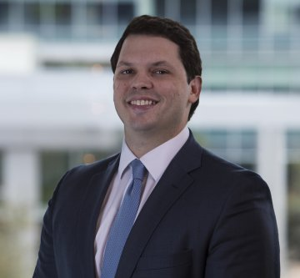
FOR IMMEDIATE RELEASE
Press Contact:
Blair Lewis
President, Global Recruiters of Mid-Cities
(817) 591–1318
blewis@grnmid-cities.com
www.grnmid-cities.com
February 22, 2018
Crossmark Global Investments names Casey Ahern as Director of National Accounts
(HOUSTON) – Crossmark Global Investments, an innovative investment management firm that helps investors align their values with investment management solutions and longtime partner of Global Recruiters of Mid-Cities, announced the hiring of Casey Ahern as Director of National Accounts on January 2, 2018, as part of its multi-year growth plan.
As Director of National Accounts, Casey Ahern will work to build and enhance the company’s platform of investment solutions and relationship management with intermediary and retirement partners.
“Casey will be instrumental in furthering our efforts to elevate our intermediary distribution platform,” said David Rentfrow, Managing Director at Crossmark Global Investments. “This team will help the firm in its mission to provide innovative investment solutions to financial advisors and the clients they serve, as well as helping our distribution partners deepen their capabilities in responsible investing.”
Global Recruiters of Mid-Cities, an Executive Search Firm, established a professional relationship with Casey in early 2015 and remained in contact with the expectation he would become an excellent addition to a company looking to grow their market presence through National Accounts and platform sales.
“We believed Casey fit not only the technical requirements for the role, but would be a great cultural fit as well,” said Blair Lewis, President of Global Recruiters of Mid-Cities.
Previously, Ahern served as Vice President of National Accounts for Carillon Tower Advisors, a subsidiary of Raymond James Financial, for five years. In this role, he was responsible for building and enhancing product distribution with Wirehouse and large regional broker-dealers.
In 2010, Ahern joined investment management firm, Eagle Asset Management, as Regional Vice President. In this capacity, he was responsible for the South Eastern Region, which included Georgia, Alabama, Mississippi, and Louisiana. He successfully led the region, which was ranked at 14 out of 15, to rank 2nd nationally in SMA sales and from 3rd ranked of 3 regions in the south to 1st ranked in sales of the southern regions.
Overseeing the placement of Casey Ahern occurred as Global Recruiters of Mid-Cities approached its sixth anniversary on February 14. As an Executive Search Firm focused on the finance industry, Global Recruiters of Mid-Cities strives to provide the best candidates available for each and every position by taking the time to learn the unique aspects of each individual client and deliver what the company calls the “Invisible Elite” to best fill the role.
For additional information, please contact: Blair Lewis, President, Global Recruiters of Mid-Cities at blewis@grnmid-cities.com, or by phone at 817-591-1318.
###
About Global Recruiters of Mid-Cities:
Global Recruiters of Mid-Cities, a partner of Global Recruiters Network, is an Executive Search Firm with a keen focus in the financial industry. Our professional network of Executive Recruiters attracts and presents well-qualified candidates utilizing our established relationships with Fortune 500 companies, providing clients and partners access to some of the most sought-after Executives, Managers, and CEOs in the job market. For more information, visit www.grnmid-cities.com.

